The Birds of Corhaven

Evelyn Yarzebinski & Kevin Soo

## Accipitridae: Kites, Hawks & Eagles

### Bald Eagle

Majestic adults have blackish-brown body with white head and tail. Several stages of immature plumages aren’t quite as majestic, from fully dark brown to messy and mottled with large patches of white. Look especially for white mottling on the belly on immatures. Scavenges and hunts near bodies of water. Soars with wings flat, like a large, dark plank. Head appears large in flight; projects far in front of wings. Surprisingly weak-sounding vocalization is a series of high-pitched whistles.

r run_columnbreak() *Typical seasons: Ordinary Time*

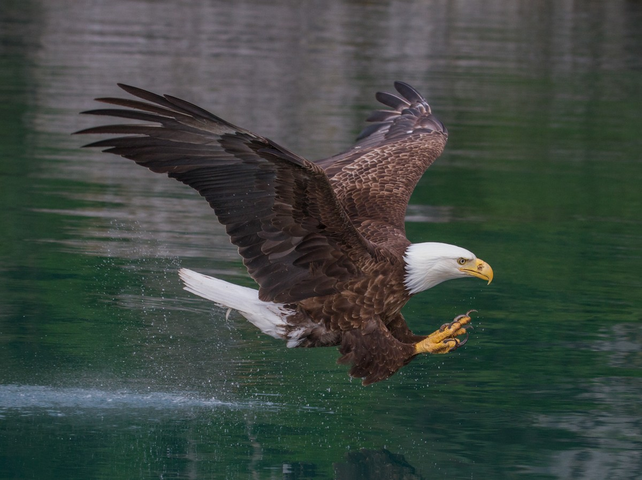

alt text here

### Cooper’s Hawk

Small to medium-sized hawk with relatively short rounded wings and rounded tail. Adults are gray above with pale orange barring below; immatures are browner and streaky. Very similar to Sharp-shinned Hawk, but larger with bigger head. Also note deeper, slower wingbeats. Breeds in forested areas; more common in suburban areas than Sharp-shinned Hawk. Feeds mainly on birds captured in flight. Often stalks feeders in search of prey.

r run_columnbreak() *Typical seasons: Ordinary Time*

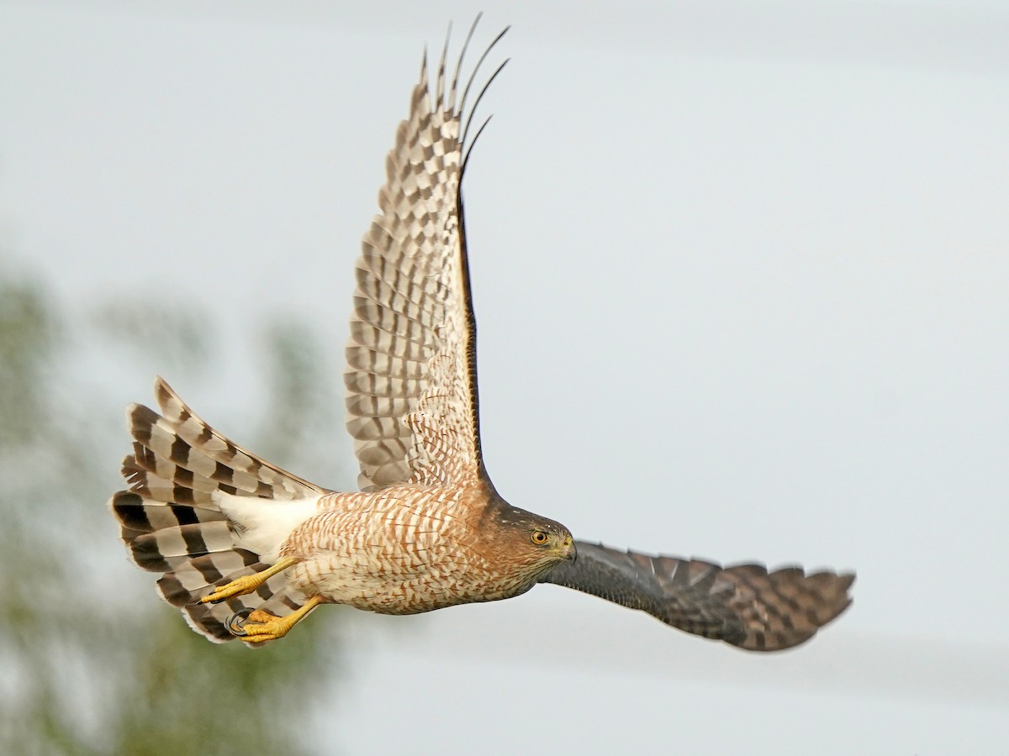

alt text here

### Red-shouldered Hawk

Smaller than Red-tailed Hawk. Adults are beautiful with rich orange barring below and bold black-and-white checkerboard patterning on wings. Often in forested areas, where they hunt from perches. Perches on wires more frequently than Red-tailed Hawk. In flight, wings seem narrow and pushed forward compared to Red-tailed or Broad-winged Hawk; also note relatively long tail. Population in California is more richly colored (darker orange) than paler Eastern birds; while Florida birds are paler with gray head and back.

r run_columnbreak() *Typical seasons: Epiphany, Ordinary Time*

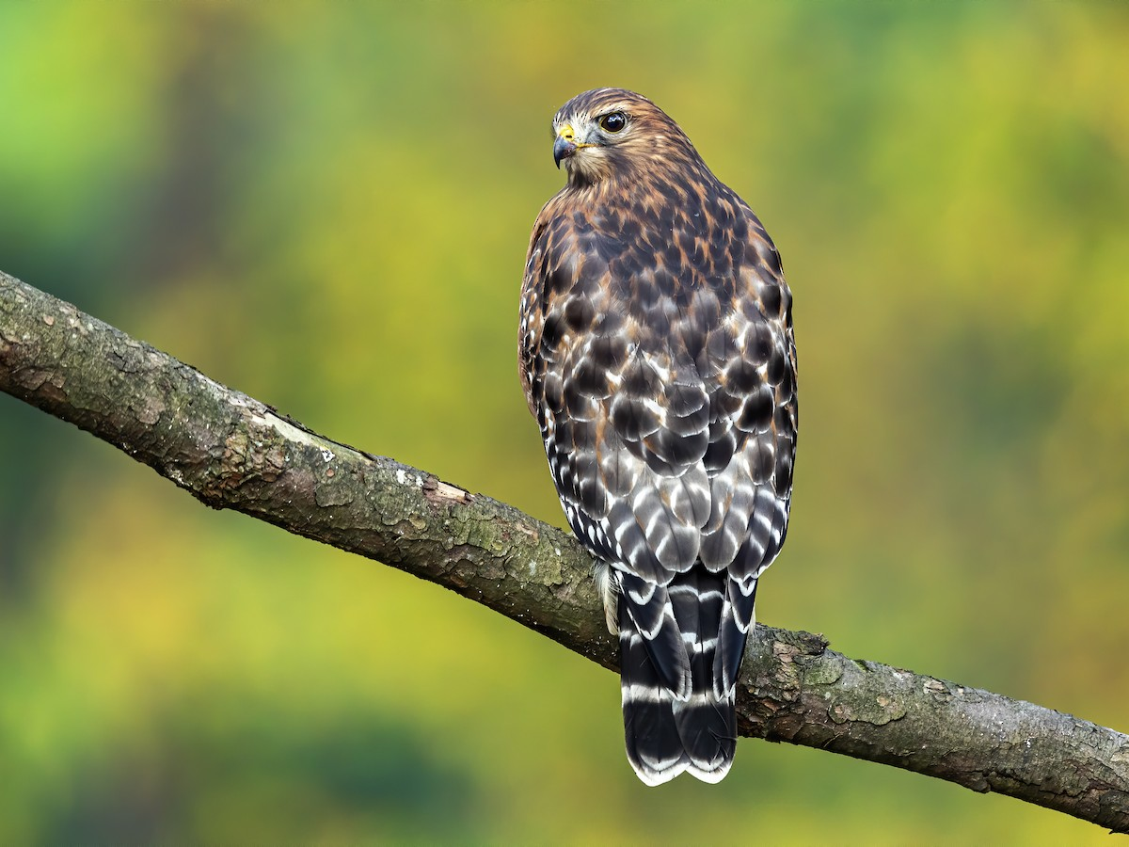

alt text here

### Red-tailed Hawk

Most common roadside raptor across much of North America. Often perches atop telephone poles, light posts, and edges of trees. Incredible variation in plumages, including less common dark morphs and various regional differences. Eastern adults have brilliant reddish-orange tail and pale underparts with obvious band of dark marks across belly. Western birds are typically darker. Immatures do not have a red tail.

r run_columnbreak() *Typical seasons: Epiphany, Lent, Ordinary Time*

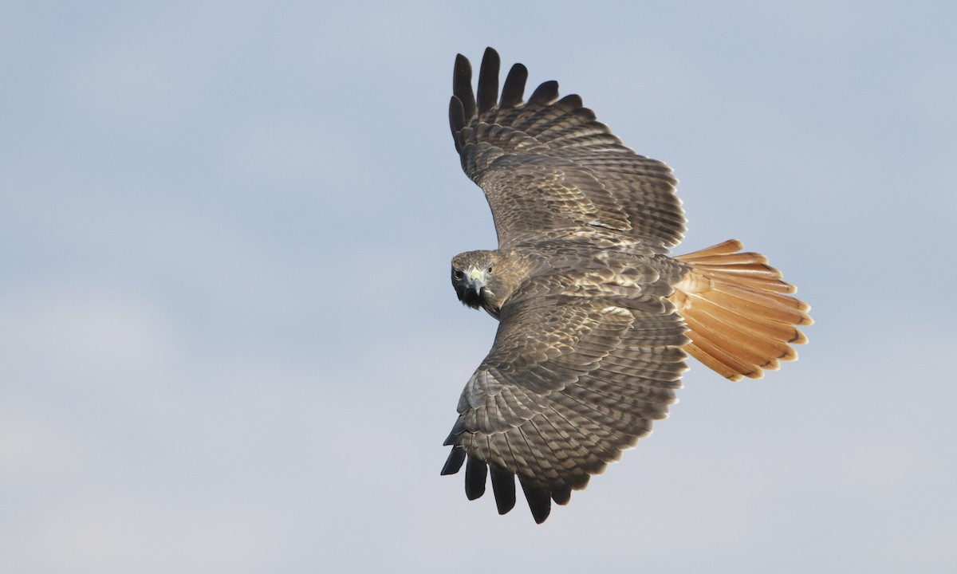

alt text here

## Alaudidae: Larks

### Horned Lark

Squat-looking bird with short legs and low-profile body. Adults are mostly sandy-brown with white belly, sometimes with blurry streaks on sides of breast. Look for bold head pattern, especially black mask and chest band. Throat color varies from yellow to white. Namesake horns on head are sometimes visible at close range. Juveniles can be confusing; they are messy-looking, grayish-brown with bold white spots and scallops on the upperparts. Note bill shape to help separate from sparrows or longspurs. Widespread in open habitats throughout the Northern Hemisphere. Typically seen in flocks, sometimes mixed in with other open-ground songbirds, running along the ground in open areas with little to no vegetation. Listen for lovely jumbled song, as well as variable high-pitched calls when flying over.

r run_columnbreak() *Typical seasons: Epiphany*

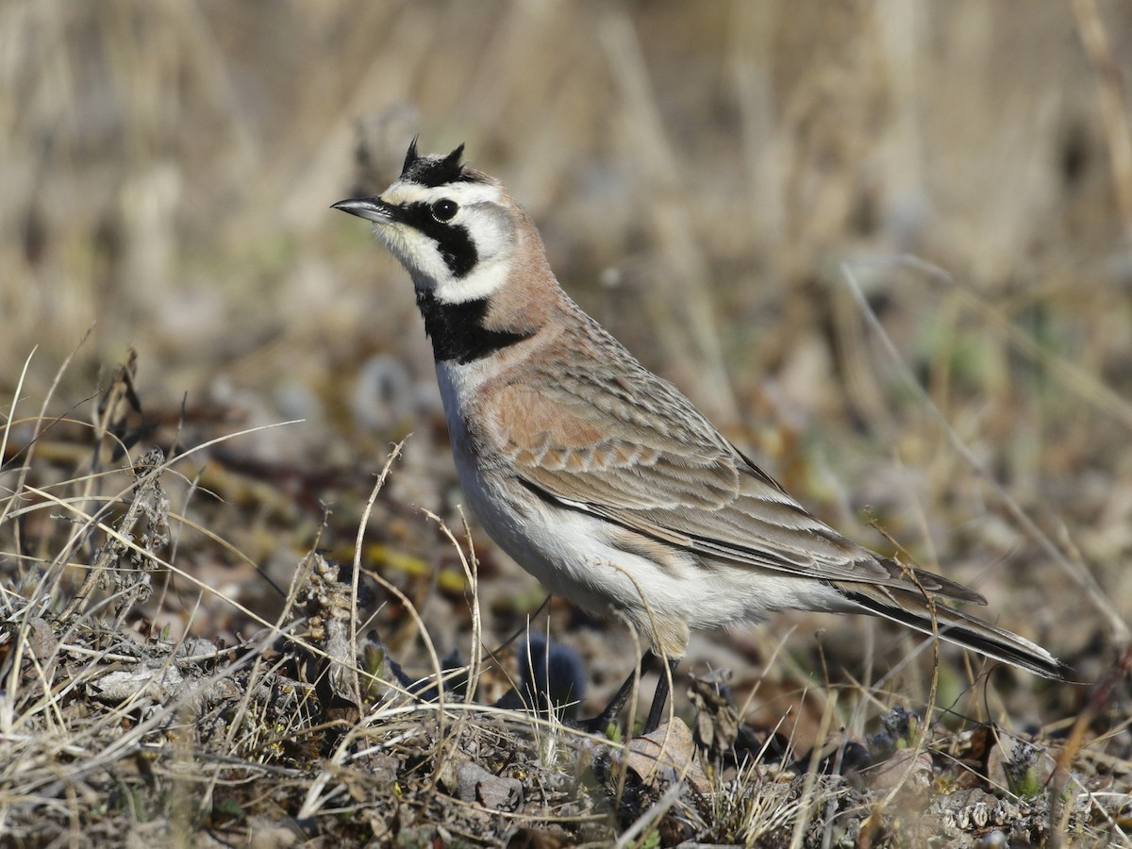

alt text here

## Alcedinidae: Kingfishers

### Belted Kingfisher

Stocky and large-headed with a shaggy crest. Bill is long, straight, thick, and pointed. Powder blue above with white underparts and blue breast band. Females have additional rusty band across belly. Almost always solitary, perched along edges of streams, lakes, and estuaries. Flies along rivers and shorelines giving loud rattling calls. Hunts for fish by plunging headfirst into the water, either directly from a perch or hovering.

r run_columnbreak() *Typical seasons: Ordinary Time*

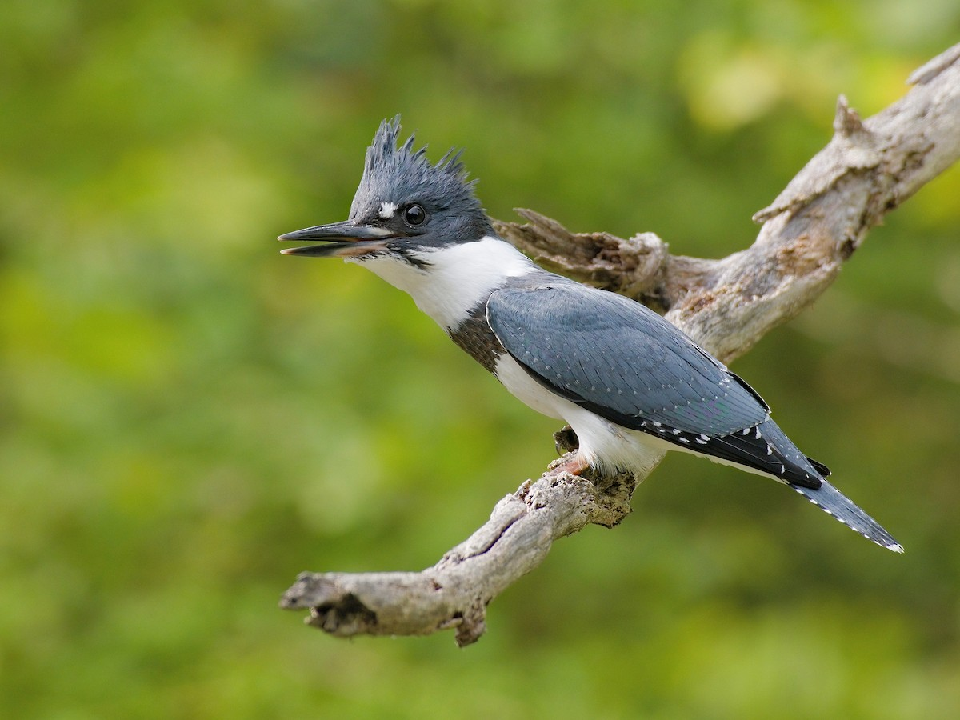

alt text here

## Anatidae: Swans, Geese & Ducks

### Blue-winged Teal

Small duck with chalky-blue patches on the upperwing (visible in flight). Breeding males unmistakable with bold white crescent in front of eye and polka-dotted sides. Females are cold brown overall and intricately patterned. Look for a hint of a pale crescent on the face, as well as a dark eyeline and pale eye-arcs. Usually found in shallow wetlands or marshes, where it can occur in pairs or flocks, sometimes mixed with other species of ducks. Compare with other teal species: female Cinnamon Teal is warmer-toned overall and has a duller face pattern, while female Green-winged Teal is more compact, darker, and has a different wing pattern in flight.

r run_columnbreak() *Typical seasons: Lent, Easter*

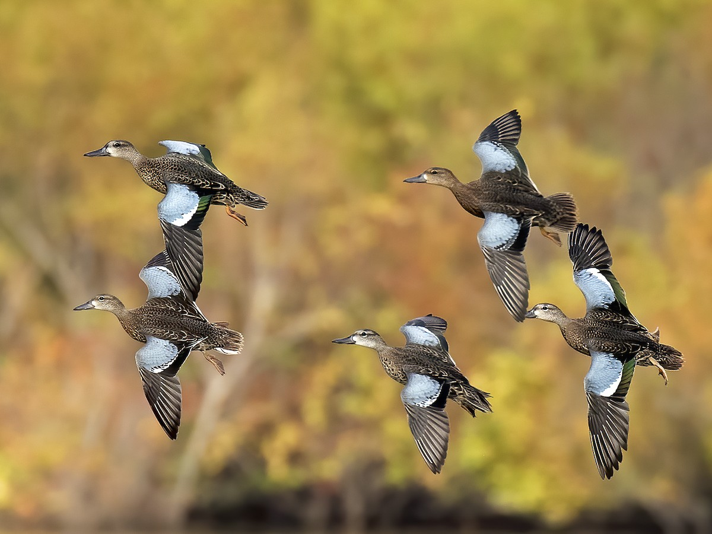

alt text here

### Canada Goose

A large brown goose with a black neck and white chinstrap. Overall size, bill size, and brown coloration variable across subspecies. Occurs in any open or wetland habitat, from city parks and golf courses to pristine marshes and Arctic tundra. Typically in flocks or family groups. Often seen in mixed flocks with Cackling Goose, especially in central and western North America. Canada Goose is almost always larger, longer-necked, and longer-billed than Cackling, although beware there is some overlap between the smallest Canada and largest Cackling. Abundant and widespread throughout the U.S. and Canada; rare in Mexico. Introduced and widely established in Europe. Listen for loud honking calls, especially as flocks migrate overhead in the classic V formation.

r run_columnbreak() *Typical seasons: Lent, Ordinary Time*

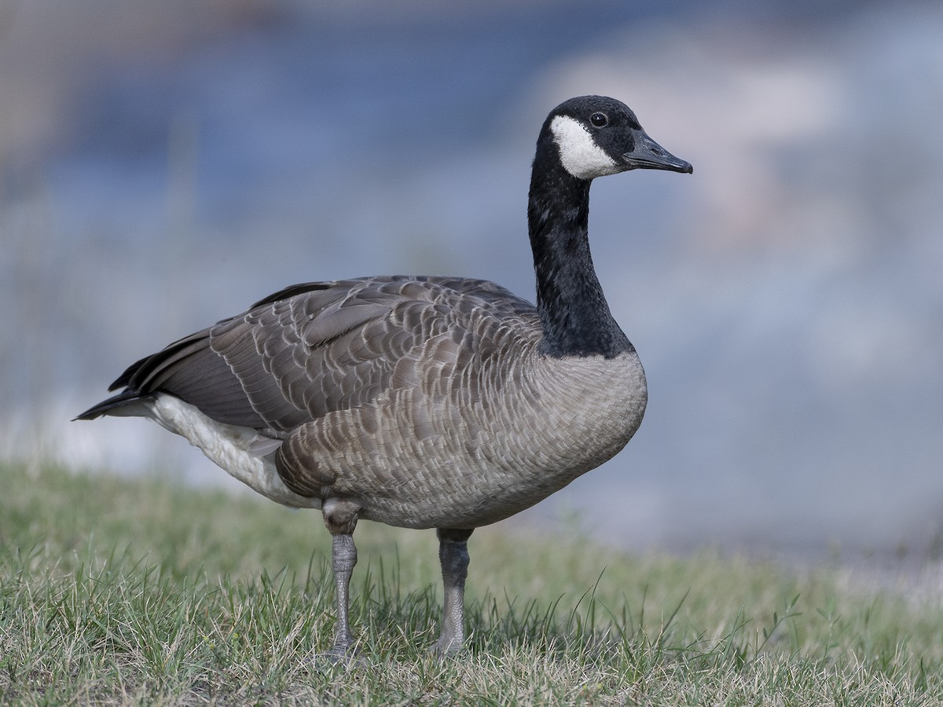

alt text here

### Canvasback

Attractive duck with distinctive triangular head; forehead slopes seamlessly into the long bill. Males are white-bodied with black chest, reddish-brown head, and red eye. Females are dull grayish-brown with unique head profile and dark brown eye. Breeds in lakes and marshes. Winters in any large body of water with submerged aquatic vegetation on which to feed. Dives frequently, searching for vegetation and invertebrates. Often gathers in large flocks in nonbreeding season.

r run_columnbreak() *Typical seasons: Lent*

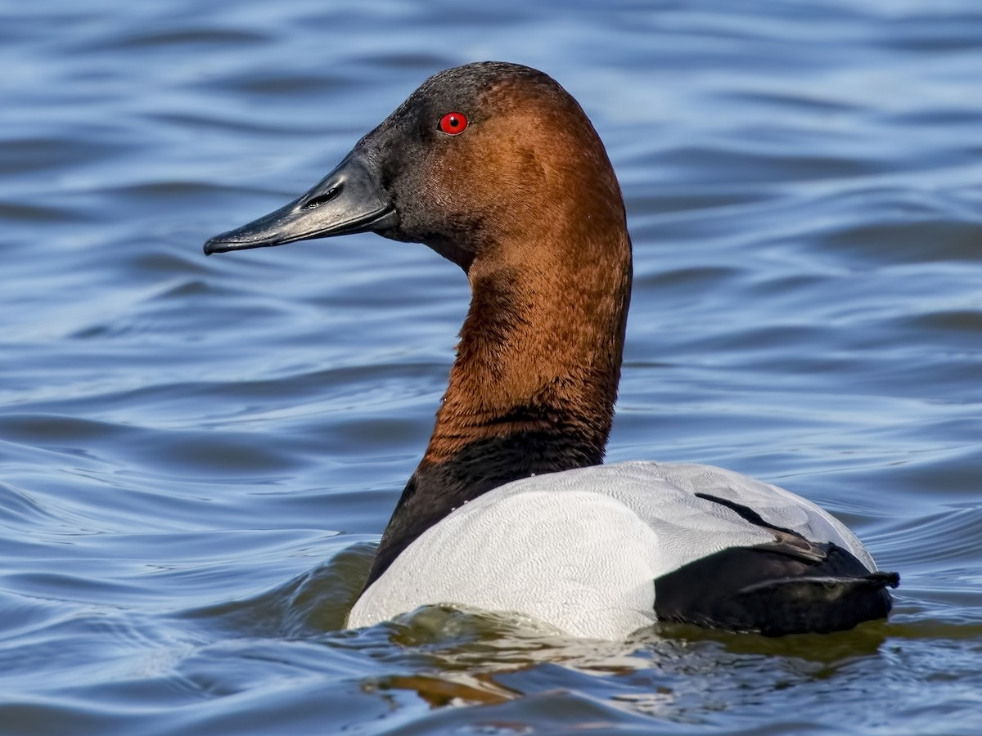

alt text here

### Common Merganser

Large duck with a sleek body and thin red bill. Breeding males have a dark green head and mostly white body with peachy blush on underparts. Females and immature males have rusty brown head and gray bodies with a cleanly demarcated white throat. Feeds in rivers, lakes, and large ponds by diving to catch fish. Hardy in winter, often staying as far north as open water permits.

r run_columnbreak() *Typical seasons: Epiphany, Lent*

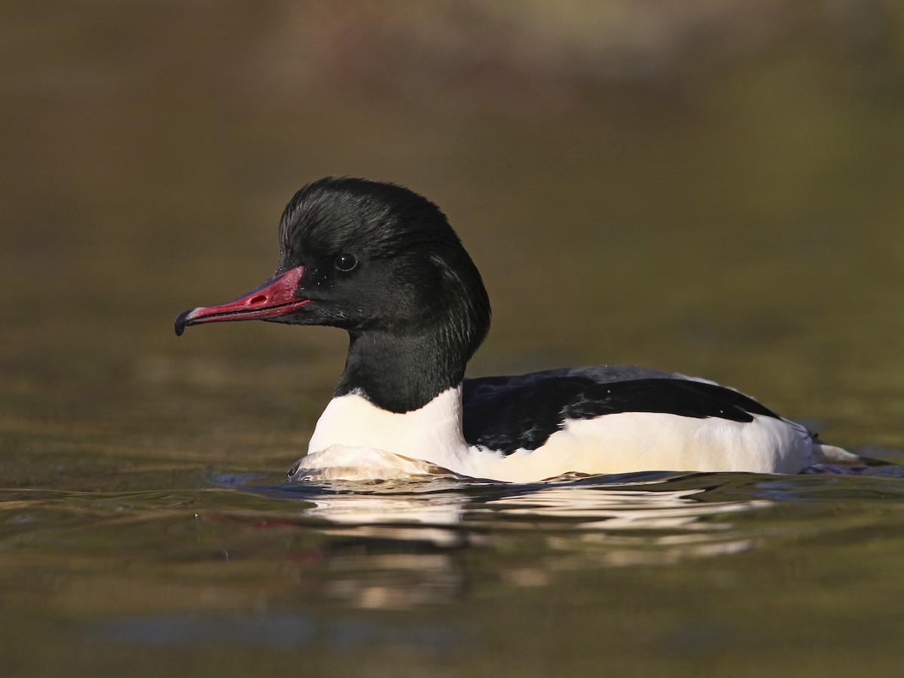

alt text here

### Gadwall

Fairly large duck with extensive range across Northern Hemisphere. Males are mostly gray with a black rear end and puffy head. Also look for small white wing patch in flight. Females are similar to Mallard, but note thinner bill, plainer face, orange line along the edge of the bill, and white wing patch in flight. Typically found in pairs or small flocks in shallow wetlands, ponds, or bays, sometimes mixed with other species of ducks.

r run_columnbreak() *Typical seasons: Lent, Christmas*

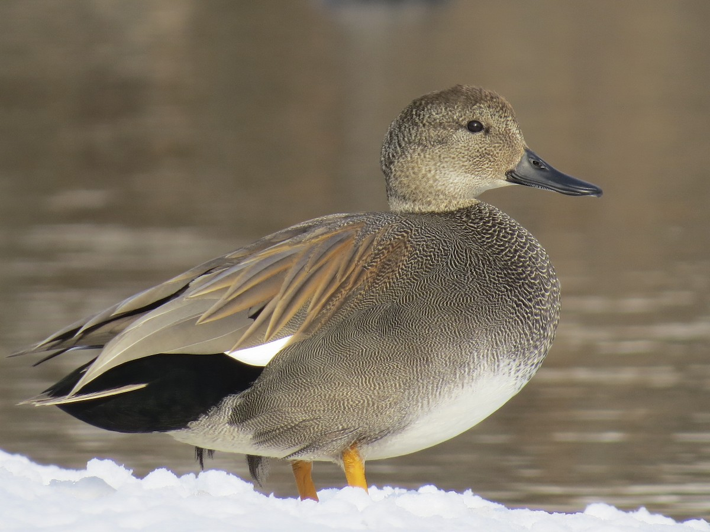

alt text here

### Hooded Merganser

Small diving duck with thin serrated bill. Breeding males have showy black-and-white crest, a couple zebra stripes on the white breast, and cinnamon-colored sides. Females are brown with a puffy crest and partly yellow bill. Looks slender and long-necked in flight, with very fast wingbeats. Widespread across much of North America, but usually only seen in pairs or small flocks. Nests in cavities near small ponds or marshes; especially fond of wooded swamps. In winter, usually found on calm bodies of water; almost never on the ocean. Sometimes mixes loosely with other duck species.

r run_columnbreak() *Typical seasons: Epiphany, Lent*

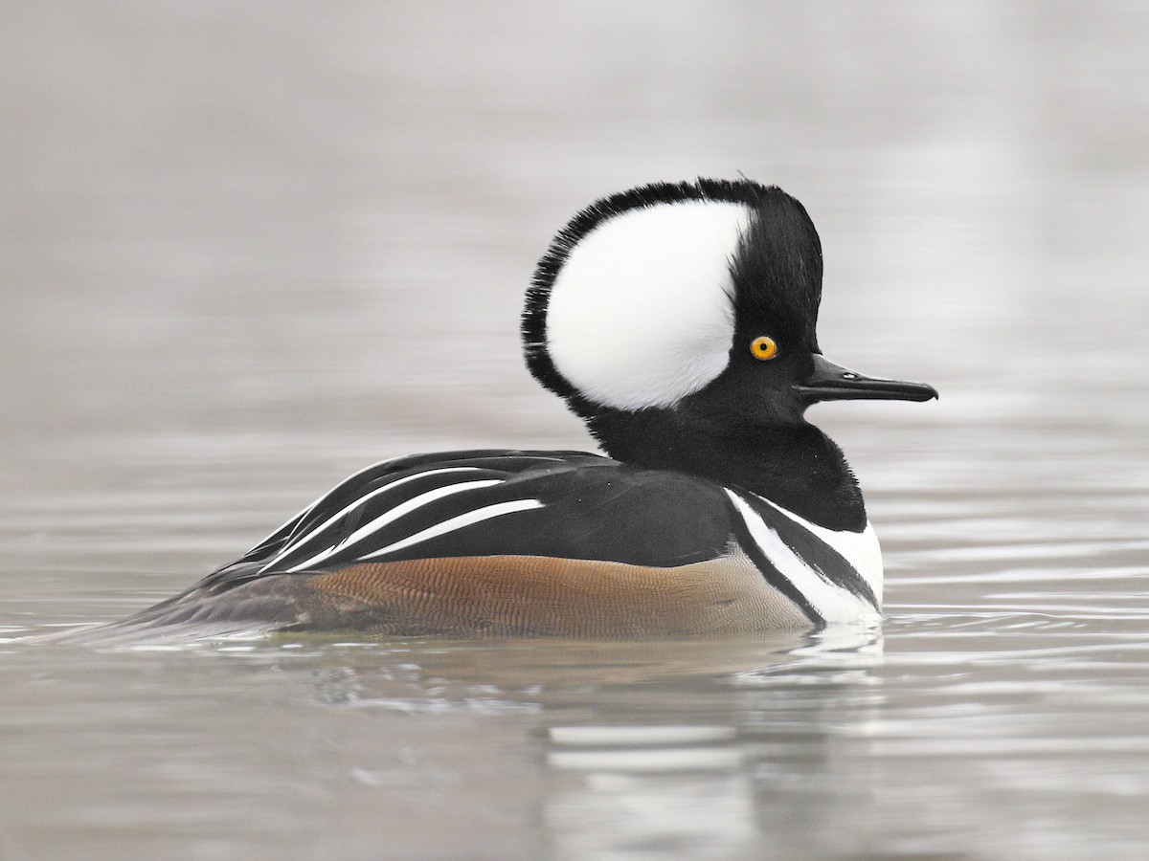

alt text here

### Mallard

A large duck, generally common and familiar within its extensive range. Males are distinctive with iridescent green head, yellow bill, chestnut breast, and gray body. Females are mottled brown with orange and black splotches on the bill. Found anywhere with water, including city parks, backyard creeks, and various wetland habitats. Often in flocks, and frequently mixes with other duck species. In North America, females can be tricky to distinguish from American Black Duck, Mottled Duck, and Mexican Duck where ranges overlap. Those species are all darker-bodied than Mallard. A good view of the wing can be helpful, too: white wingbars on the leading and trailing edges of the blue wing patch are bolder on Mallard. Frequently hybridizes with those species, which can be even more confusing. Any bird with extensive white in the tail or curled feathers above the tail has some Mallard genes.

r run_columnbreak() *Typical seasons: Epiphany, Lent, Ordinary Time*

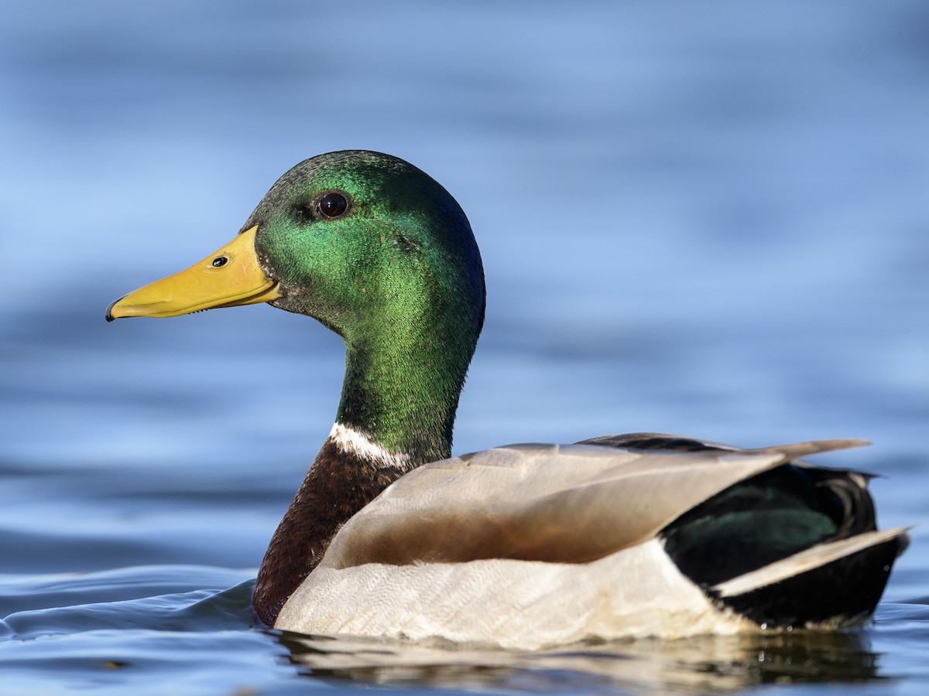

alt text here

### Northern Shoveler

Medium-sized duck; smaller than a Mallard. Huge, spoon-shaped bill visible at a distance and in flight. Breeding males have dark green head, white breast, and chestnut sides and belly. Females buffy-brown with large, distinctive bill. Chalky-blue upperwing. Forages by sifting through the water, often swimming in spirals in groups.

r run_columnbreak() *Typical seasons: Epiphany, Lent*

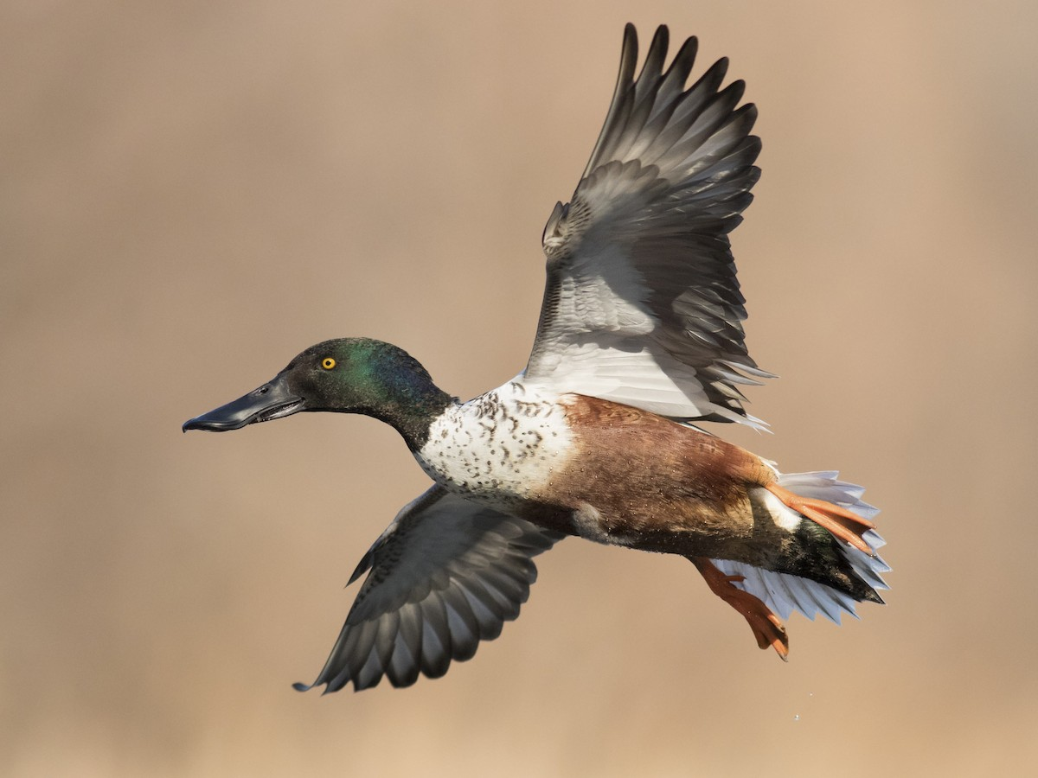

alt text here

### Ring-necked Duck

A relatively small diving duck with a tall peaked crown. Males are handsome with glossy black head and back, clean gray sides, and a brighter white spur on the side. Females are grayish-brown, often with a paler patch at the base of the bill and a white eyering. Both sexes have a white band near the tip of gray bill. Also note gray, not white, wingstripe in flight. Usually favors small bodies of water, such as beaver ponds and cattail marshes, but also occurs on larger lakes, rivers, and bays. Can be found in mixed flocks with other diving ducks, although usually in smaller numbers than scaup. Compare with both species of scaup and Redhead (especially females).

r run_columnbreak() *Typical seasons: Lent*

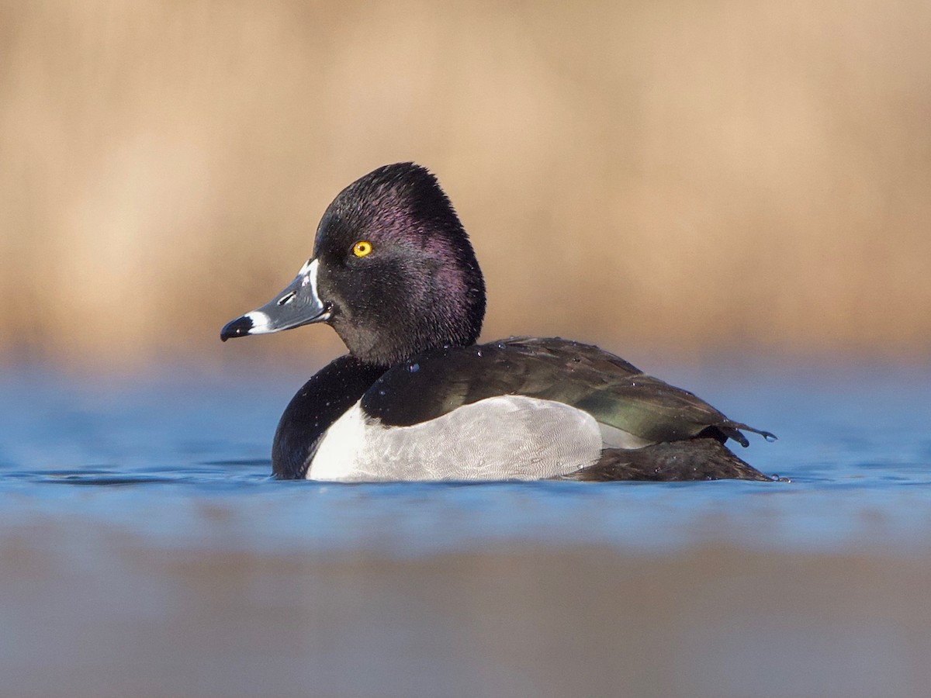

alt text here

### Wood Duck

Breeding males are stunning with ornate, colorful patterns visible up close; appears dark overall at a distance. Females gray-brown with thin white eyering. Crest on head. Found in wetlands and flooded woods. Flies through trees with exceptional maneuverability, thanks to its long tail. Often shy and quick to flush. Call is a loud, screeching whistle.

r run_columnbreak() *Typical seasons: Lent, Ordinary Time*

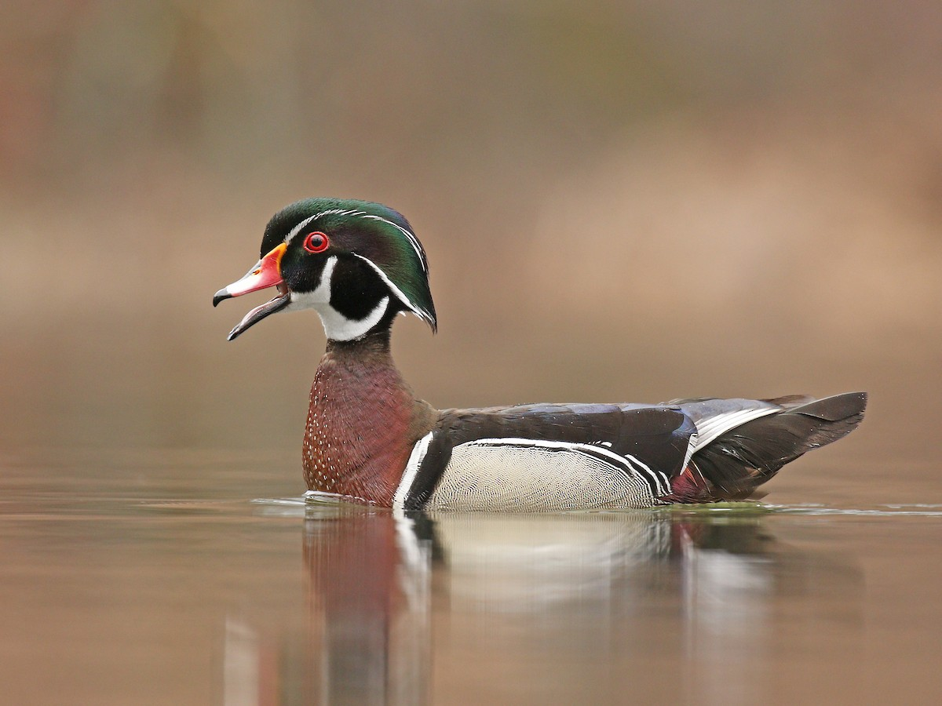

alt text here

## Apodidae: Swifts

### Chimney Swift

The “flying cigar” with a blunt head, squared-off tail, and long, sickle-shaped wings. Body is dark gray with a slightly paler throat. Flies all day long with ridiculously fast, snappy wingbeats. Nests and roosts in chimneys. Often seen in small groups, twittering and cruising around town in search of insects. The only swift in the eastern U.S.

r run_columnbreak() *Typical seasons: Easter, Ordinary Time*

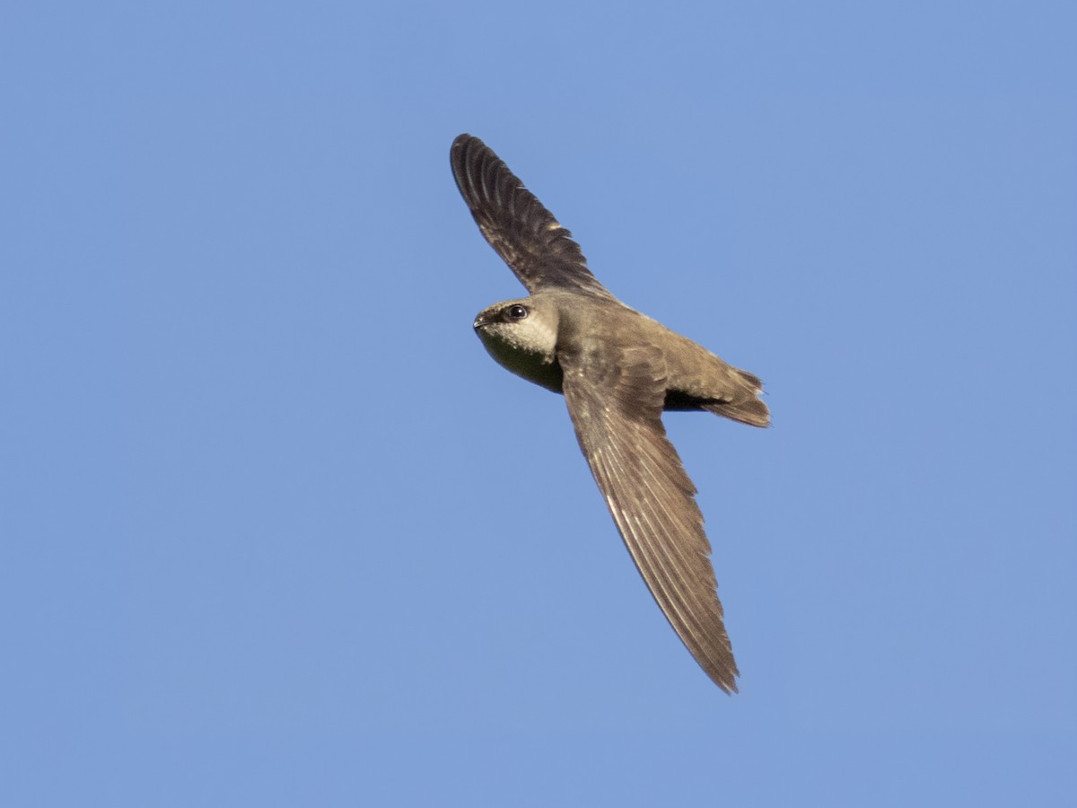

alt text here

## Ardeidae: Bitterns, Herons & Egrets

### Great Blue Heron

Huge gray heron, no other similar species in range. Note large yellow-orange bill, short black plumes on head, and black and chestnut pattern on shoulder. Immatures are more brownish than adults, and have a dark crown. Fairly common and widespread throughout North America; wintering range extends to northern South America. Occurs in almost any wetland habitat, from small ponds to marshes to saltwater bays. Usually seen singly but can gather in numbers where food is plentiful. White form, sometimes considered a separate species (“Great White Heron”), is found in southern Florida and the Caribbean. It is most similar to Great Egret but has a larger bill.

r run_columnbreak() *Typical seasons: Ordinary Time*

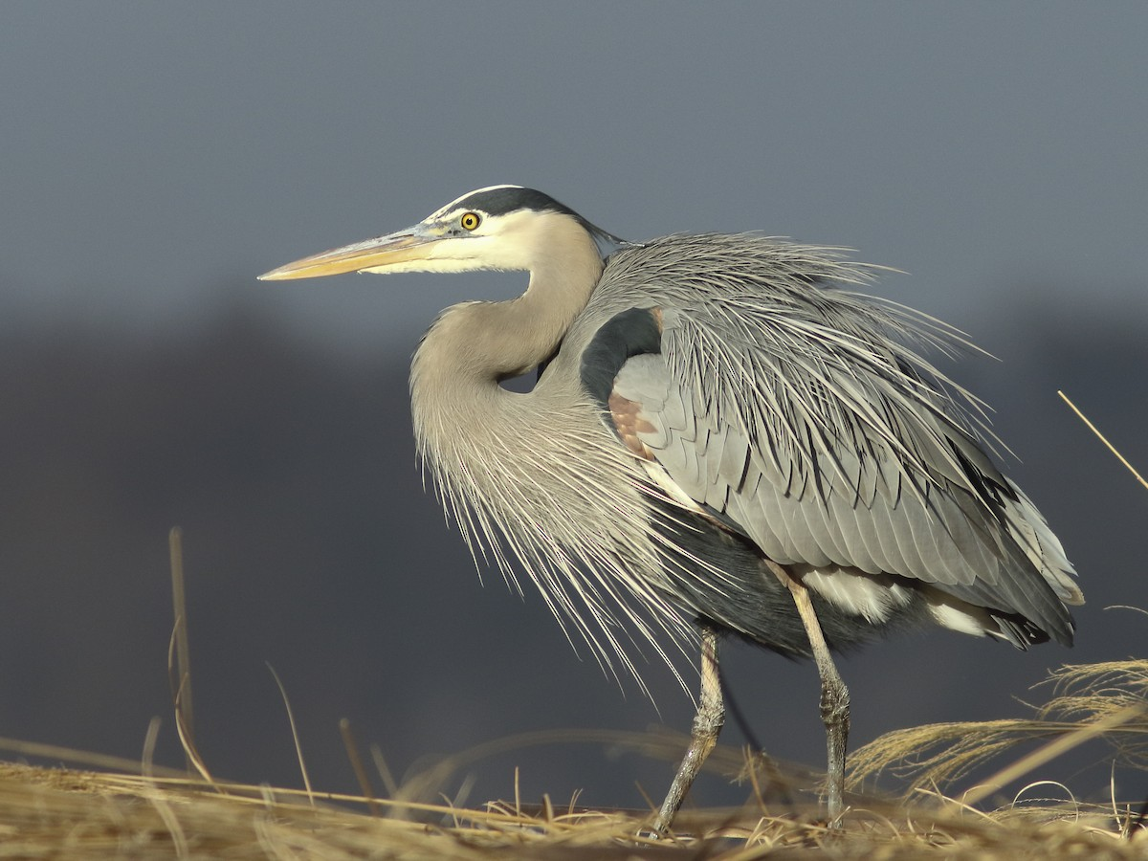

alt text here

### Great Egret

Large, lanky, long-necked white heron. Size and black legs help separate from other egrets. Widespread and fairly common across the globe. Bill color varies across range: always yellow in the Americas, black in breeding season elsewhere. Occurs in any shallow wetland, including ponds, marshes, and tidal mudflats. Slowly stalks prey in shallow water. Often seen singly, but sometimes gathers in large numbers where food is plentiful. Breeds in colonies, frequently mixed with other egrets and herons.

r run_columnbreak() *Typical seasons: Ordinary Time*

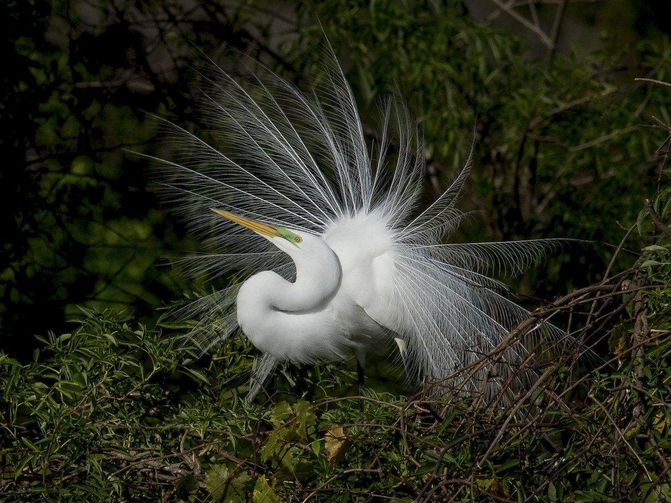

alt text here

## Bombycillidae: Waxwings

### Cedar Waxwing

Plump, smooth-plumaged bird with distinctive thin, high-pitched call. Adults have a sleek crest, black mask, pale yellow wash on the belly, and yellow-tipped tail. Juveniles are drabber than adults, with coarse streaking on the breast and a reduced mask. Widespread and fairly common in open woodlands, orchards, and shrubby areas throughout most of North America. Winter range is variable and somewhat dependent on fruit crops; sometimes ventures as far south as Panama. Often gathers in large flocks, especially around fruiting trees. Compare with Bohemian Waxwing in the northern part of range; Cedar is smaller, browner, and has a white (not rufous) undertail.

r run_columnbreak() *Typical seasons: Ordinary Time*

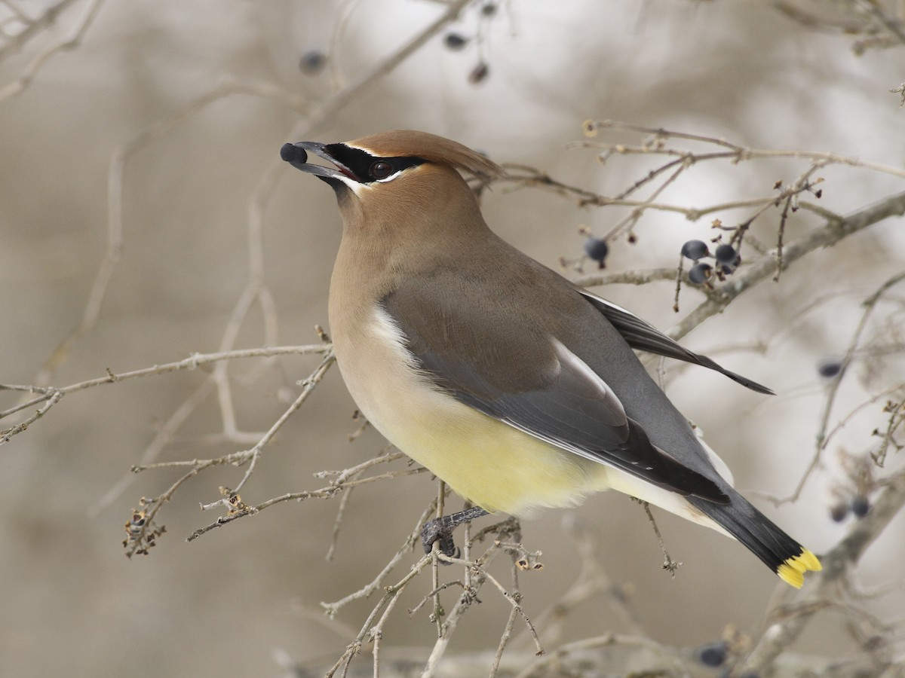

alt text here

## Cardinalidae: Tanagers, Cardinals, Grosbeaks & Dickcissels

### Indigo Bunting

Breeding males are entirely blue with a slightly darker head. Females are plain brown with a whitish throat, bluish tail, and faint streaks on the underparts. Breeds in shrubby areas at the edge of forests and fields. Males often sing from a high exposed perch. Winters mainly in Middle America and the Caribbean, where it frequently gathers in flocks in weedy fields. Females can be very difficult to distinguish from Lazuli Bunting, although their range doesn’t overlap much. Indigo usually shows more streaking on the underparts; also note fainter wingbars, duller breast, and more contrasting whitish throat.

r run_columnbreak() *Typical seasons: Easter, Ordinary Time*

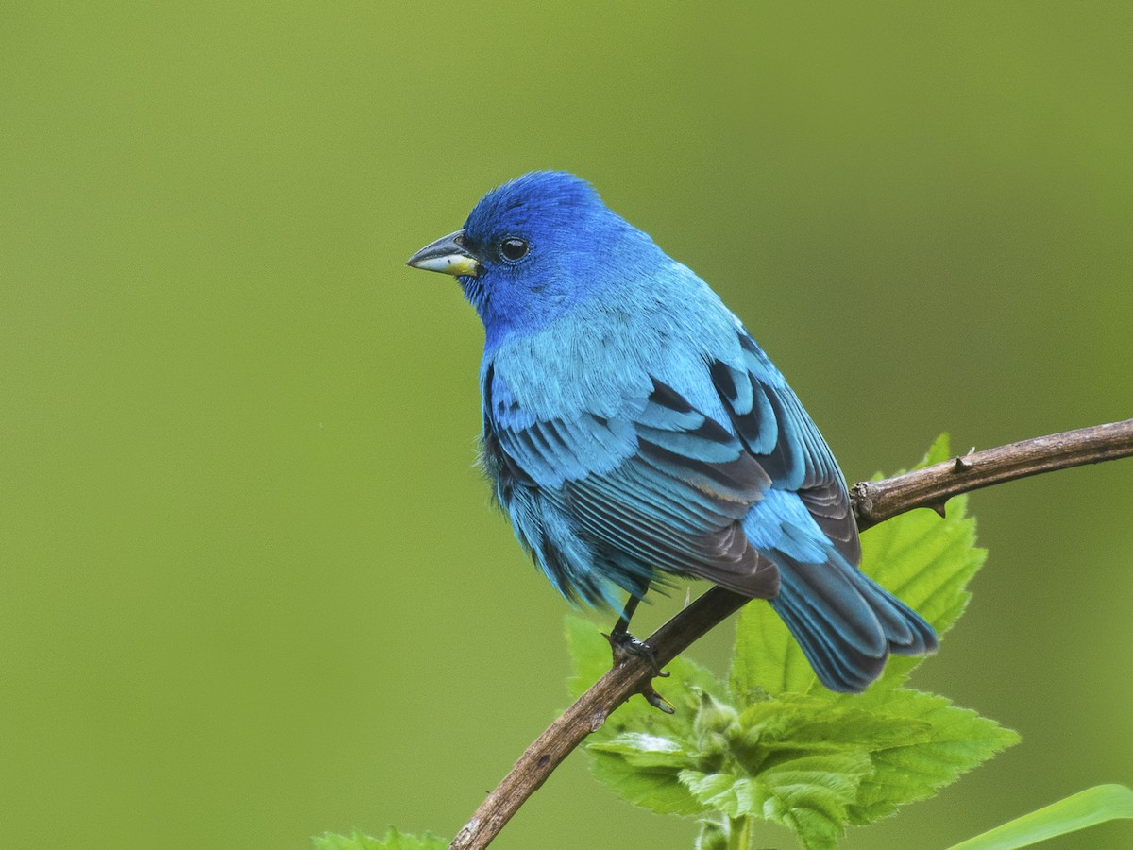

alt text here

### Northern Cardinal

Striking and familiar backyard bird throughout most of eastern North America; also occurs in the southwestern U.S. and fairly extensively in Mexico. Crest, large red bill, and long tail render this species distinctive even with a poor view. Male is entirely red with a black face. Female is brownish overall with redder wings and tail. Usually seen in pairs or small groups near dense cover, especially thickets near forest edges. Frequently visits bird feeders. Listen for high-pitched metallic chips and series of loud, sweet whistles.

r run_columnbreak() *Typical seasons: Ordinary Time*

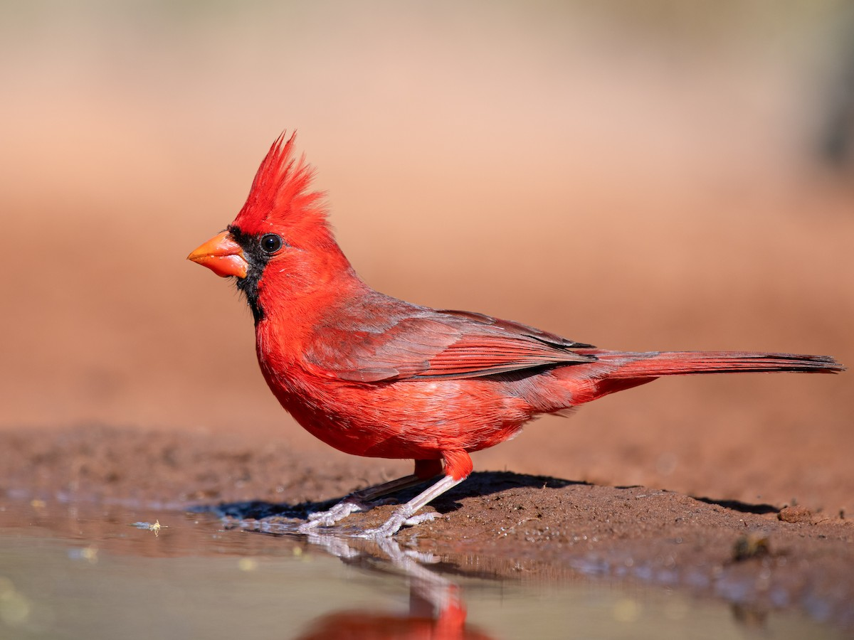

alt text here

### Rose-breasted Grosbeak

Breeding adult males are striking black and white with bright red triangle on breast. Nonbreeding males, females, and immatures are streaky below with a bold head pattern. Always look for the very thick, pale pinkish bill. Fairly common and widespread in eastern North America, especially in deciduous forests. Winters to northern South America. Visits feeders. Listen for sweet robinlike song and squeaky call. Females are sometimes confused with Purple Finch but note much larger overall size, large pinkish bill, and bolder white markings on wings. Also compare females and immature males with extremely similar Black-headed Grosbeak, which is usually identifiable by range. Rose-breasted usually has more extensive, coarser streaking on underparts and usually lacks orange tones.

r run_columnbreak() *Typical seasons: Easter*

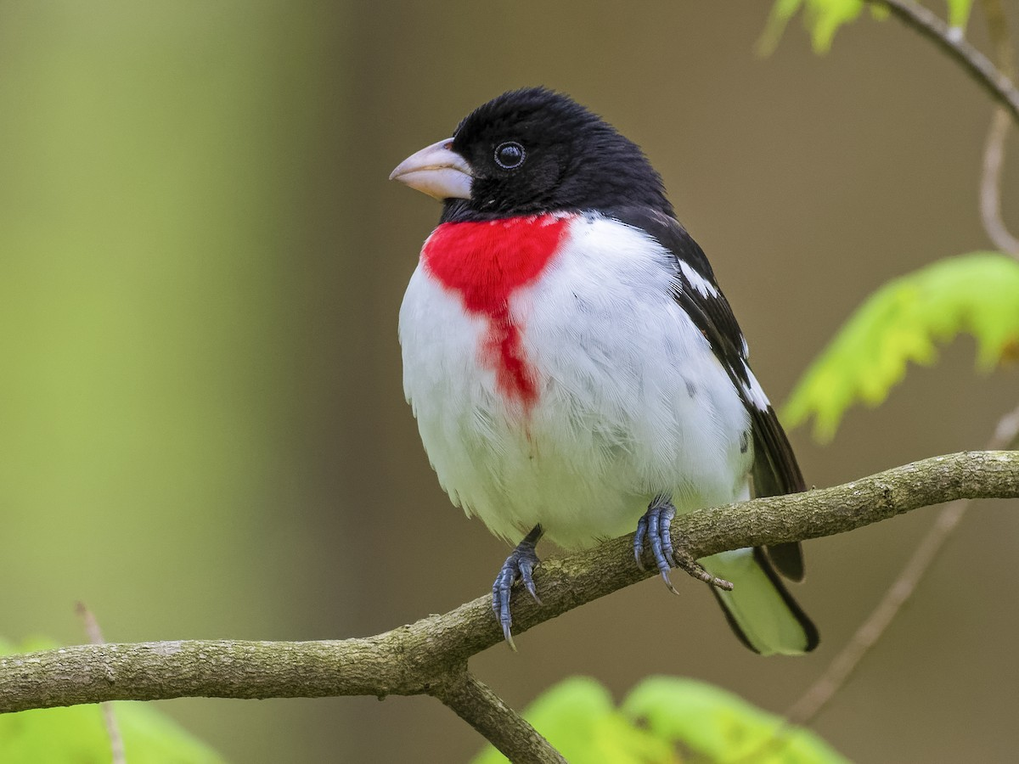

alt text here

## Cathartidae: New World Vultures

### Black Vulture

Large raptor. Uniform black with silvery patches on undersides of wingtips. In flight, broad, rounded wings with distinct “fingers” are held flat like a board. Notice very short tail and small black head. Soars in flocks, often with other vultures and hawks. Flight style is distinctive; bat-like, strong snappy wingbeats followed by short glides. Look for them along highways eating roadkill, or picking through dumpsters.

r run_columnbreak() *Typical seasons: Easter, Ordinary Time*

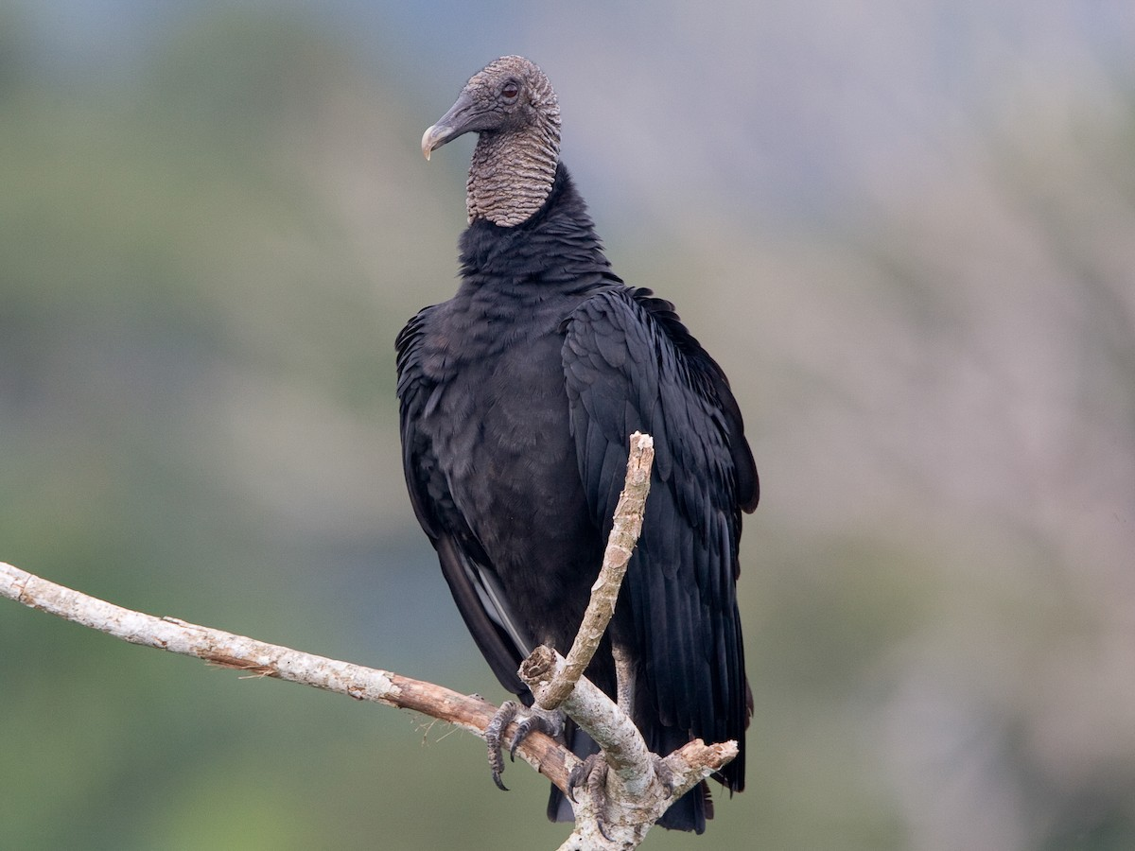

alt text here

### Turkey Vulture

Large raptor. Appears dark from a distance. Up close, dark brown above with bare red head. In flight, undersides of wings are two-toned; lighter on the entire trailing edge of the wing, opposed to just wingtips on Black Vulture. Wings are held slightly raised when soaring, making a “V” when seen head-on. Tends to wobble in flight. Wingbeats slower and deeper than Black Vulture. Glides relatively low while sniffing for carrion, or riding thermals to higher vantage points. Also huddles around roadkill or dumpsters.

r run_columnbreak() *Typical seasons: Ordinary Time*

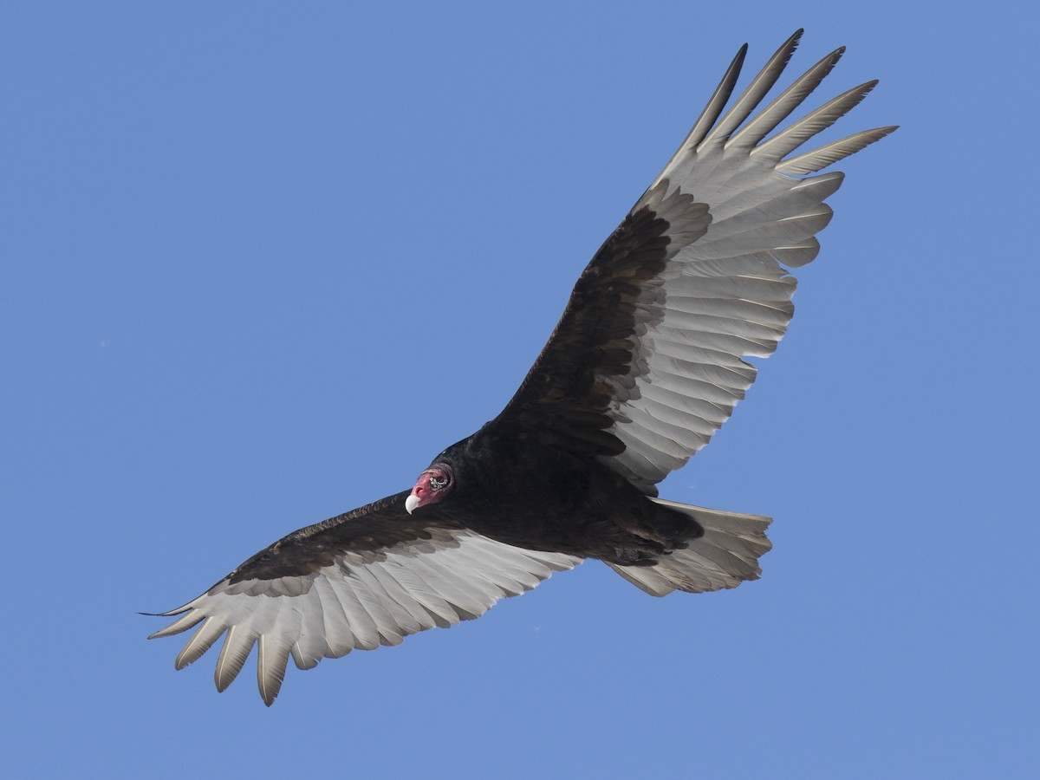

alt text here

## Charadriidae: Plovers

### Killdeer

Common, large plover. Slender shape with long wings and tail. Look for two black breast bands, unique among plovers in its range. Often nests near human development: parking lots, school roofs, road edges, and farms, usually on bare gravel. Adults perform broken-wing displays to distract predators from their nests and young. Gathers in larger numbers in migration and winter, often in fields with short grass or barren dirt. Occurs throughout North America; more local along the Pacific coast of northern South America. Can be very vocal; listen for loud namesake “kill-deer” call.

r run_columnbreak() *Typical seasons: Ordinary Time*

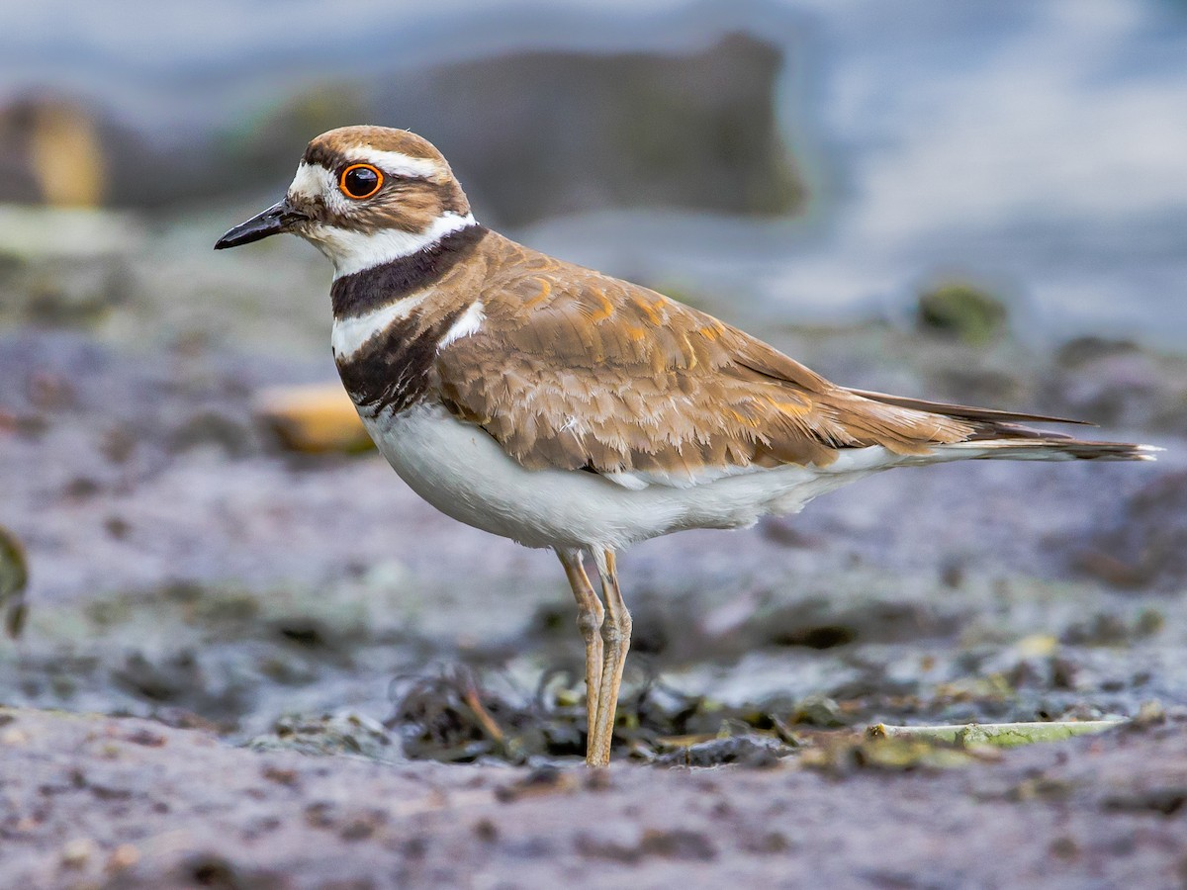

alt text here

### Semipalmated Plover

Small, orange-legged plover with solid dark breast band. Medium-brown upperparts are the color of wet sand, noticeably darker than Piping or Snowy Plovers. Look for short, blunt bill with orange base (often indistinct on juveniles). Feeds on mudflats and beaches, often mixed with other shorebirds. Even when in a flock, individuals are typically spread out rather than remaining a tight unit. Breeds on the tundra or rocky beaches at northern latitudes; winters to southern South America. Migrants are common and widespread, inland and coastal. Listen for distinctive two parted “chu-weep!” calls, and assorted chortles and chuckles.

r run_columnbreak() *Typical seasons: Easter*

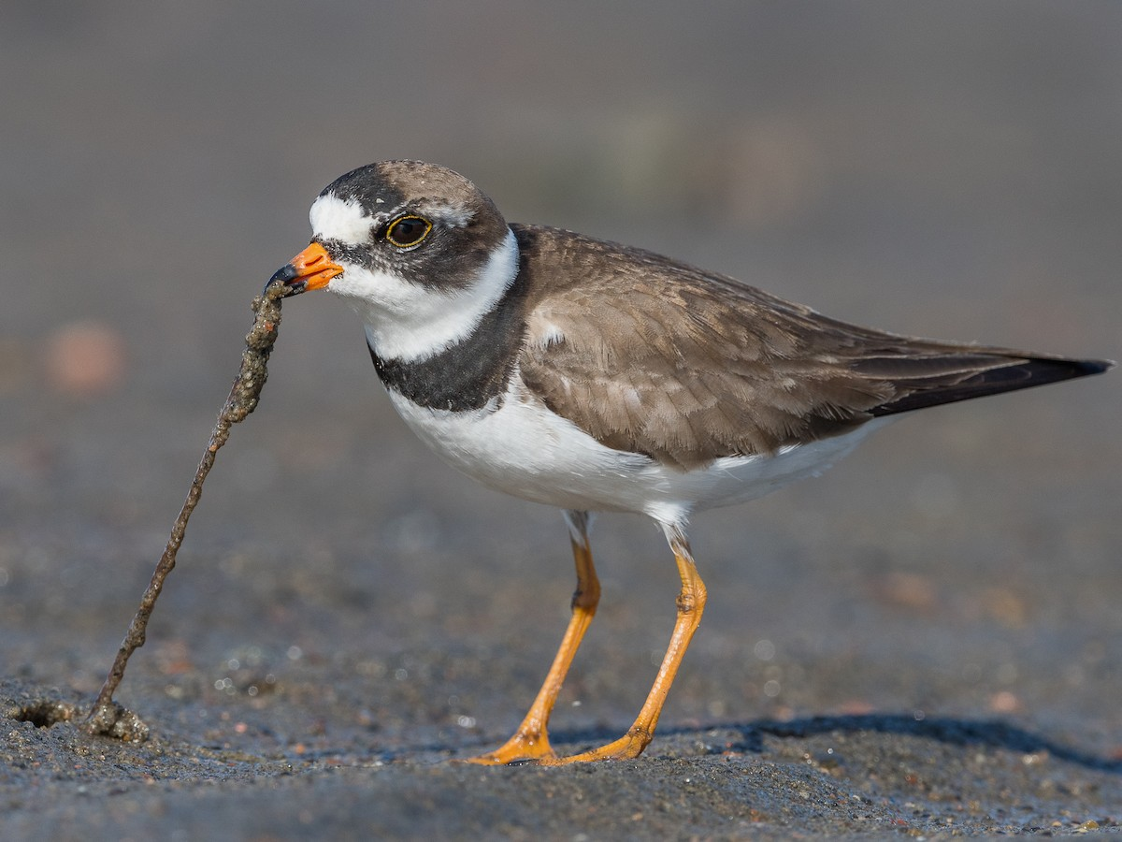

alt text here

## Columbidae: Pigeons and Doves

### Mourning Dove

Svelte with a long, pointed tail. Plain brown overall with dark spots on wing. Juvenile is covered with pale scaly pattern, but is much larger and longer-tailed than ground doves. Widespread and common throughout much of North America, from southern Canada to Panama, including the Caribbean. Found in a variety of habitats from agricultural fields to lightly wooded areas. Loves suburbs, where it often sits on telephone wires and visits bird feeders. Avoids dense forest, but found on forest edges. Usually seen in pairs or small flocks, sometimes gathering in larger numbers, especially in winter. Listen for distinctive cooing song and whistling wings as it takes off.

r run_columnbreak() *Typical seasons: Ordinary Time*

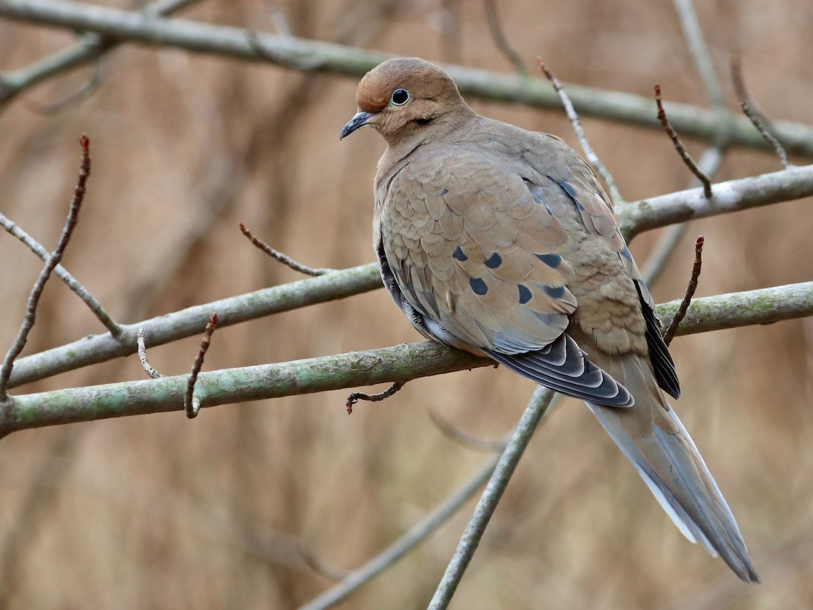

alt text here

### Rock Pigeon

Fairly large pigeon with wild and feral populations throughout the world. True wild birds nest on cliffs and in caves from western Europe to central Asia. Pale gray overall with two bold black wingbars and iridescent purple and green on neck. Feral varieties are common in cities and farmland, often in large flocks. Variable plumage: some identical to wild-type birds, but can be completely black, white, or orangey-brown and any combination in between.

r run_columnbreak() *Typical seasons: Epiphany, Ordinary Time*

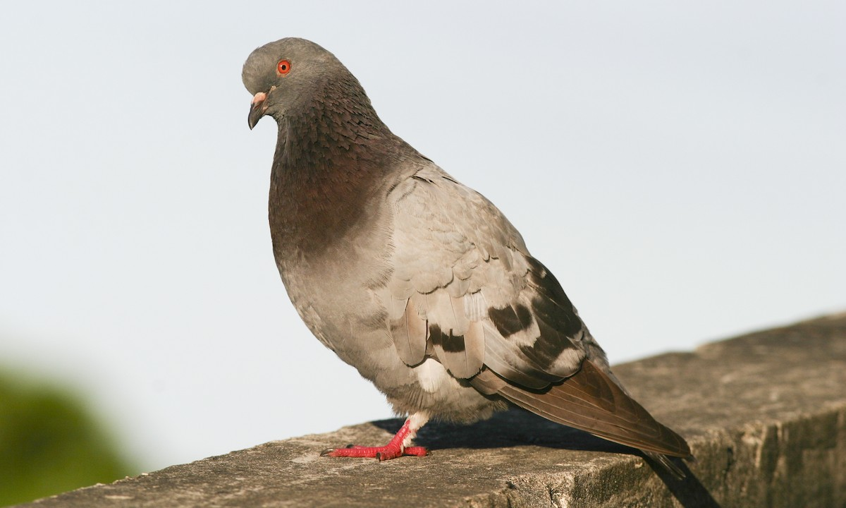

alt text here

## Corvidae: Jays, Crows & Magpies

### American Crow

This is the common crow over much of the U.S. and Canada. Most easily identified by voice, a familiar “caw,” often repeated. Common in any open habitats, including fields, open woodlands, marshes, and cities, thriving around humans. Very social, usually seen in flocks, sometimes numbering in the hundreds or even thousands. Aggressive, sometimes seen chasing away hawks and owls. Separated from ravens by smaller size, smaller bill, shorter tail, and shorter, broader wings. Compare with Fish Crow, which is extremely similar in appearance, and best separated by voice. Includes the species formerly known as Northwestern Crow.

r run_columnbreak() *Typical seasons: Epiphany, Lent, Ordinary Time*

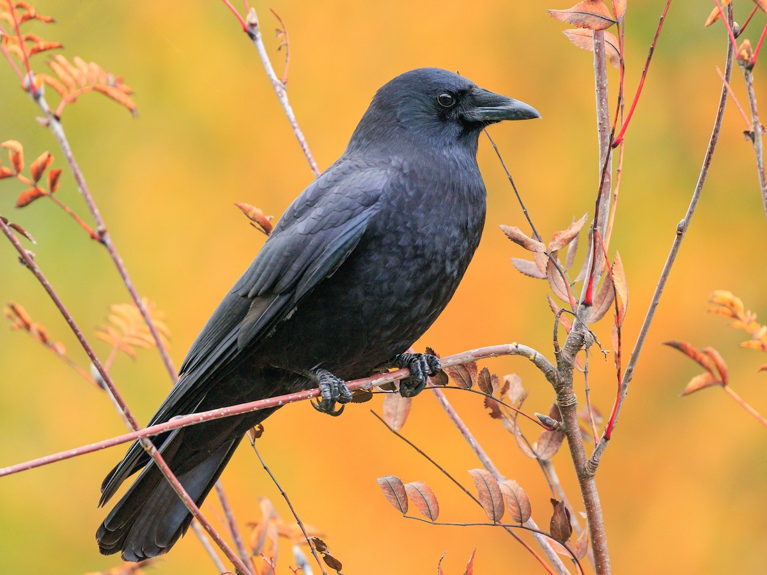

alt text here

### Blue Jay

Familiar but stunning jay found year-round throughout most of eastern North America. Bright blue above and pale gray below with a fluffy crest. Also look for black necklace and black and white markings on the wings and tail. Pairs or small groups travel through mature deciduous or coniferous woodlands, often revealing their presence with loud, harsh “jay” calls. Frequently visits bird feeders, where it is often aggressive towards other birds.

r run_columnbreak() *Typical seasons: Ordinary Time*

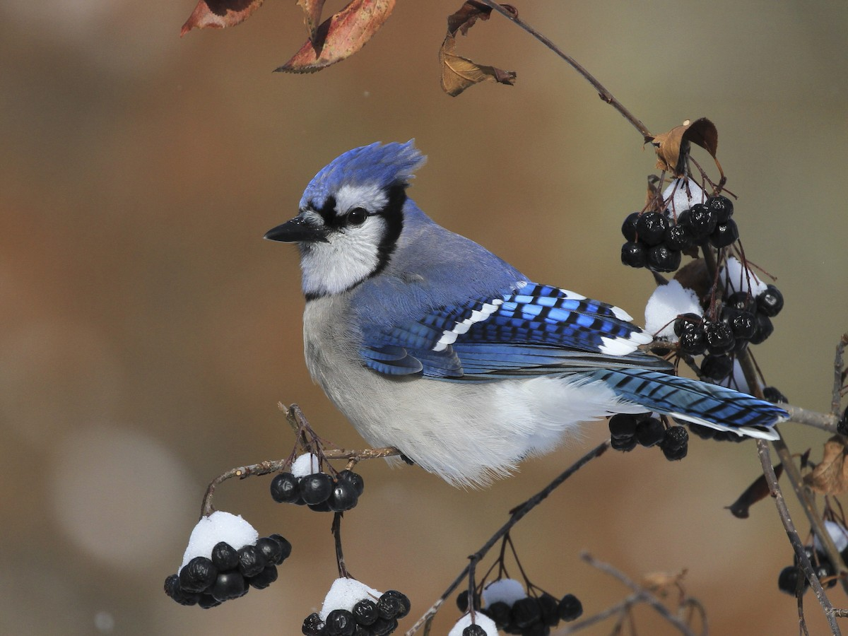

alt text here

### Common Raven

Large, glossy-black bird with a wedge-shaped tail. Larger than a crow with a longer, thicker bill. Distinctive shape in flight, with rather long, swept-back wings and long tail. Note smoother, steadier wingbeats compared with faster, choppier wingbeats of crows. Extensive range throughout the Northern Hemisphere. Found in a wide variety of habitats, including desert, coniferous forest, coastlines, sagebrush, tundra, and grasslands. Often solitary or in pairs, but can gather in small groups. Typical call is a loud, guttural croak, but makes an astonishing variety of other strange noises. Compare with Chihuahuan Raven in the southwestern U.S. and Mexico, and with various large, all-dark crows and ravens in Europe and Asia.

r run_columnbreak() *Typical seasons: Ordinary Time*

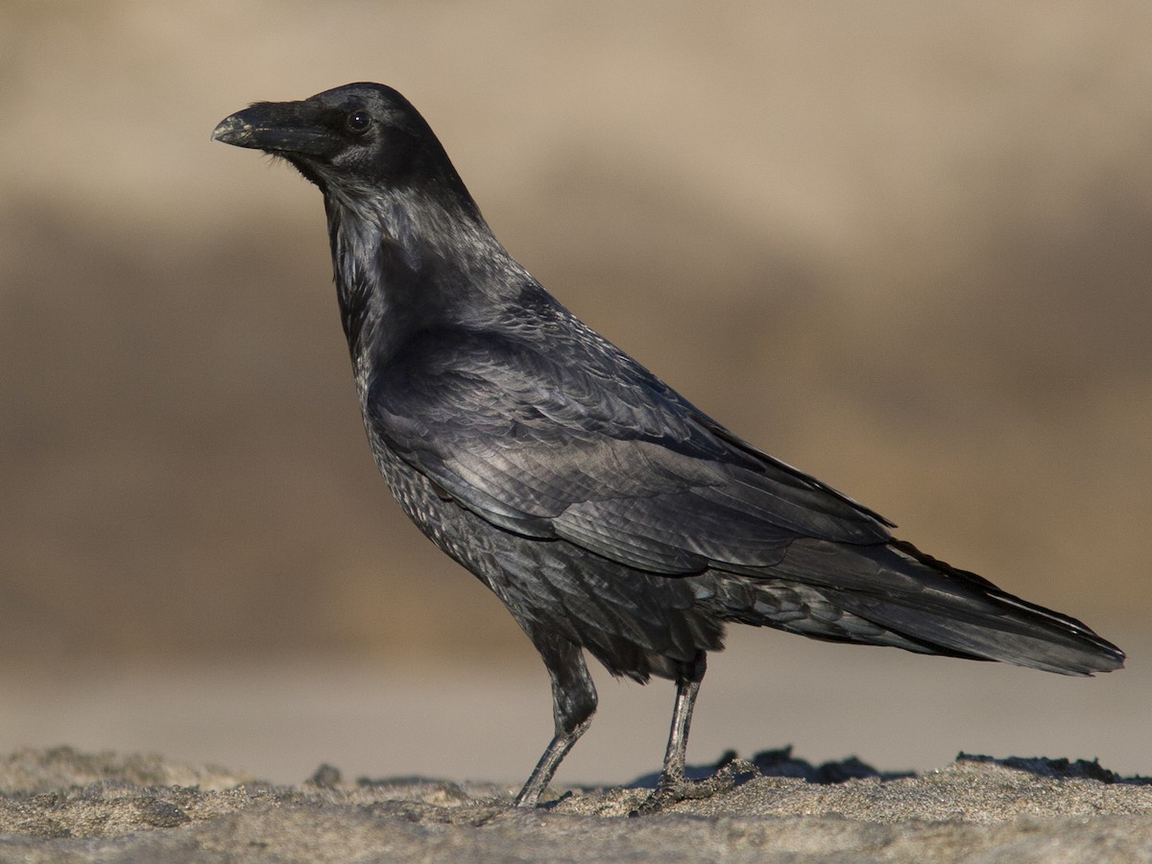

alt text here

### Fish Crow

A relatively small, glossy crow. Very difficult to separate from American Crow by appearance; look for Fish Crow’s slightly more tapered wings, quicker wingbeats, and shorter legs. Most easily identified by voice, a nasal “eh-uh” or single nasal caws. Mostly restricted to the southeastern U.S., especially along the coast, but range expanding slightly northward and inland in recent years. Often near water, but also seems especially fond of fast-food parking lots and dumpsters.

r run_columnbreak() *Typical seasons: Ordinary Time*

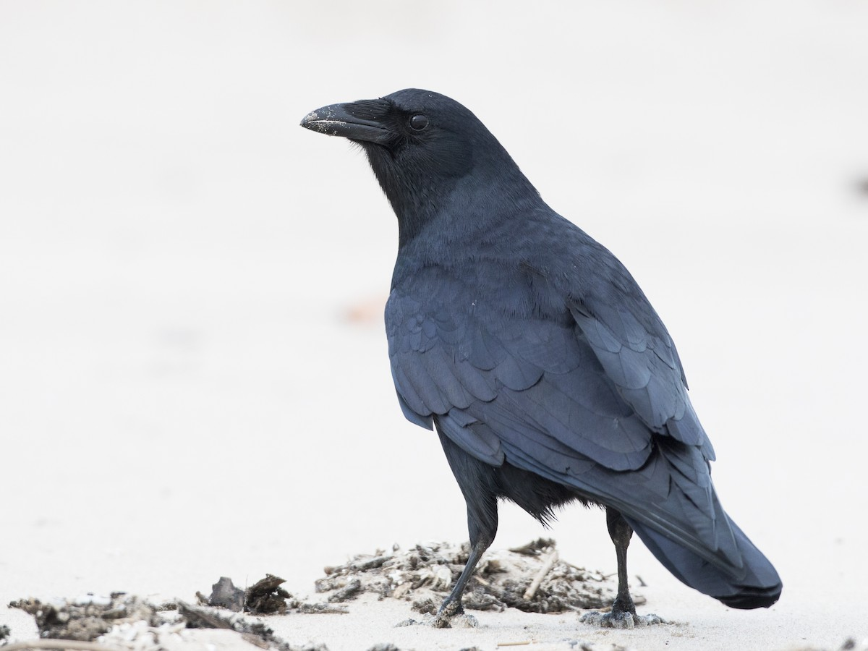

alt text here

## Falconidae: Falcons

### American Kestrel

Petite falcon roughly the same size as Mourning Dove, but with a larger head and wider tail. In flight, note long, narrow wings and square-tipped tail. Often seen perched on telephone wires, along roadsides, in open country with short vegetation and few trees. From a perch or hovering, they usually drop to the ground to snatch small mammals and insects. Nests in cavities. Widespread across the Americas.

r run_columnbreak() *Typical seasons: Lent, Ordinary Time*

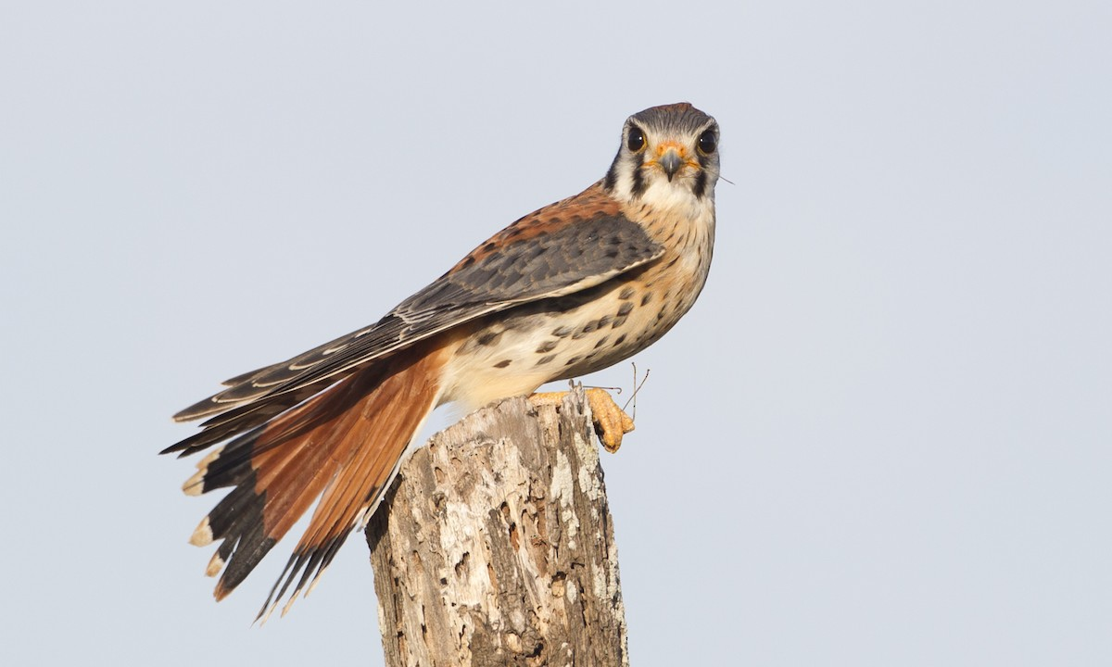

alt text here

## Fringillidae: Siskins, Crossbills & Allies

### American Goldfinch

Small finch. Sharply pointed bill is pink in summer, grayish-brown in winter. Small head, long wings, and short, notched tail. Adult males in spring and summer are bright yellow with black forehead and wings. Females are dull yellow below and olive above with two distinct wingbars. In winter, they are drab, buffy-brown. Active and acrobatic. Sometimes in large numbers at feeders or on ground below. Found in weedy fields, cultivated areas, roadsides, orchards, and backyards.

r run_columnbreak() *Typical seasons: Ordinary Time*

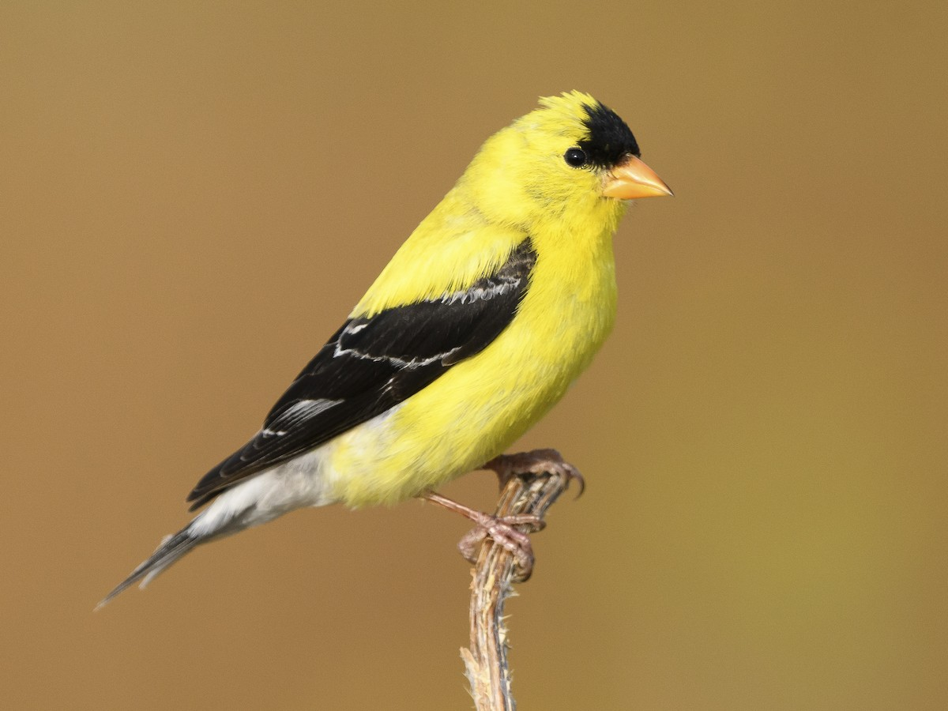

alt text here

### House Finch

Frequents suburban settings across North America, along with open woods, brushy field edges, and deserts. Males vary in shades and intensity of red. Some males are yellow or orange. Females are drab gray-brown overall with plain faces and blurry streaks on underparts. Similar to Purple and Cassin’s Finch, but House Finch males are more orangey-red with color equally bright on crown, throat, and breast. Red color is mostly restricted to head and upper chest, contrasting with cold gray-brown nape, back, and wings. Pale sides show distinct brown streaks, lacking red tones. Females lack bold face pattern and have more diffuse patterning overall. Often sings loudly in neighborhoods and visits feeders.

r run_columnbreak() *Typical seasons: Ordinary Time*

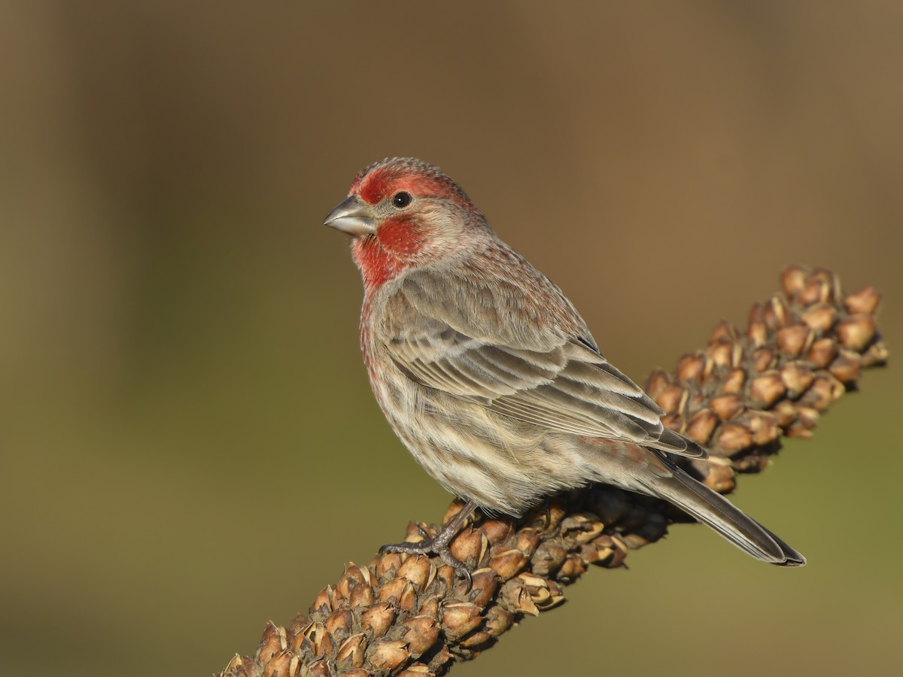

alt text here

## Hirundinidae: Martins and Swallows

### Barn Swallow

A fairly large, colorful swallow. Usually easy to identify with its long, forked tail and dark rump. Iridescent navy-blue above with a rich orange throat and forehead. Underparts vary across range, from bright buffy-orange to whitish. Occurs in any open habitat, especially large fields and wetlands. Often seen foraging in flocks, sometimes mixed with other species of swallow. Typically nests close to human habitation; builds a muddy cup nest in a barn or under a dock. Listen for dry, scratchy “svit svit” calls. Note head and breast pattern and tail length to help separate from various similar species in Africa, Asia, and Australia (e.g., Welcome Swallow, Angolan Swallow, Pacific Swallow).

r run_columnbreak() *Typical seasons: Easter, Ordinary Time*

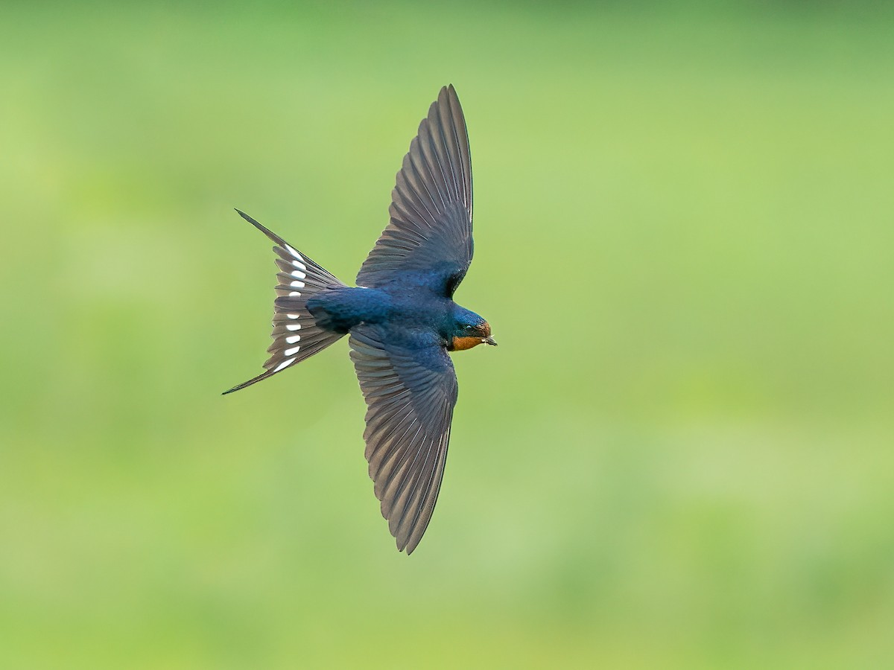

alt text here

### Northern Rough-winged Swallow

Plainest swallow in North America. Plain brown above with indistinct brown wash across throat and breast. Wings are relatively broad; tail is short and square (or slightly notched). Juveniles have rusty wingbars. “Ridgway’s” subspecies, mainly found on the Yucatan peninsula, is larger and lankier, almost recalling a martin. Look for the deeper notch in the tail and dark-tipped undertail coverts. Often seen near water, sometimes in mixed flocks with other swallows. Breeds in holes and crevices, often along riverbanks or under a bridge. Not a colonial nester like Bank Swallow. Call is a low, grating buzz that rises slightly in pitch. Compare with Bank Swallow, which has a contrasting dark chest band. Also very similar to Southern Rough-winged Swallow, which overlaps in Central America. Southern Rough-winged has a brighter tawny throat and paler rump.

r run_columnbreak() *Typical seasons: Easter, Ordinary Time*

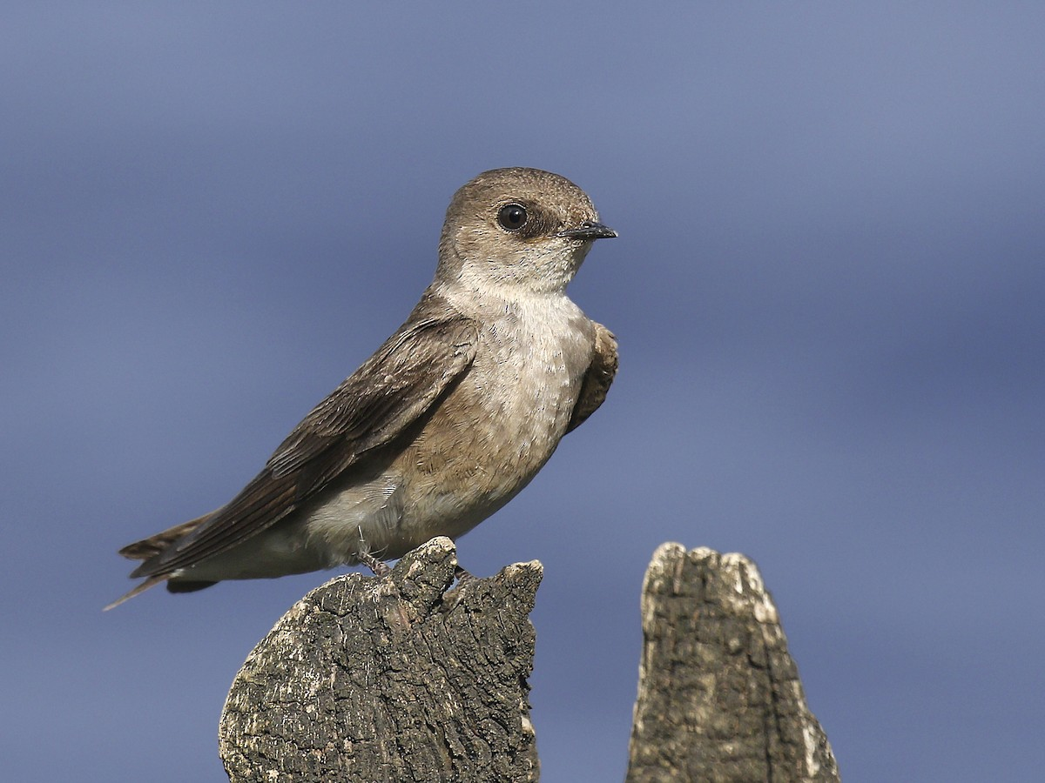

alt text here

### Purple Martin

Large, dark swallow. Distinctive north of Mexico, where it is the largest swallow. Adult males are dark overall with a purplish-blue iridescence visible at close range. Females are grayer with iridescence on the crown and back, and variable splotchy patterning on the underparts. Immatures lack any purplish color and have a whiter belly. Gives a distinctive liquid gurgling call. In the eastern U.S., nests exclusively in nest boxes and martin houses; also uses natural cavities in parts of the western U.S. and Mexico. Departs breeding grounds in the late summer, locally staging in massive numbers. Winters primarily in the Amazon basin of South America. During migration and winter, identification is complicated by several other extremely similar species of martin. Identification features are not well known; some are best left unidentified.

r run_columnbreak() *Typical seasons: Ordinary Time*

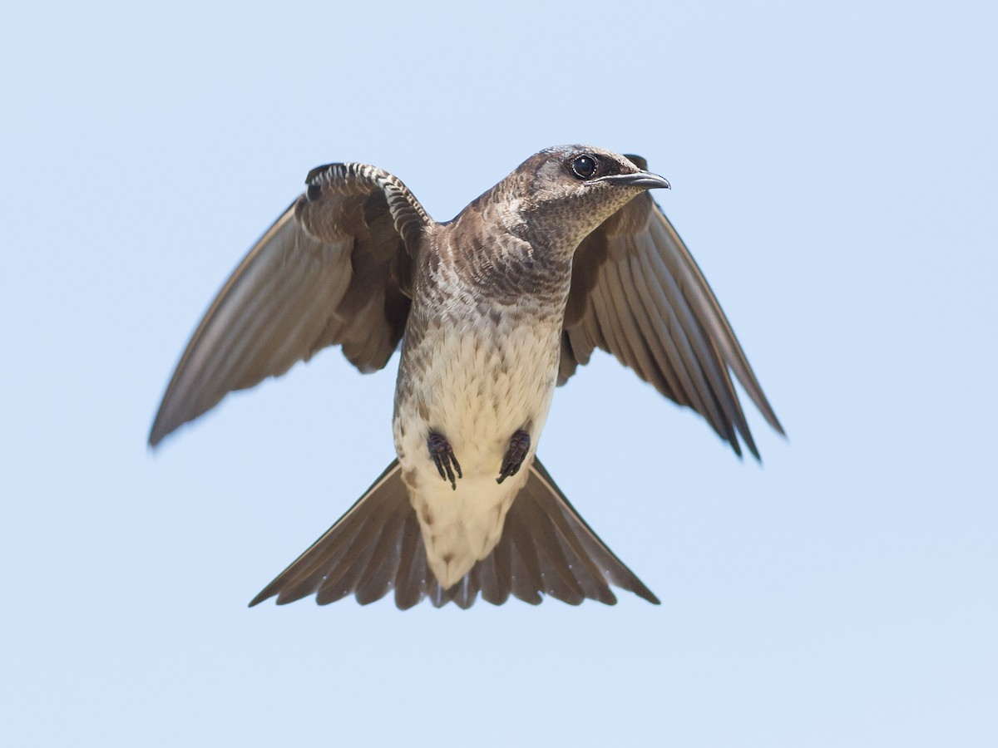

alt text here

### Tree Swallow

Common and widespread throughout most of North America, breeding as far north as Alaska and wintering to Panama. A medium-sized swallow, with gleaming white underparts. Adult males are bright iridescent blue-green above; females and immatures are duller brownish with limited or no iridescence. Always note compact shape, fairly broad wings, and slightly notched tail. Occurs in a variety of open habitats including grassy fields, lakes, and marshes. Often in flocks, sometimes mixed with other species of swallows. Breeds in cavities, including human-made nest boxes. Listen for cheery gurgling calls. Compare especially with Violet-green Swallow; note Tree Swallow does not show extensive white wrapping around the cheek or the sides of the rump.

r run_columnbreak() *Typical seasons: Ordinary Time*

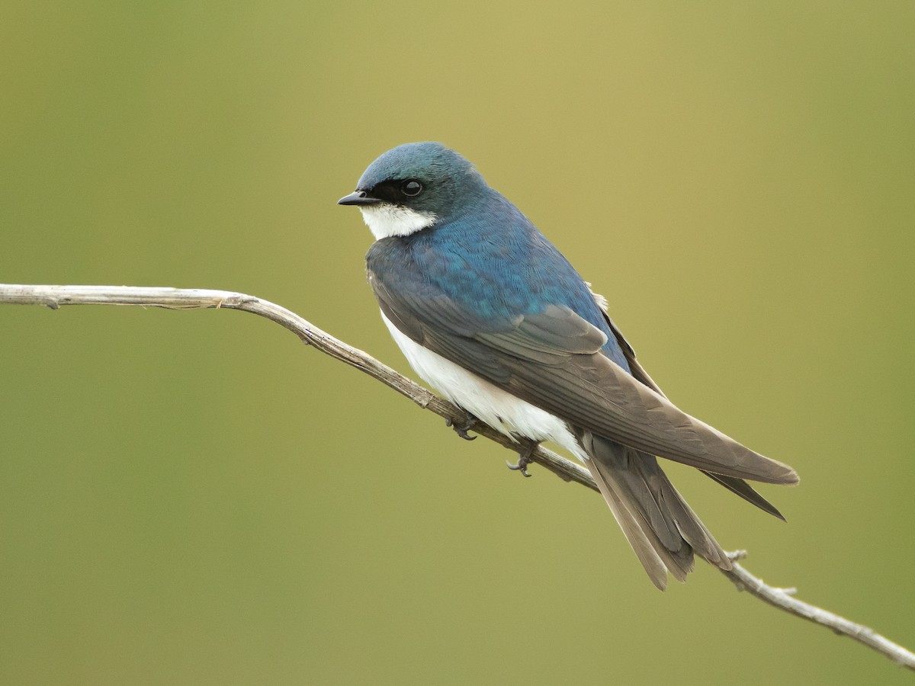

alt text here

## Icteridae: Blackbirds, Meadowlarks & Orioles

### Baltimore Oriole

The common oriole in the eastern U.S., wintering to northern South America. Adult males are stunning: bright orange with a black head and bold white wingbar. Females vary from yellowish to bright orange below, often with blotchy black on the head. Breeds in deciduous trees in open woodlands, forest edges, orchards, riversides, parks, and backyards. Listen for rich whistled song. Visits feeders with nectar and fruits. Females can be very difficult to distinguish from Bullock’s Oriole, and hybrids do occur. Baltimore is usually brightest on the breast, not the face.

r run_columnbreak() *Typical seasons: Easter*

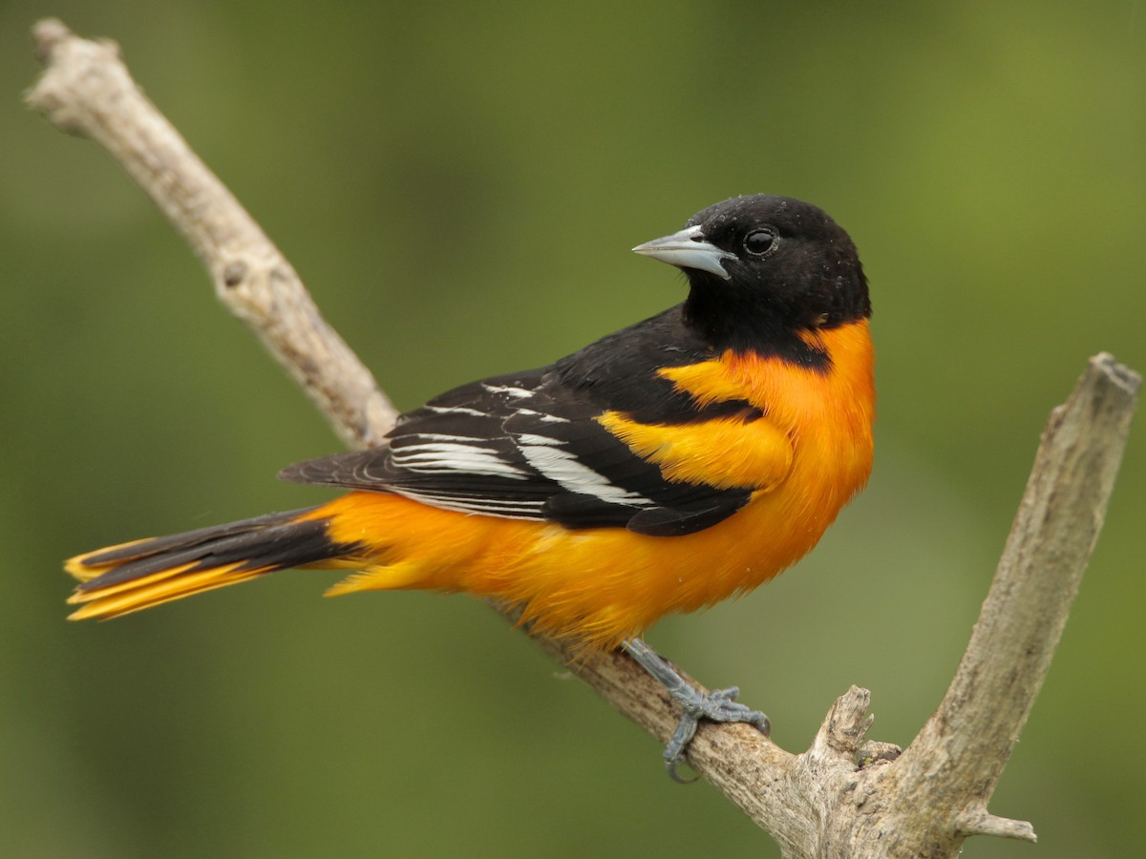

alt text here

### Brown-headed Cowbird

Stout bill. Short tail and stocky body. Males are glossy black with chocolate brown head. Females are gray-brown overall, without bold streaks, but slightly paler throat. Juveniles streaked brown. Found in open woods, farmland, and stockyards. Forages by walking on the ground. Often in flocks with other blackbirds in winter. Visits feeders. Unpopular due to their parasitic habit of laying eggs in nests of other birds.

r run_columnbreak() *Typical seasons: Christmas*

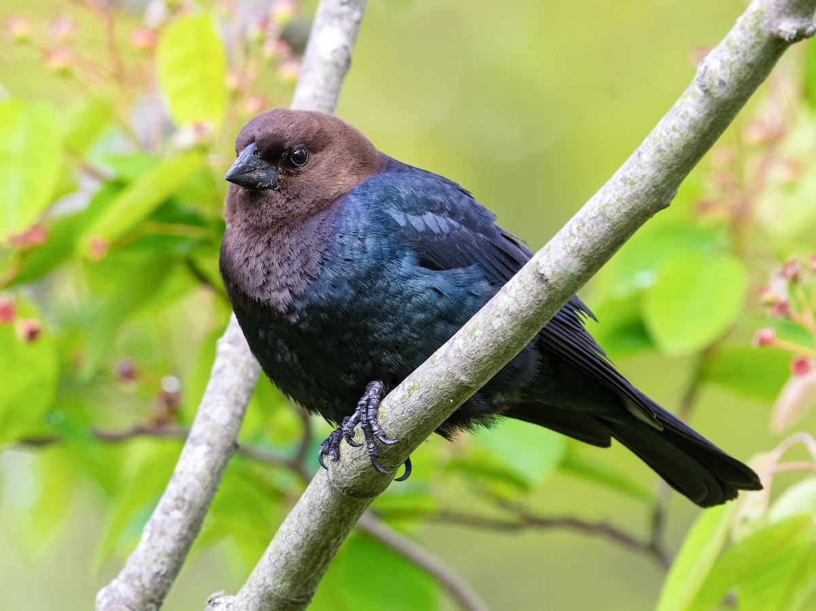

alt text here

### Common Grackle

Lanky, fierce-looking, glossy blackbird. A bit larger than a jay; smaller, proportionally longer-tailed and shorter-winged than a crow. Staring yellow eye and long heavy bill (compared to Red-winged Blackbird). Often in flocks with other blackbirds in winter. Forages in fields, scrubby areas, and open woods. Visits feeders.

r run_columnbreak() *Typical seasons: Epiphany*

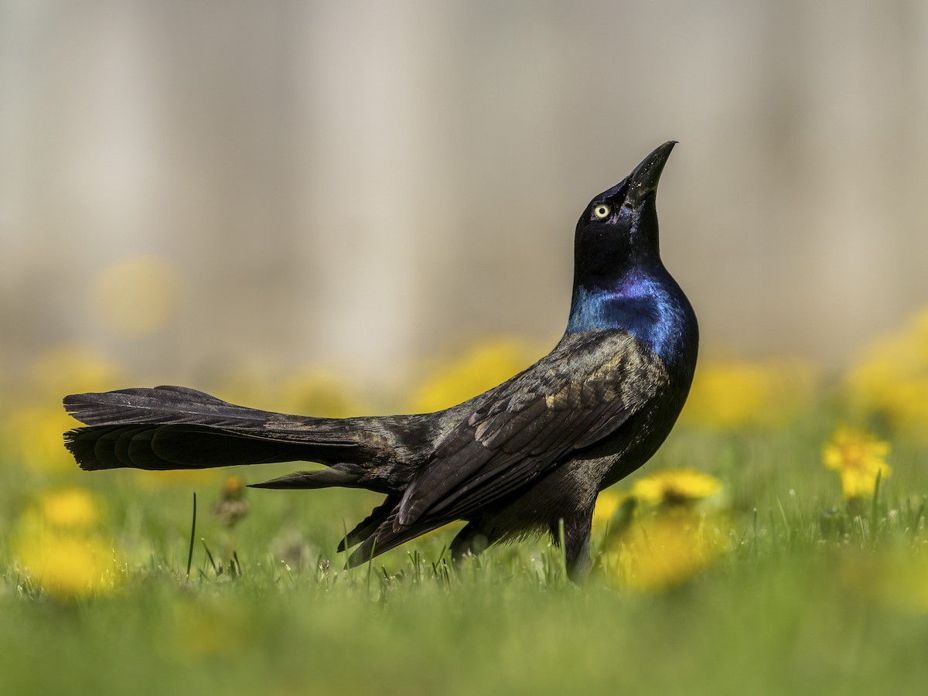

alt text here

### Eastern Meadowlark

Streaked brown above and yellow below with distinctive black “V” on breast. In flight, short wings and spiky tail with white outer feathers are apparent. Breeds in fields and grasslands throughout eastern North America, with a disjunct population (“Lilian’s” Meadowlark) in the Southwest. Also occurs throughout Mexico and Central America, into northern South America, and in Cuba. Winters in dense grassy habitats, often in small loose groups. Extremely similar to Western Meadowlark and best distinguished by voice: listen for high-pitched, clear whistles and short buzzy calls. In winter, plumage looks slightly darker and more contrasty than Western Meadowlark, with a more contrasting head pattern. Eastern is somewhat more tied to more pristine grassland habitats, but with some overlap.

r run_columnbreak() *Typical seasons: Easter, Advent*

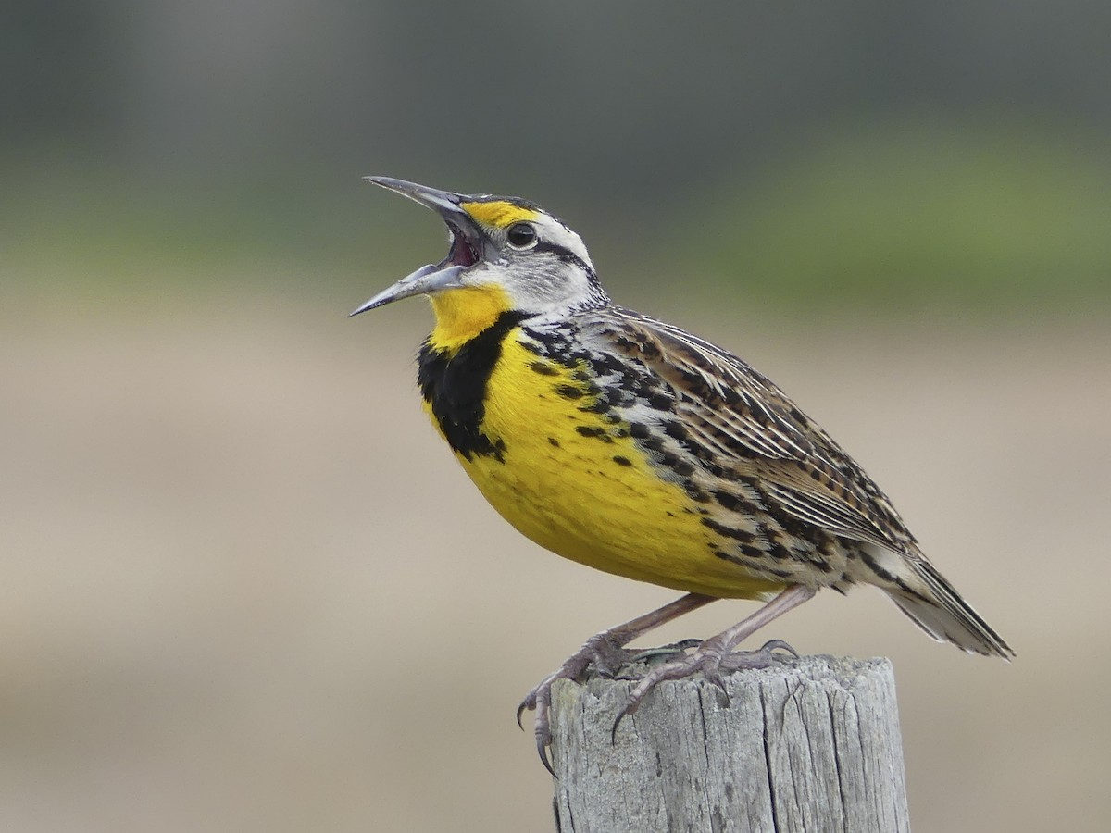

alt text here

### Red-winged Blackbird

Males are black with red shoulder patch that is sometimes concealed. Males have rusty feather edges in the winter. Females are streaked brown and often confused with sparrows. Look for long, sharply pointed bill. Often in flocks, especially in winter. Visits feeders. Breeds in marshes and scrubby, wet fields. Distinctive song, especially as migrants arrive in early spring.

r run_columnbreak() *Typical seasons: Lent, Ordinary Time*

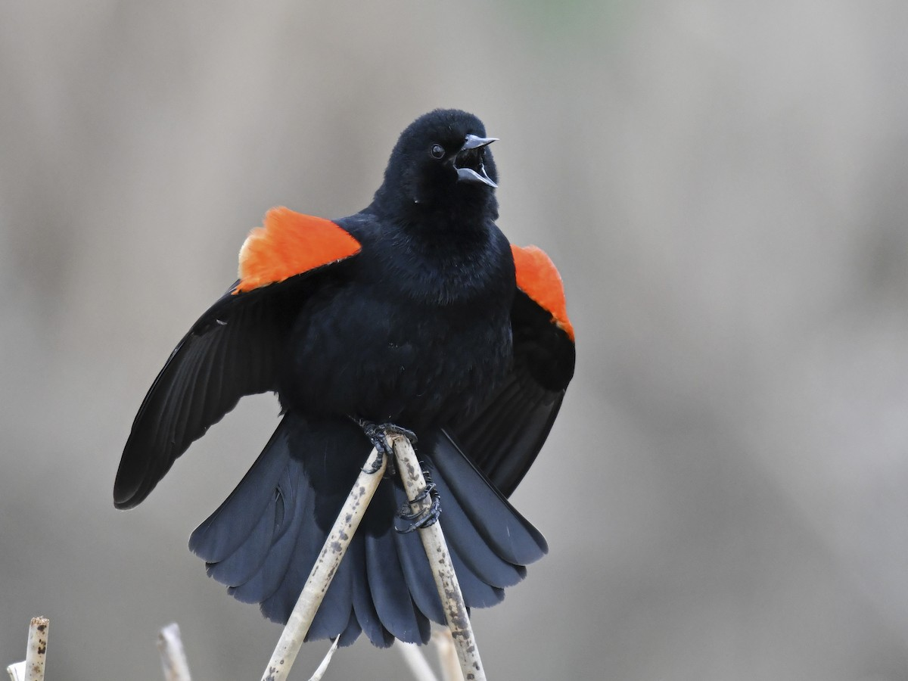

alt text here

## Laridae: Gulls, Terns & Skimmers

### Ring-billed Gull

Fairly small gull, common and widespread throughout most of North America. Breeding adults are white-headed with a bold black ring around the bill; nonbreeding adults have smudgy brown markings on the head. Note pale eye and yellow legs. Immatures are mottled brownish overall; note pink bill with black tip. Found along lakes, rivers, ponds, and beaches. More common inland than most other gull species, and quite fond of parking lots and urban areas. Often in flocks. Most similar to Mew Gull, but larger and larger-billed. Immatures of the two species are especially difficult to differentiate, but Ring-billed is usually more coarsely mottled.

r run_columnbreak() *Typical seasons: Epiphany, Lent*

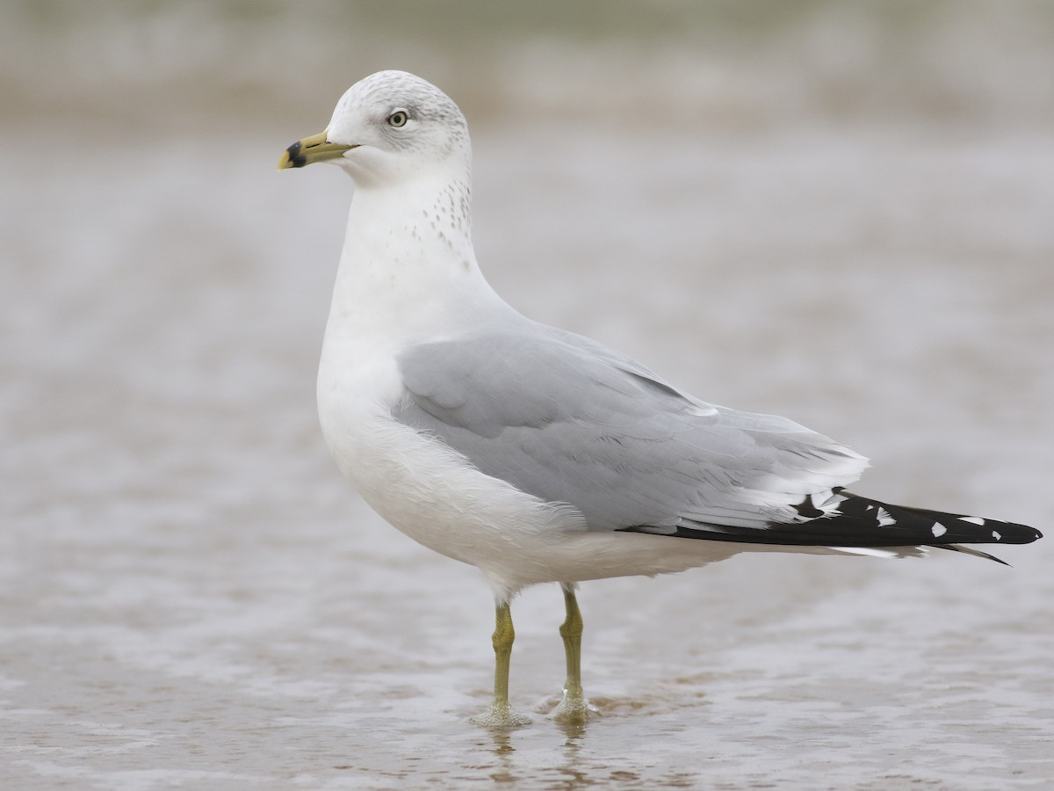

alt text here

## Mimidae: Catbirds, Mockingbirds & Thrashers

### Brown Thrasher

Longer-tailed and slightly larger than a robin. Rich rufous upperparts and heavy dark streaking on whitish underparts. Yellow eyes. Often skulks in thick vegetation in scrubby fields and forest edges. Mimics other species in its song, delivering a complex string of paired phrases.

r run_columnbreak() *Typical seasons: Ordinary Time*

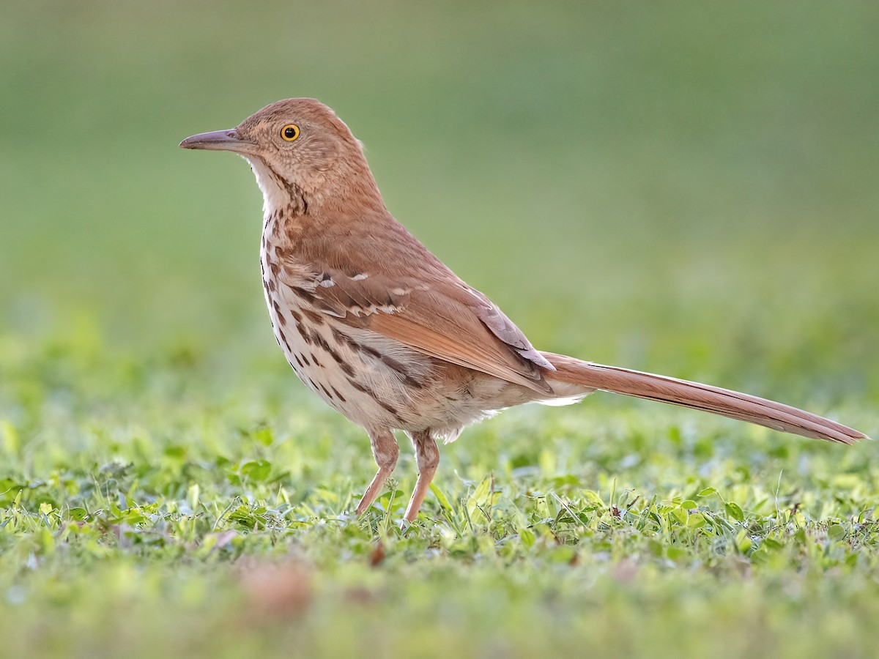

alt text here

### Gray Catbird

Medium-sized songbird, smaller than a robin, with a smooth gray body, black cap, and rusty-red undertail. Sometimes mimics other species in complex, jumbled song. Prefers dense shrubs and small trees in forest edges, streamside thickets, and old fields. Occasionally feeds on suet.

r run_columnbreak() *Typical seasons: Easter, Ordinary Time*

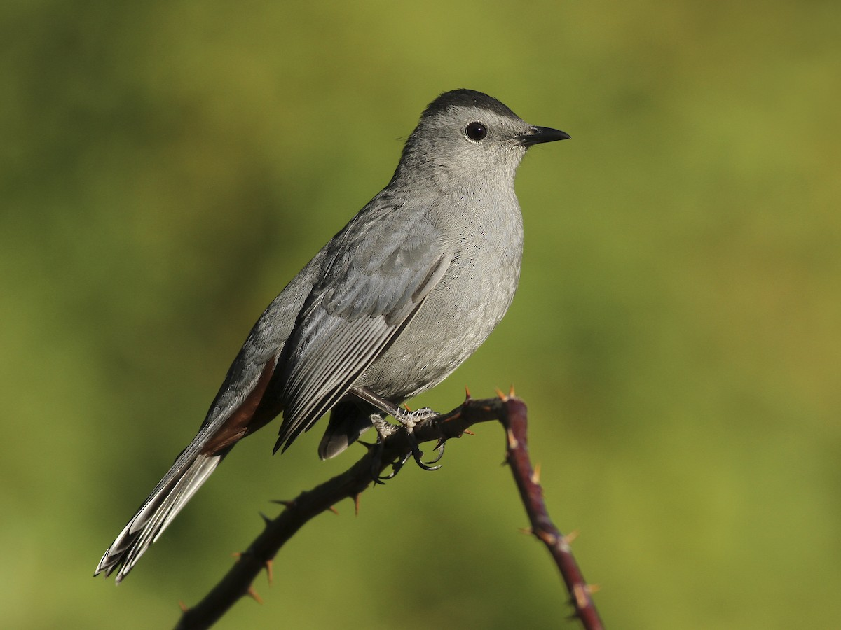

alt text here

### Northern Mockingbird

Gray with whitish underparts and long tail. In flight, it becomes much flashier with large white patches on the black wings and tail. Pale eye. Found in a variety of habitats with bushes and trees, from neighborhoods to desert scrub and old pastures. Mimics birds, car alarms, slamming doors, and other noises in its song, repeating a phrase 5-7 times before switching to next set of notes.

r run_columnbreak() *Typical seasons: Ordinary Time*

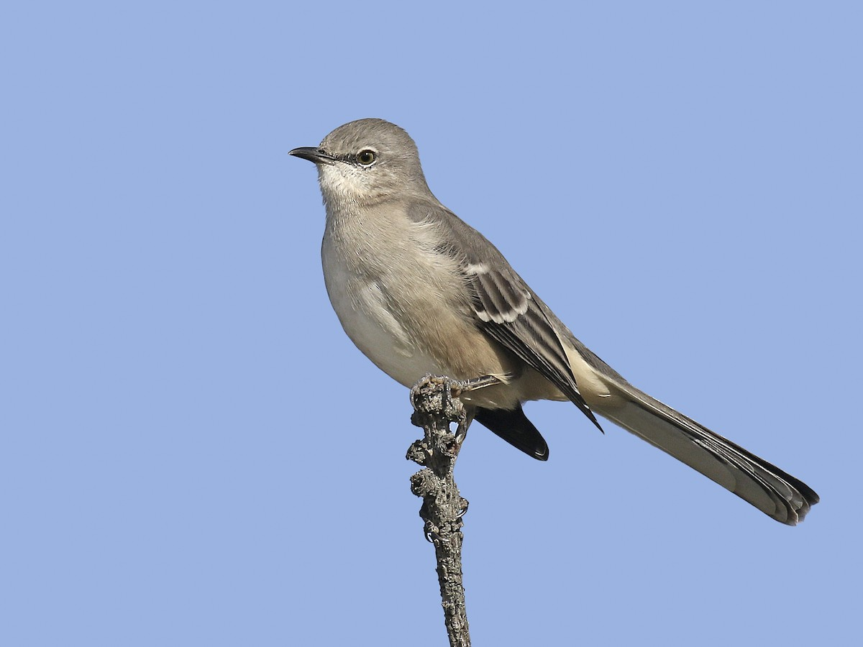

alt text here

## Motacillidae: Pipits

### American Pipit

Slender and drab songbird of open country. Usually grayish above and streaked below, but some lack streaks in breeding season. Distinguished from similar-looking (unrelated) sparrows by thin bill and lanky appearance with long legs. Walks on the ground with jerky motions and frequently bobs tail. Flocks are often heard as they pass overhead or flush from a barren field; listen for sharp, high-pitched call notes and look for flashing white outer tail feathers. Song, given from a perch or in flight, is an often impressively lengthy series of repetitive, high-pitched notes.

r run_columnbreak() *Typical seasons: Lent, Easter*

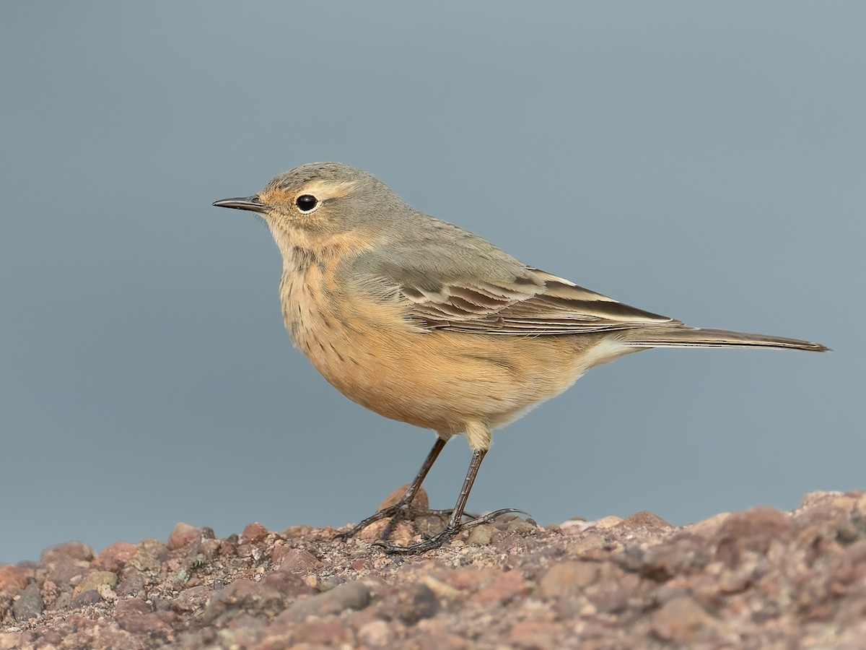

alt text here

## Paridae: Chickadees and Titmice

### Carolina Chickadee

This tiny, plump-bodied, big-headed bird is a familiar woodland resident and backyard visitor in the southeastern U.S. The only chickadee in almost all of its range. Gray overall with contrasting head pattern: black cap, white cheek, and black throat. Short, stubby bill is used for hammering open seeds. Often the core of mixed flocks of songbirds. Visits feeders. Nearly identical to Black-capped Chickadee, but range barely overlaps. Especially note voice, duller gray wings, and less buffy coloration on flanks of Carolina. Beware that hybrids occur frequently in the overlap zone and some are best left unidentified.

r run_columnbreak() *Typical seasons: Lent, Ordinary Time*

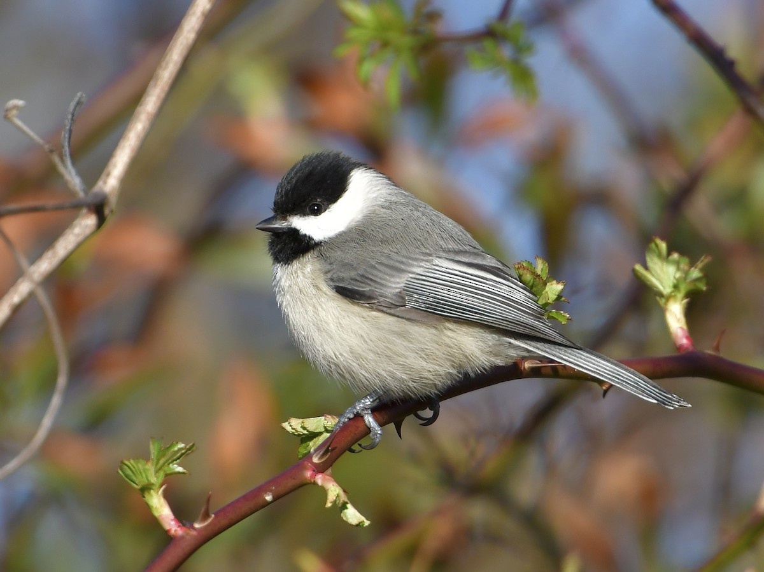

alt text here

### Tufted Titmouse

Common backyard bird in the eastern U.S. Look for its overall gray plumage with paler underparts and orangey sides. Crest is gray, but forehead is black. Often in flocks with chickadees and other songbirds. Listen for clear, whistled “peter-peter-peter.” Visits feeders.

r run_columnbreak() *Typical seasons: Ordinary Time*

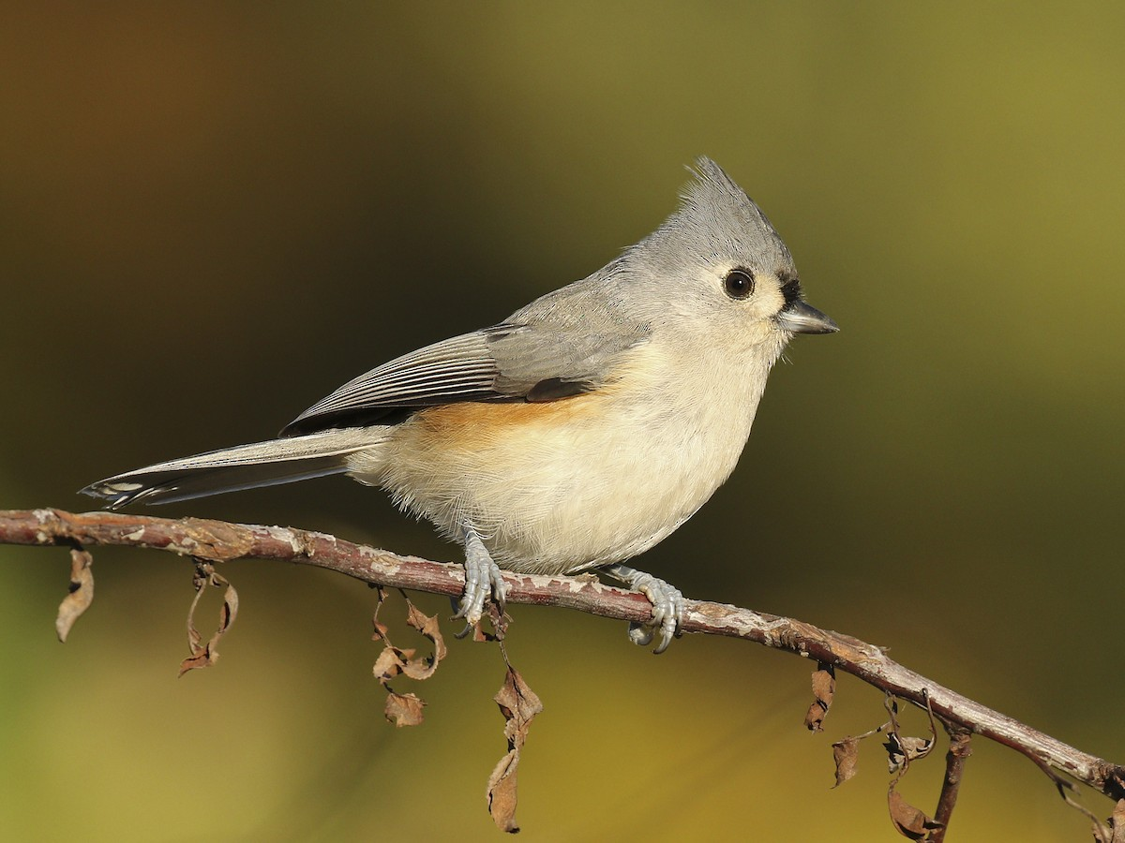

alt text here

## Parulidae: Wood Warblers

### Yellow-rumped Warbler

One of the most common and widespread warblers; often the core member of mixed warbler flocks during migration, especially early in spring and late in fall. Two main populations: “Audubon’s” breeds mainly in the mountains of the western U.S. and into British Columbia; “Myrtle” breeds from the eastern U.S. across Canada to Alaska. All plumages show a bright yellow rump and yellow on the sides. Most “Audubon’s” have a yellow throat, but dull immature females can be off-white. “Myrtle” Warblers have a white throat that wraps around below the cheek. Both subspecies breed in coniferous or mixed forests, often near clearings or edges. In migration and winter, found in any woodland or open shrubby area, including coastal dunes, fields, parks, and residential areas. Often sallies out from a conspicuous perch to snatch insects. Also eats berries in the winter. Calls frequently: a flat “check” (Myrtle) or rising “chit” (Audubon’s). Another distinctive sedentary population, surely a separate species, occurs very locally in the highlands of Guatemala: Goldman’s Warbler. Males are strikingly black overall, and show a mostly yellow throat with white corners.

r run_columnbreak() *Typical seasons: Easter*

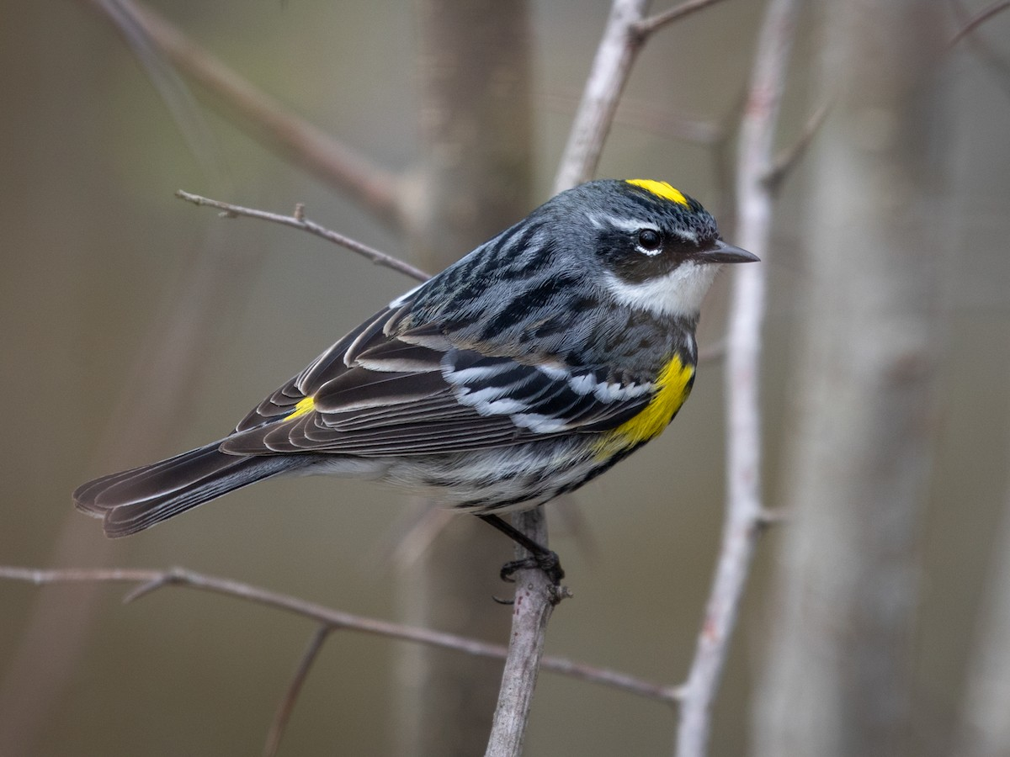

alt text here

## Passerellidae: New World Sparrows and Towhees

### Chipping Sparrow

Small, slender sparrow with short bill and long, narrow tail. Plain grayish breast, rusty cap, and black eyeline in breeding season. Not as bright in winter, but still shows a brown cap and dark eyeline. Juveniles are extensively streaky. Common and widespread throughout most of North America. Usually found in open woodlands, scrubby areas, or even in suburban settings. Often gathers in flocks in fall and winter. Visits feeders. Frequently heard singing a fairly dry trill. Compare with similar Clay-colored, American Tree, and Brewer’s sparrows, but look for Chipping Sparrow’s gray rump and dark eyeline.

r run_columnbreak() *Typical seasons: Easter, Ordinary Time*

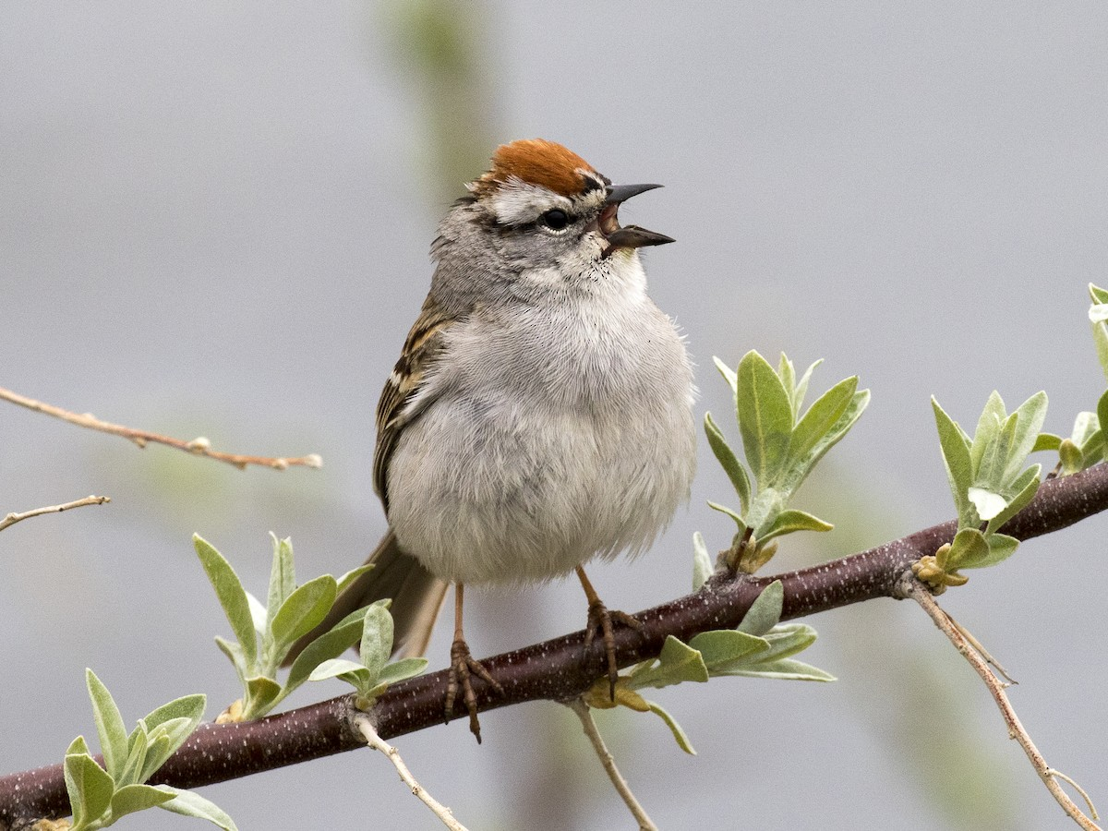

alt text here

### Dark-eyed Junco

Unique sparrow with incredible variation between populations. Generally patterned with gray, white, and shades of tan. All have pinkish bills and white outer tail feathers. Juveniles are streaky. Breeds in a variety of forested habitats, especially with conifers. Found in any wooded habitat in the winter, often in flocks. Usually forages on the ground for seeds, but also fond of brushy thickets or weedy fields. Visits feeders. Subspecies include: Slate-colored (widespread), Oregon (West), Pink-sided (Rockies), Gray-headed (Rockies and southwest U.S. to Mexico), Red-backed (central Arizona and New Mexico), and White-winged (breeds in Black Hills, winters mainly Colorado).

r run_columnbreak() *Typical seasons: Epiphany, Lent*

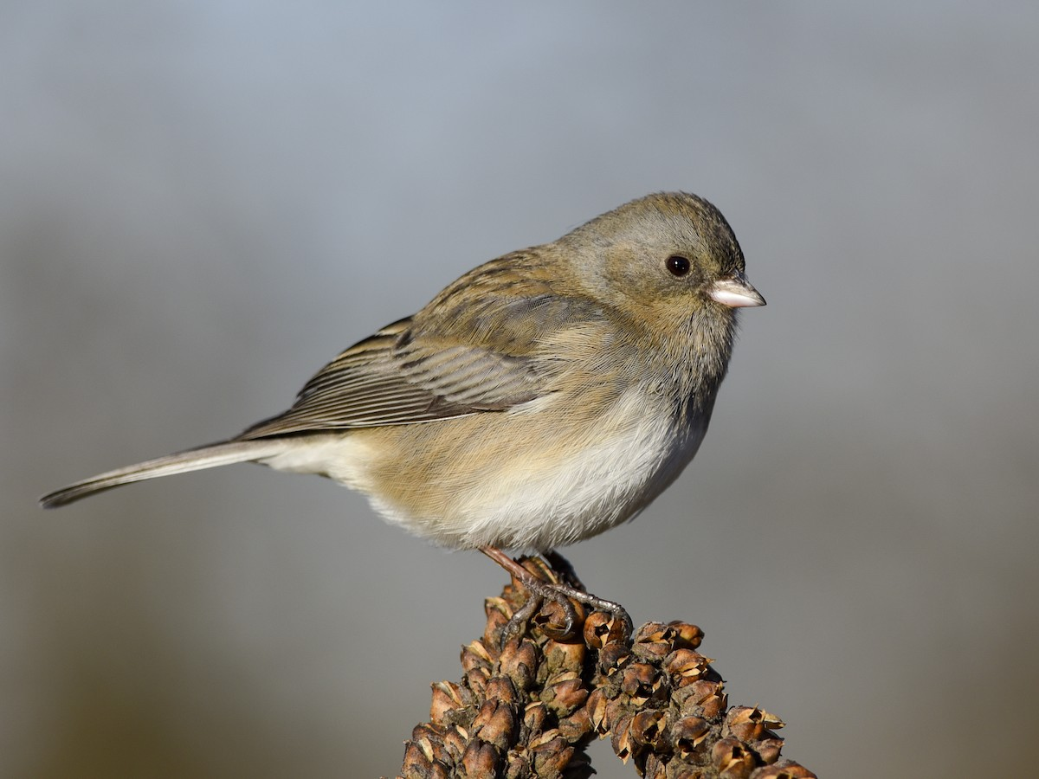

alt text here

### Eastern Towhee

Large, striking, long-tailed sparrow of the eastern U.S. and Canada. Black above with bright rufous sides and a white belly. Eye color varies from white (in the southeastern U.S) to dark red (further north). In flight, note white corners on tail. Also note females are browner than jet-black males. Most similar to Spotted Towhee, but Eastern is mostly black above, only showing single white patch on folded wing. Hybridizes with Spotted Towhee in central U.S. and south-central Canada; hybrids usually show intermediate wing pattern. Inhabits scrubby areas and forest edges with thickets. Forages primarily by hopping along ground, scraping away leaf litter. Males sing from atop shrubs and low trees. Visits feeders.

r run_columnbreak() *Typical seasons: Easter, Ordinary Time*

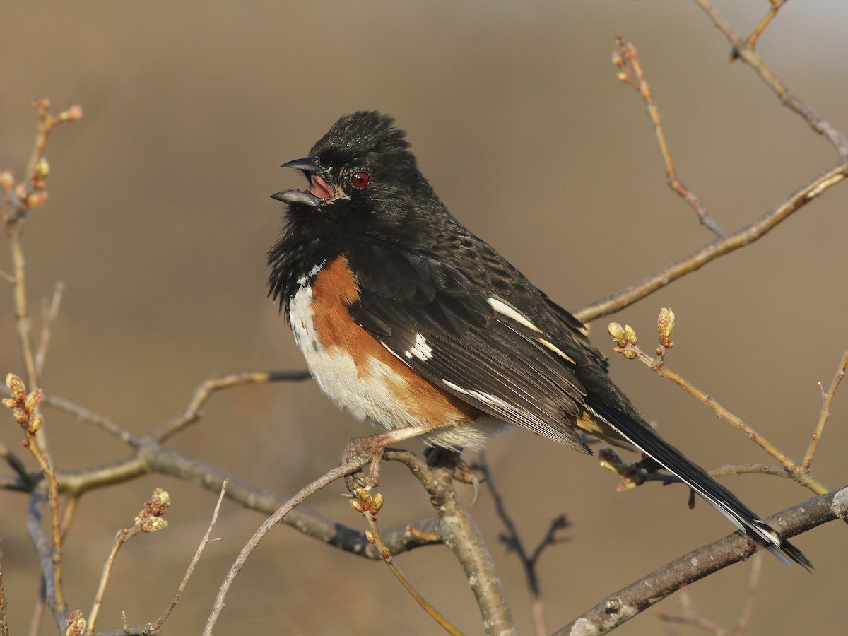

alt text here

### Field Sparrow

Small, slender, blank-faced sparrow. Can be either gray or buffy overall, but always note small pink bill, plain face, and thin white eyering. Inhabits overgrown fields and other brushy areas in eastern North America. Often joins flocks of sparrows in winter. Can visit feeders, but less frequently than Chipping or American Tree sparrows. Song is a series of bell-like notes, accelerating like a dropped ping-pong ball.

r run_columnbreak() *Typical seasons: Easter, Ordinary Time*

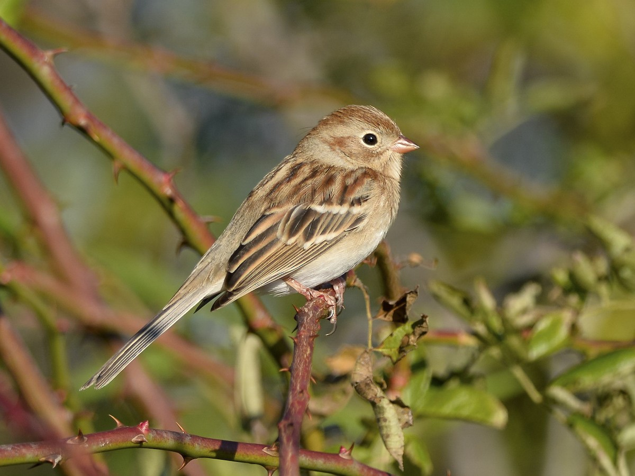

alt text here

### Song Sparrow

One of the most common and widespread sparrows in North America. Fairly large with a long, rounded tail. Overall coarsely patterned with gray and brown, usually with more reddish-brown wings and tail. Look especially for thick brown streaks on the underparts and a broad dark mustache stripe. Significant variation in plumage geographically: relatively pale and rusty in the southwestern U.S.; blacker streaking in California; overall dusky in the Pacific Northwest. Larger, longer-tailed and usually more rusty than Savannah Sparrow. Found in a variety of scrubby habitats both near and far from human development, especially edges of fields, often near water. Listen for husky “chimp” calls and melodic song with chips and trills.

r run_columnbreak() *Typical seasons: Easter, Ordinary Time*

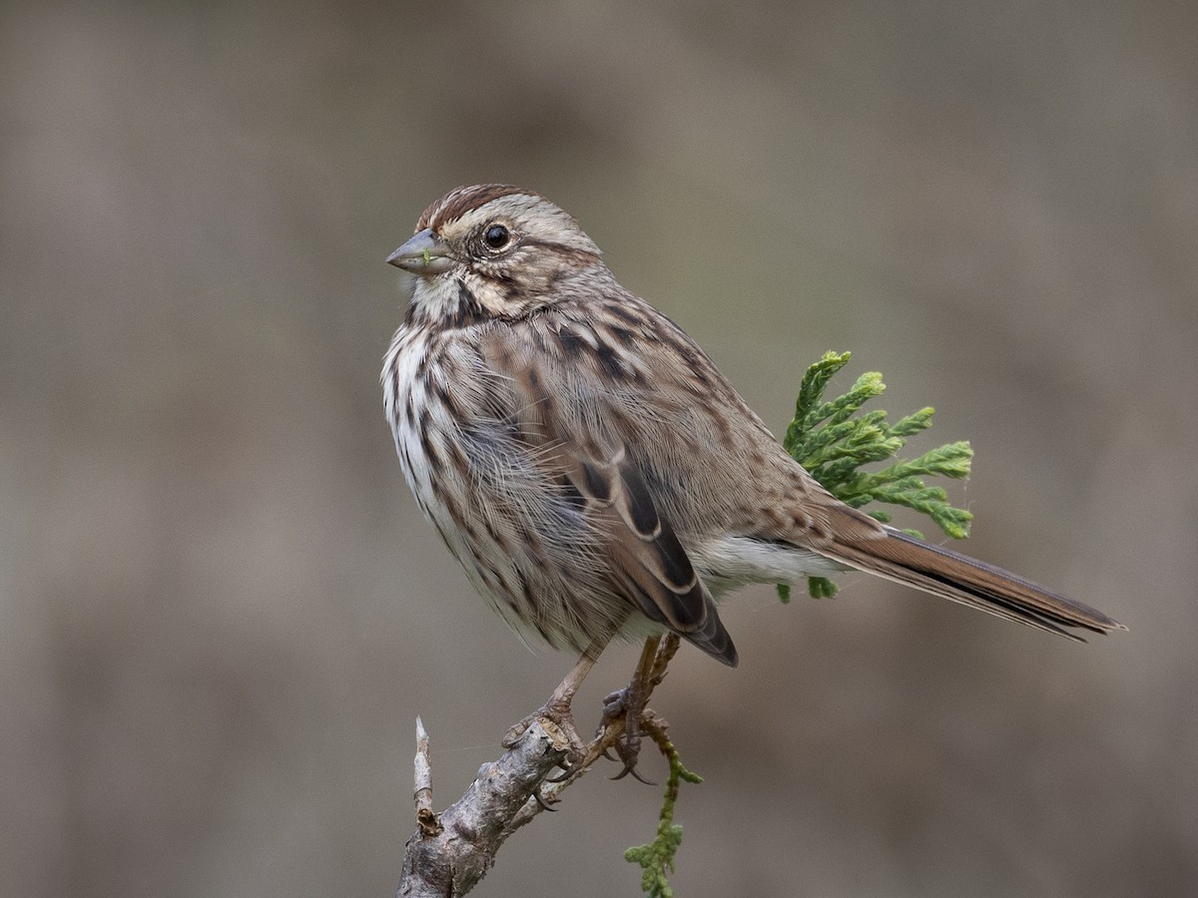

alt text here

### White-crowned Sparrow

Large, long-tailed sparrow with striking head pattern. Adults have black and white stripes on the head, while immatures show brown and tan. Underparts are plain grayish without streaks. Bill color varies from yellow to pink, but always brighter than White-throated Sparrow. Breeds in brushy areas or thickets in open forest, often with conifers. In migration and winter, can be found in any brushy or weedy areas, often hopping on the ground. Visits feeders.

r run_columnbreak() *Typical seasons: Epiphany, Easter*

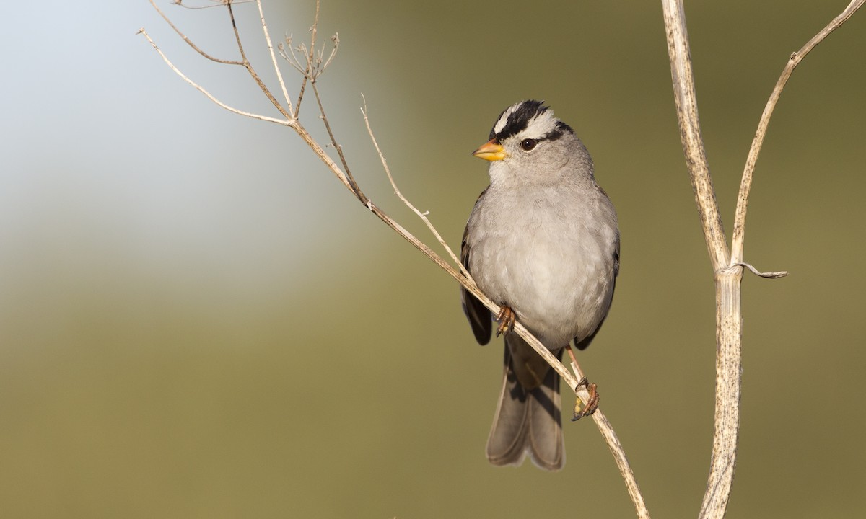

alt text here

### White-throated Sparrow

Large, long-tailed sparrow. Usually shows a bold head pattern and contrasting white throat. Two morphs with different head colors: white-striped and tan-striped. Both morphs show a yellow patch in front of the eye, but it is more obvious on white-striped birds. Adults have a fairly plain gray-brown breast without bold streaks, but immatures can be quite streaky. Note the grayish bill, unlike White-crowned Sparrow. Breeds in coniferous or mixed forests, often near clearings. In migration and winter, can be found in woods, forest edge, thickets and shrubby fields. Whistled song often transcribed as “Old Sam Peabody” or “O Sweet Canada.” Visits feeders.

r run_columnbreak() *Typical seasons: Epiphany, Lent*

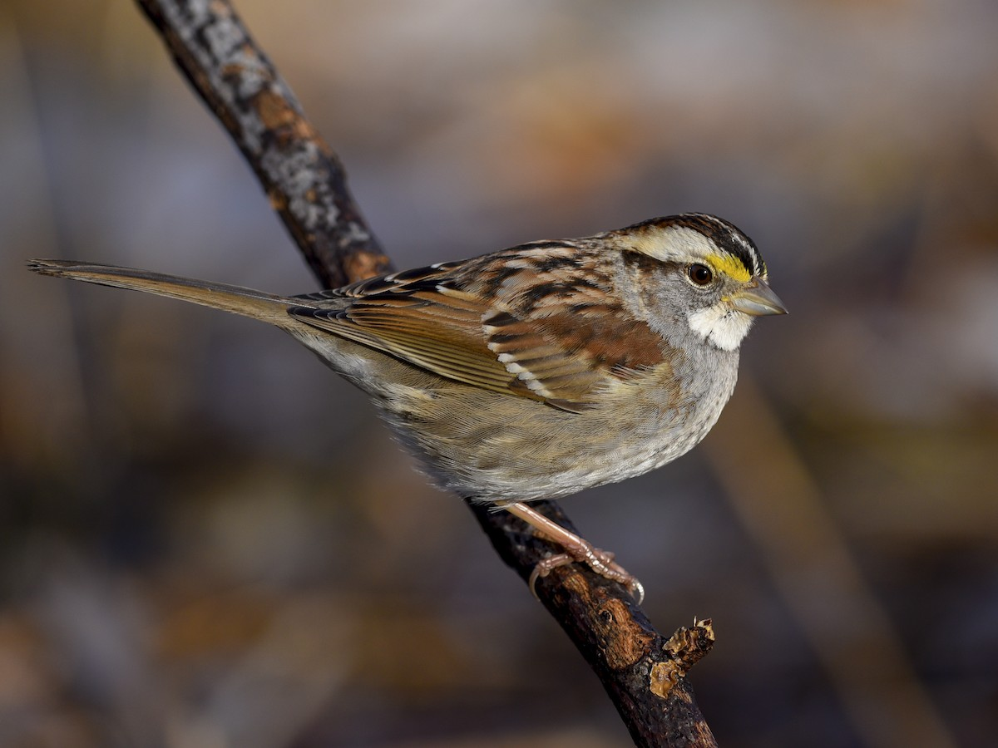

alt text here

## Passeridae: Old World Sparrows

### House Sparrow

Widespread and abundant in cities, neighborhoods and farms. Avoids dense woods. Flocks cluster in dense bushes, bustling around and chattering to one another. Males have smart black bibs, bright rufous napes, and stunningly patterned wings with brilliant buffs and browns. Underparts are pale pearly-gray. Females are plain brown with cute face and lighter eyebrow. Native to Eurasia; introduced to much of the rest of the world.

r run_columnbreak() *Typical seasons: Epiphany, Easter, Ordinary Time*

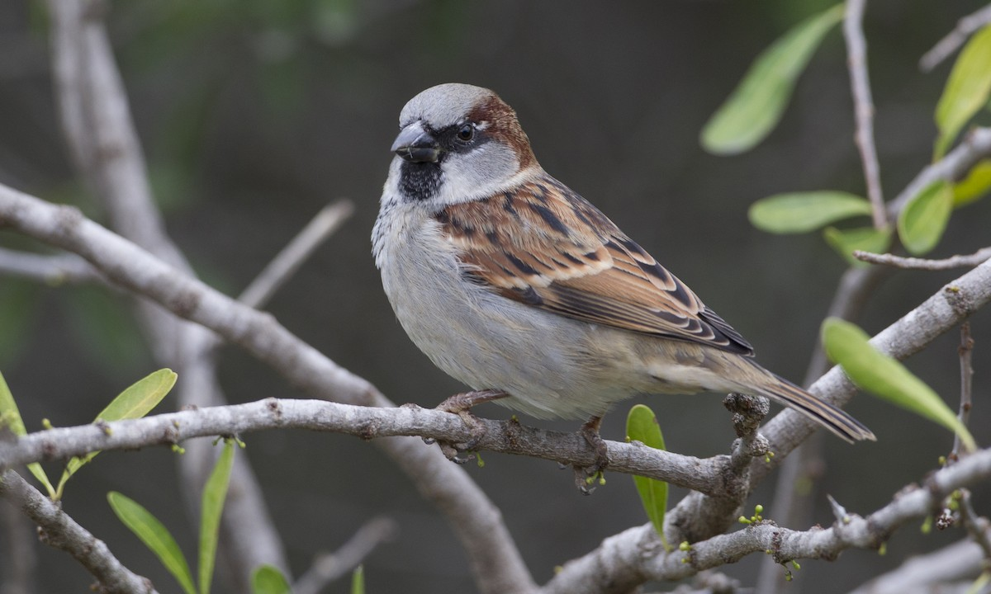

alt text here

## Picidae: Woodpeckers

### Downy Woodpecker

Tiny woodpecker, common and widespread across much of North America. Black-and-white plumage is nearly identical to the larger Hairy Woodpecker. Focus on the bill: Downy has a very short bill, much shorter than the length of the head. Also note the small black markings on the white outer tail feathers. Pacific population has smaller white spots on the wing and a grayer body than Eastern birds. Occurs in any wooded habitat, though western birds are more restricted to riparian areas. Often forages on smaller branches than Hairy Woodpecker. Familiar visitor to backyard feeders, especially fond of suet. Calls include a soft “pik!” and descending rattle, weaker than Hairy Woodpecker.

r run_columnbreak() *Typical seasons: Lent*

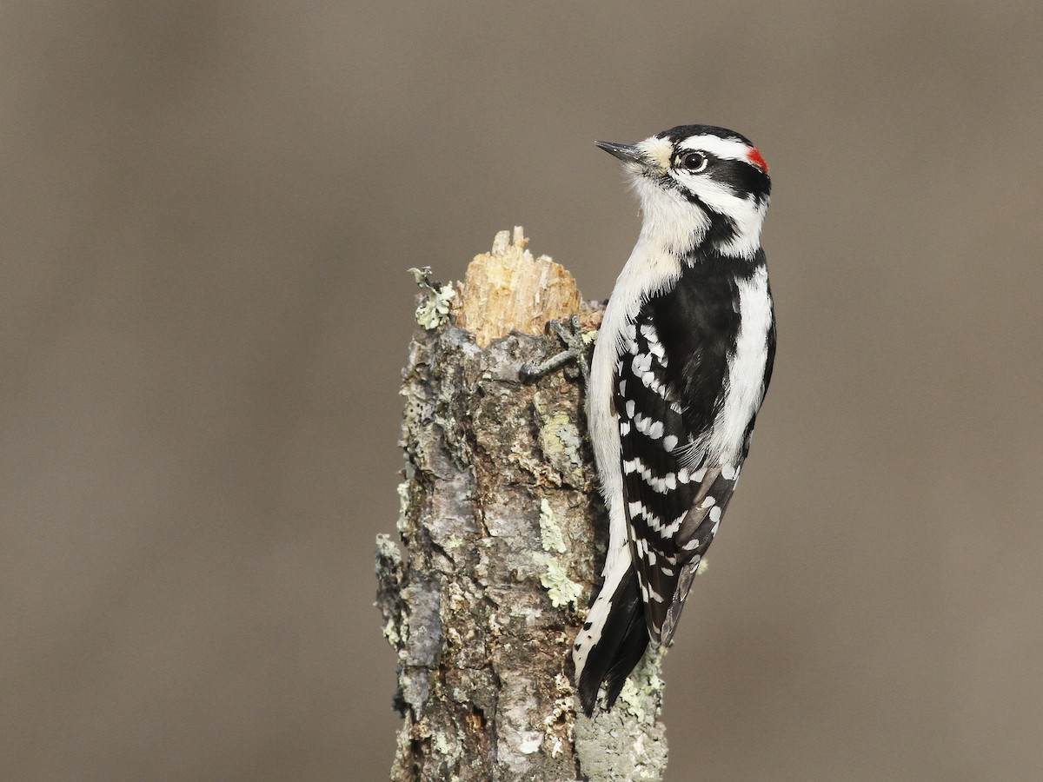

alt text here

### Hairy Woodpecker

Medium-sized woodpecker, common and widespread across North America as far south as western Panama. Black-and-white plumage is nearly identical to the smaller Downy Woodpecker. Focus on the bill: Hairy has a longer bill, about the length of the head. Also look for clean white outer tail feathers. Some variation in color across range; birds in western North America and especially Central America are brownish, with limited white in the wing. Occurs in wooded habitats with large trees. Familiar visitor to backyard feeders, especially fond of suet. Calls include a loud “peek!” and a fast rattle, stronger than Downy Woodpecker.

r run_columnbreak() *Typical seasons: Epiphany*

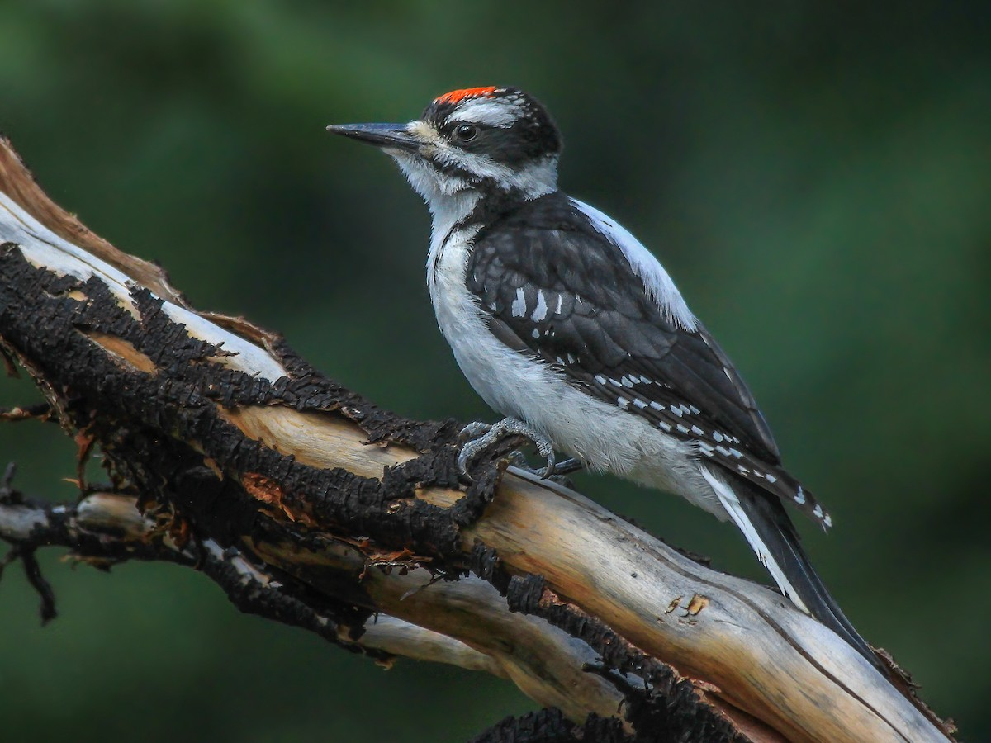

alt text here

### Northern Flicker

Large, brownish woodpecker with black barring on the back and black spots on the belly. Easily recognized in flight by its bright white rump. Also note large black crescent-shaped mark on breast. Wings and tail flash yellow or red, depending on the subspecies. Generally “Yellow-shafted” is found in eastern and northern North America, and “Red-shafted” is found in western North America as far south as Oaxaca. Birds from Chiapas to Nicaragua are larger with entirely brown crown, sometimes considered a separate species. Typically singly or in pairs, but can gather in large loose groups during migration and winter. Often seen feeding on the ground in open areas, foraging for ants and worms. Vocal and conspicuous: listen for loud “kleer!” call and series of laughing notes.

r run_columnbreak() *Typical seasons: Easter, Ordinary Time*

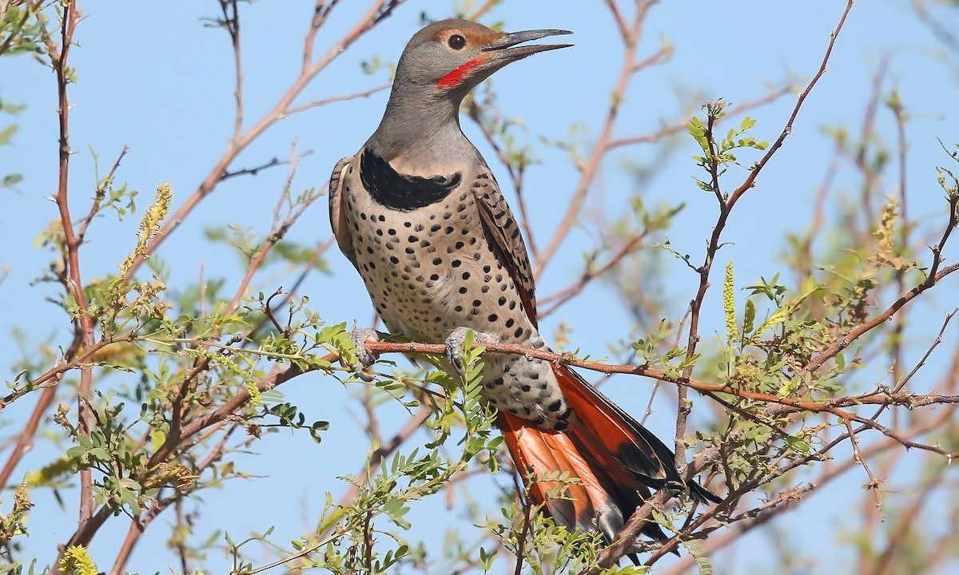

alt text here

### Pileated Woodpecker

Large, unmistakable woodpecker. Mostly black, with red crest and bold white stripes on head and neck. Flies with deep, rowing wingbeats, almost like a crow but more irregular; also look for mostly white underwings and white patches on upperwing. Pairs inhabit mature deciduous or coniferous forests with large trees. Makes large oval-shaped holes in decaying trees to search for insects. Listen for slow resonant drumming and loud clucking calls. Occasionally visits feeders in appropriate habitat, especially fond of suet.

r run_columnbreak() *Typical seasons: Lent*

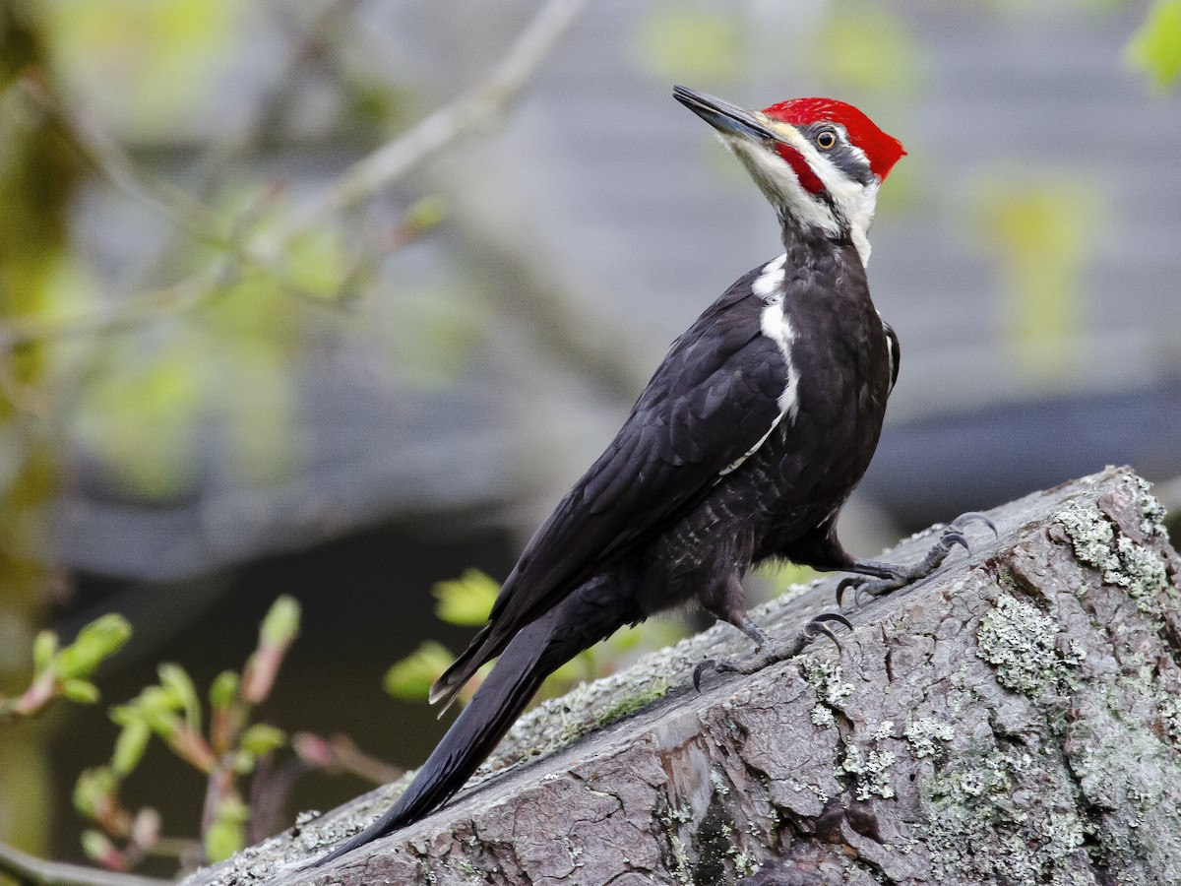

alt text here

### Red-bellied Woodpecker

Medium-sized woodpecker that is not well named; rarely is the slight red wash on the belly visible! Instead, note the black-and-white barring on the back and wings, plain buffy breast and face, and red nape. On adult males, look for the red extending onto the crown. In flight, look for the white rump. Found in forested and suburban areas, typically preferring deciduous trees. Slowly expanding its range northward. Visits feeders, especially for suet. Nests in cavities.

r run_columnbreak() *Typical seasons: Easter, Ordinary Time*

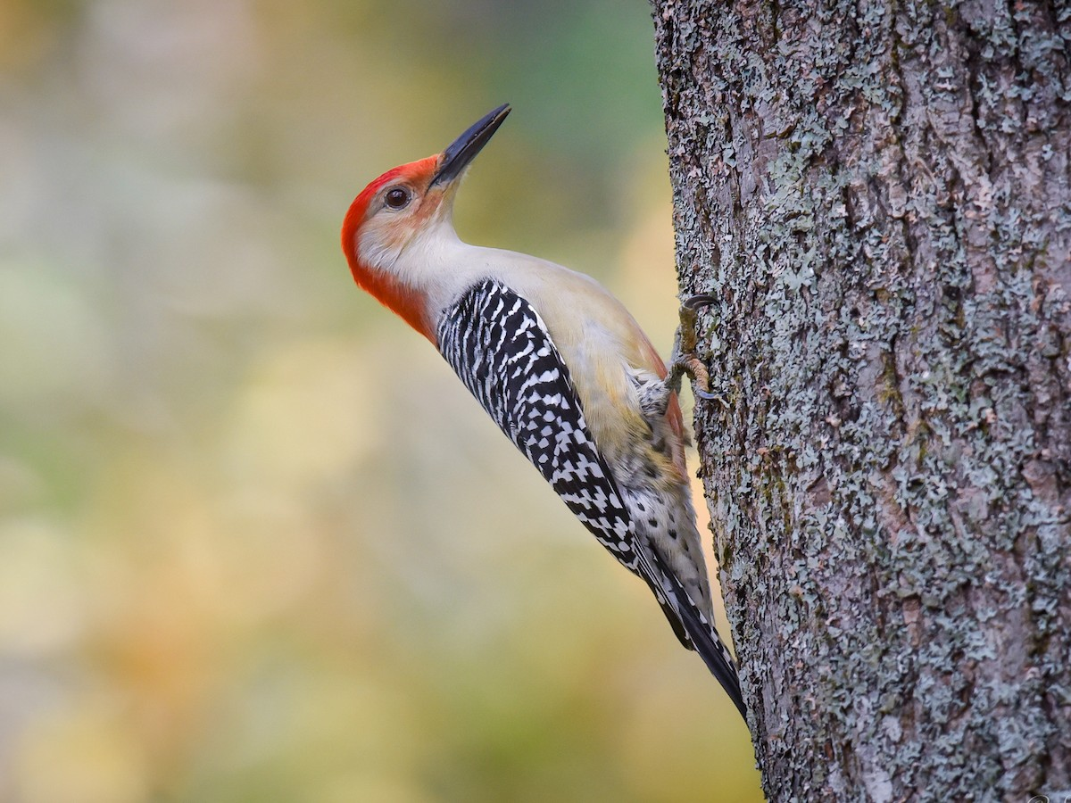

alt text here

## Scolopacidae: Sandpipers

### Least Sandpiper

Tiny brownish sandpiper. At all ages, most easily distinguished from other small sandpipers by darker, more brownish coloration. Juveniles are particularly bright with rusty tones on the upperparts. Also note fine-tipped bill and yellowish legs, but beware legs can be covered with dark mud and other peeps (like Semipalmated Sandpiper) can rarely show slightly greenish legs. Habitat and behavior are helpful supporting clues, too. Typically forages in a crouched posture with bent legs, picking for invertebrates in the mud. Often in small loose groups, but not in large, tight flocks like Semipalmated or Western Sandpipers. Prefers drier mud, often on the higher edges of mudflats or small patches of water in marshes. Widespread and common, especially inland. Breeds in various wetland habitats throughout Alaska and Canada. Winters from the southern U.S. to South America. Listen for high-pitched, rolling “greeep!” calls.

r run_columnbreak() *Typical seasons: Easter*

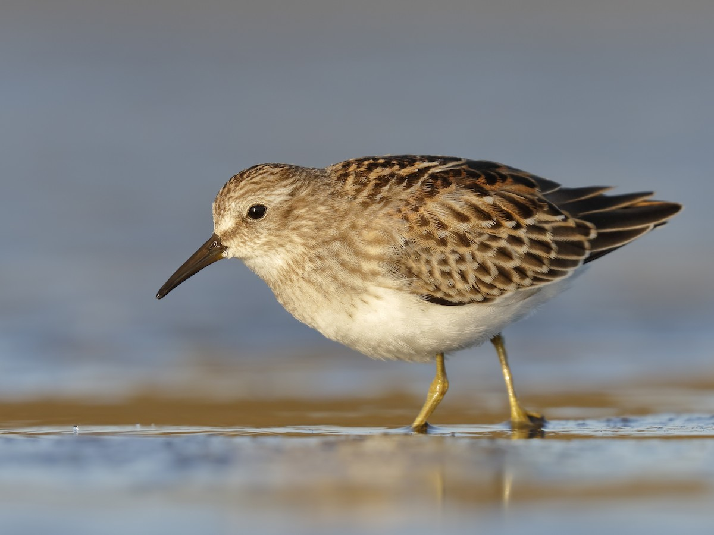

alt text here

### Lesser Yellowlegs

Medium-sized shorebird with bright yellow legs. Plumage is essentially identical to Greater Yellowlegs: gray upperparts with white speckling, streaky neck, and white belly. Proportions are most important for identification. Lesser is smaller overall with shorter, narrower, straighter bill, shorter neck, more rounded head, and smaller chest. Forages actively on mudflats and in shallow pools and marshes, often in loose mixed flocks with Greater Yellowlegs. Somewhat more likely to be found in smaller, marshier habitats than Greater, but much overlap. Listen for soft, whistled “tew” calls, typically only one or two notes, unlike the stronger series of notes from Greater.

r run_columnbreak() *Typical seasons: Easter*

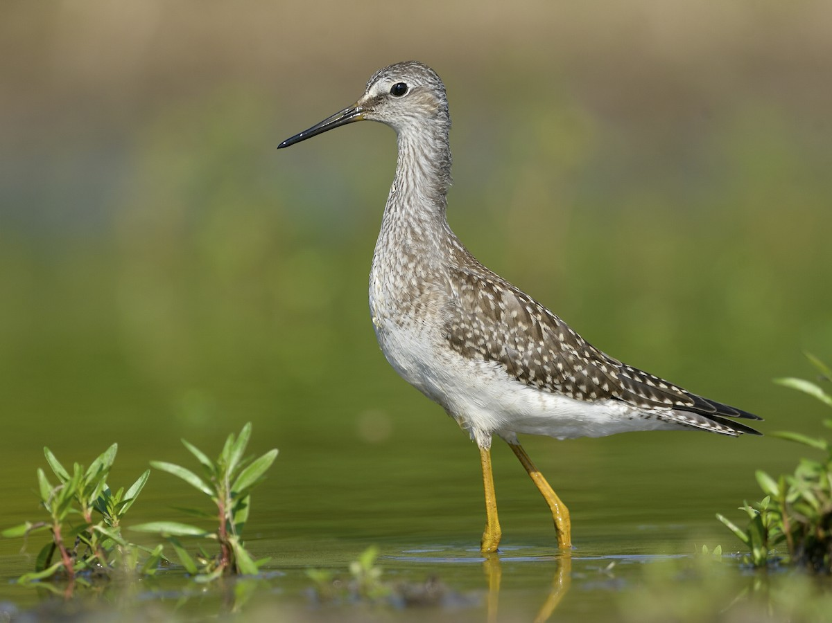

alt text here

### Semipalmated Sandpiper

Small, grayish-brown sandpiper. Typically shows relatively short, blunt-tipped bill, but this varies across the breeding range: western populations are shortest-billed, eastern populations are longest, and females have longer bills than males! Also note blackish legs, although they can appear dull gray or greenish. In breeding plumage, fairly pale grayish brown, sometimes with brighter rusty cap and cheek. Nonbreeding is plain gray above and white below. Juveniles have attractive scaly pattern on upperparts, and variable coloration: usually grayish with some buffy areas, occasionally brighter rufous. Most similar to Western and Least Sandpipers. Western averages slightly larger and longer-billed, with brighter rufous on breeding adults and juveniles; nonbreeding birds paler but extremely similar to Semipalmated. Least Sandpiper is darker and browner. Breeds on high Arctic tundra. Migrates to South America for the winter; very rarely lingers in the U.S. past November, unlike Western Sandpiper. Usually found in flocks, sometimes in very large numbers. Prefers open mudflats, but also found in marshes and beaches.

r run_columnbreak() *Typical seasons: Easter, Ordinary Time*

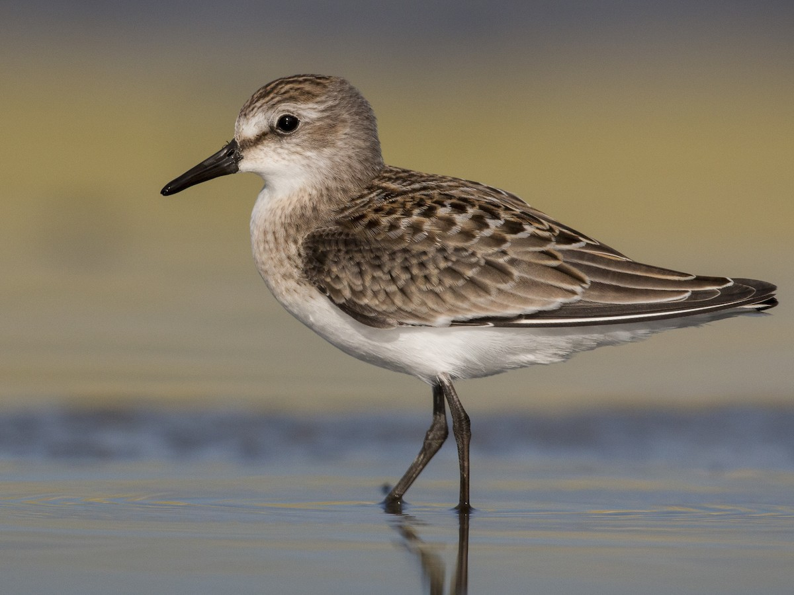

alt text here

### Solitary Sandpiper

Medium-sized shorebird. Gray above and white below, with fine white speckling on wings and bold white spectacles. Note dark underwing and dark rump in flight. Smaller and shorter-legged than Lesser Yellowlegs, with duller greenish legs. Often alone, but multiple individuals may gather loosely in appropriate habitat. Tips body like Spotted Sandpiper, but less constantly and not as quick and dramatic. Breeds around ponds and marshes in the boreal forest; uses old songbird nests in trees, unlike most other shorebirds. In migration and winter, mostly seen on small bodies of water like muddy ponds, lake edges, and slow-moving streams. Extensive winter range throughout Central and South America. Listen for piercing, high-pitched “tsee-weet!” call.

r run_columnbreak() *Typical seasons: Easter, Ordinary Time*

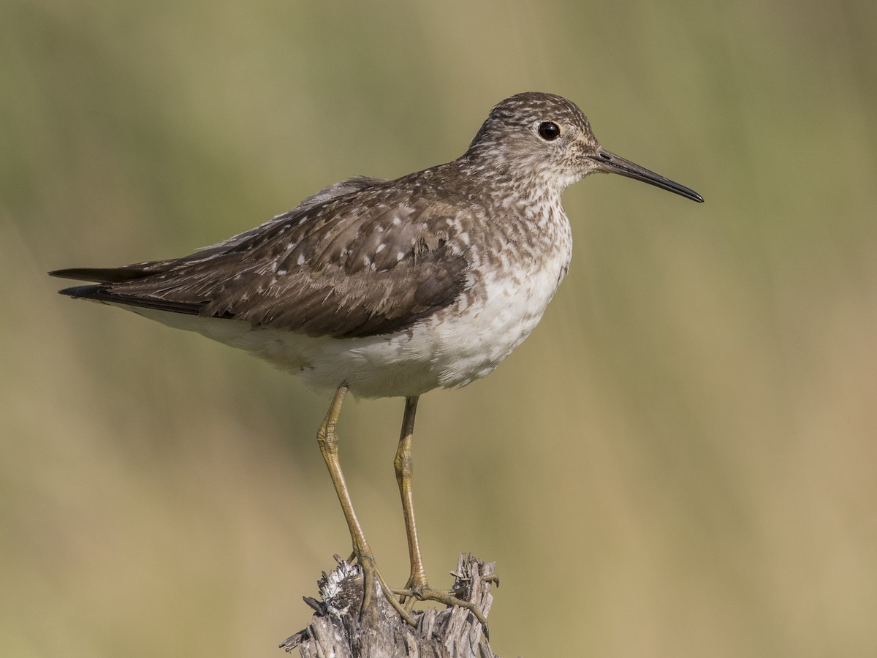

alt text here

### Spotted Sandpiper

Small shorebird. Constantly bobs its tail while working edges of streams, ponds, and lakes for invertebrates. Several individuals may be found at the same body of water, but never forms tight flocks. Underparts spotted in summer; plain in winter. Listen for two- or three-noted whistled call as they flush from shorelines. Distinctive wingbeats: snappy and below horizontal.

r run_columnbreak() *Typical seasons: Easter*

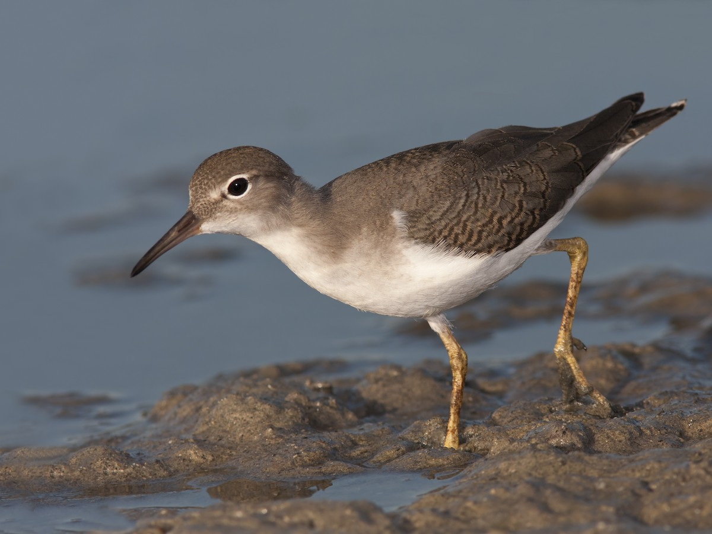

alt text here

### Wilson’s Snipe

Plump, well-camouflaged shorebird that blends into wet meadows and marshes. Dark and heavily marked, with pale buffy stripes on back and face. Extremely long bill used to probe into mud for invertebrates. Similar in shape to American Woodcock but much darker with extensive markings on underparts. Fairly common and widespread throughout North America, wintering to northern South America. Found in muddy wetlands, flooded fields, and marshes, usually singly but sometimes gathering in loose groups. When flushed, listen for rough call note. On breeding grounds, watch and listen for aerial flight display, given day and night: a rapid series of hoot-like noises produced by the outer tail feathers in flight.

r run_columnbreak() *Typical seasons: Lent, Easter, Ordinary Time*

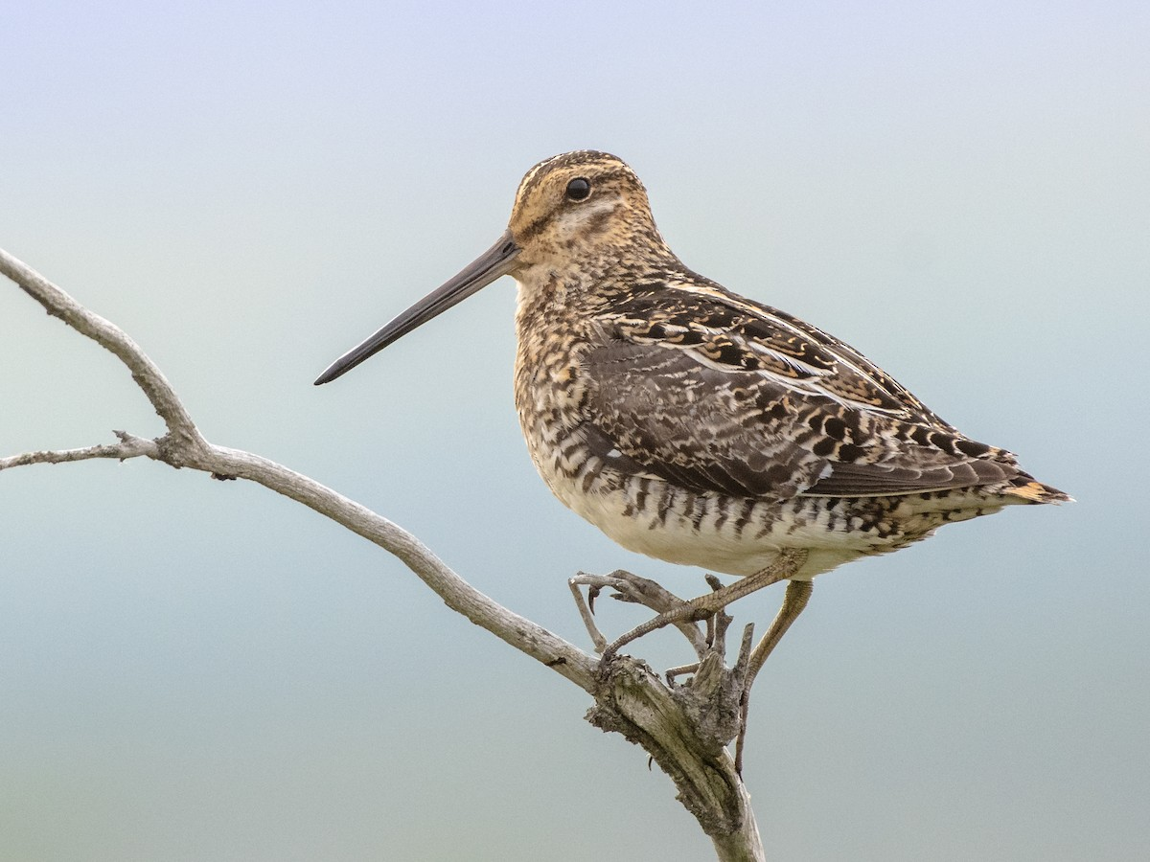

alt text here

## Sittidae: Nuthatches

### White-breasted Nuthatch

The largest nuthatch in North America, with distinctive white face, black cap, and blue-gray upperparts. Also note rusty lower belly and undertail coverts. Females have a slightly paler crown than males. Fairly common and widespread, usually in mature woodlands with large trees. Creeps along tree trunks and branches, often upside-down. Sometimes joins mixed flocks with other songbirds. Visits feeders. Listen for insistent yammering calls. Some subtle variation across range, mainly in the darkness of the sides and back, width of the black crown, and vocalizations.

r run_columnbreak() *Typical seasons: Ordinary Time*

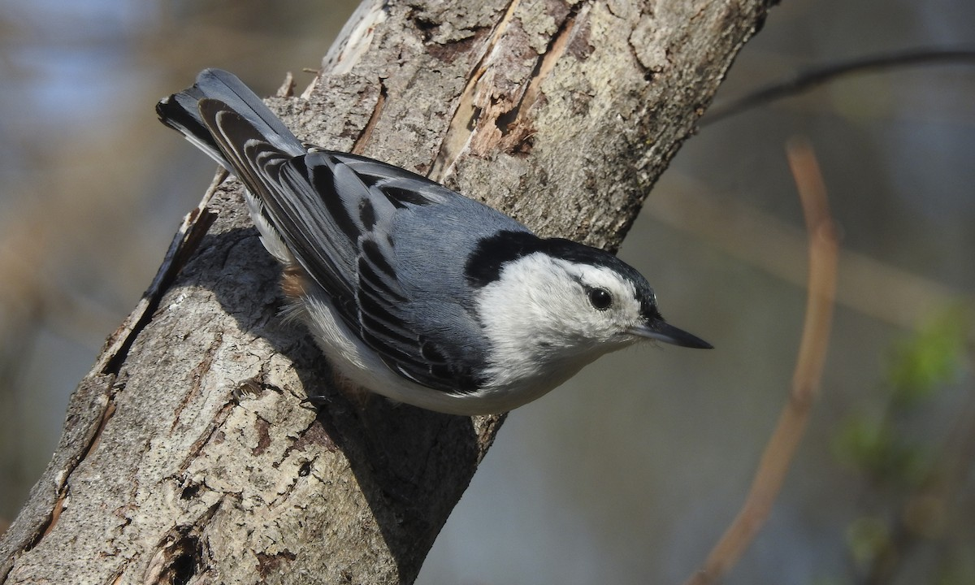

alt text here

## Strigidae: Typical Owls

### Eastern Screech-Owl

Small, stocky owl with large head and no neck. Pointed ear tufts are often raised. Varies in color from gray to bright rufous (reddish-brown). Intricate pattern is perfect for camouflage against tree bark. Yellow eyes. Active at night when they prey on small birds and mammals. More often heard than seen; listen for its descending whinny and longer trill. Roosts and nests in cavities, including nest boxes. Found in a variety of habitats with trees, particularly near water.

r run_columnbreak() *Typical seasons: Ordinary Time*

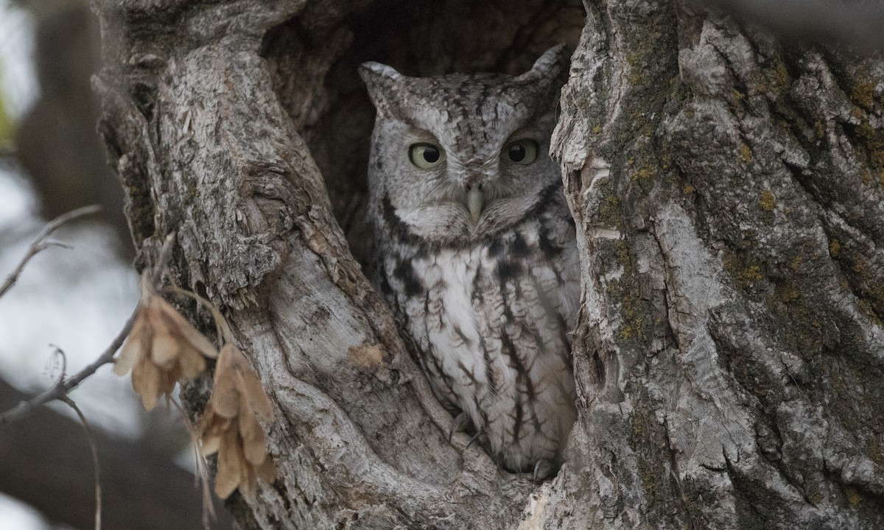

alt text here

## Sturnidae: Starlings

### European Starling

Stocky and dark overall. Short tail, triangular wings, and long, pointed bill. Close look reveals beautiful plumage. In breeding season, shows purple and green iridescence on body with yellow bill. In winter, bold white spots cover the entire body. Native to Eurasia; introduced in many regions worldwide, where it is now abundant. Often in large flocks. Makes variety of squeaky vocalizations, including proficient mimicry of other species. Inhabits a wide range of open habitats, often in very close proximity to people. Visits feeders, and is often aggressive.

r run_columnbreak() *Typical seasons: Ordinary Time*

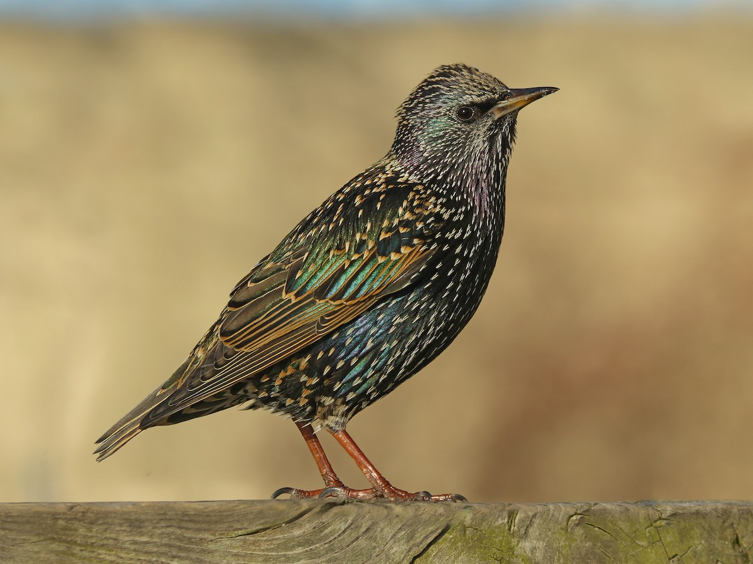

alt text here

## Trochilidae: Hummingbirds

### Ruby-throated Hummingbird

Small hummingbird found in a variety of woodland and brushy habitats. Male distinctive with ruby-red throat and black chin. Female has whitish underparts with almost no buffy tones (perhaps a very light wash on flanks). Readily comes to sugar water feeders and flower gardens. Default summer hummingbird over most of eastern U.S. and Canada. Winters south to Panama. Very difficult to distinguish from Black-chinned Hummingbird, especially females and young males; thankfully limited range overlap. Ruby-throated averages somewhat brighter green above, shorter- and straighter-billed, and has slightly narrower outer wing feathers, but these differences are all extremely subtle.

r run_columnbreak() *Typical seasons: Ordinary Time*

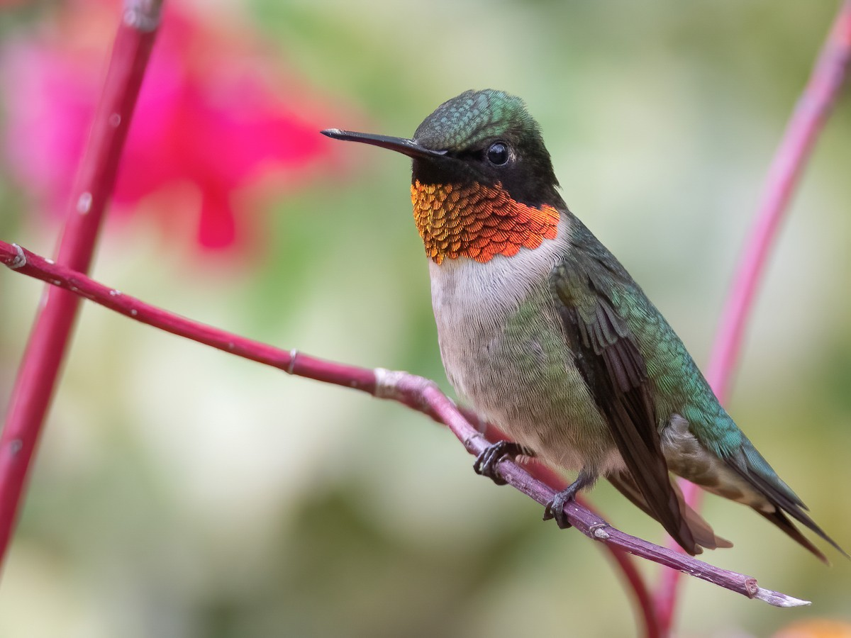

alt text here

## Troglodytidae: Wrens

### Carolina Wren

Bold white eyebrow. Warm brown above, buffy-orange underparts. Slightly decurved bill. Tail is about as long as body and often cocked up. Usually in hiding in dense vegetation, tangled understory, or brush piles in forested areas. Nests in peculiar places around backyards, such as tucked in a drainpipe or grill. Occasionally feeds on suet or mealworms at feeding stations. Listen for loud, ringing song and variety of calls. Unlike House Wren they are not migratory and stay nearby their breeding grounds year-round.

r run_columnbreak() *Typical seasons: Easter, Ordinary Time*

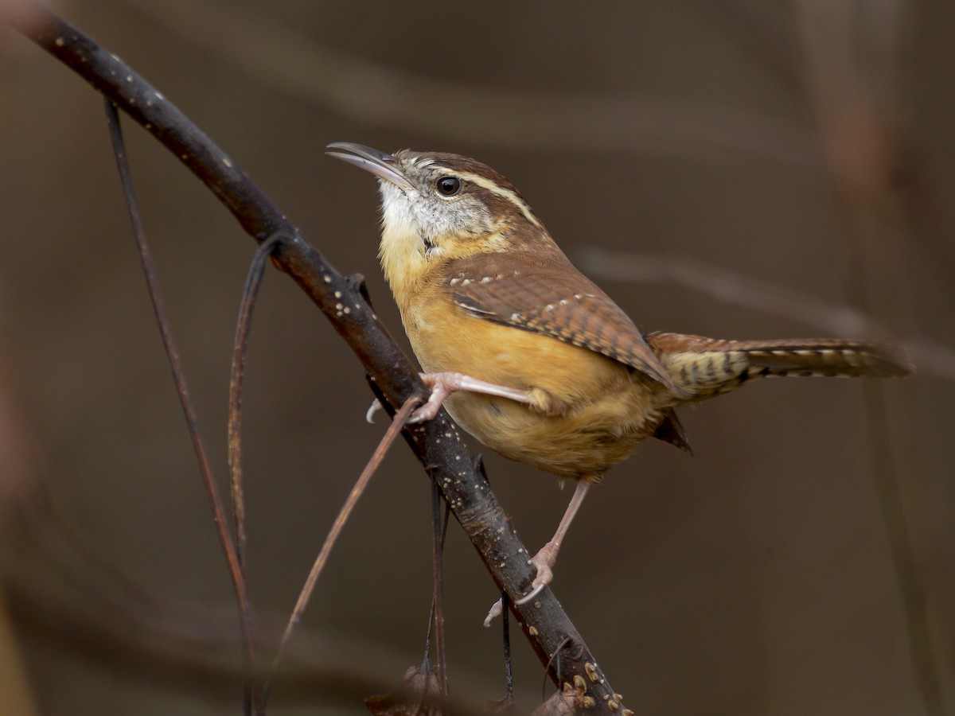

alt text here

## Turdidae: Thrushes

### American Robin

Fairly large songbird with round body, long legs, and longish tail. Gray above with warm orange underparts and blackish head. Hops across lawns and stands erect with its bill often tilted upward. In fall and winter, forms large flocks and gathers in trees to roost or eat berries. Common across North America in gardens, parks, yards, golf courses, fields, pastures, and many other wooded habitats.

r run_columnbreak() *Typical seasons: Lent*

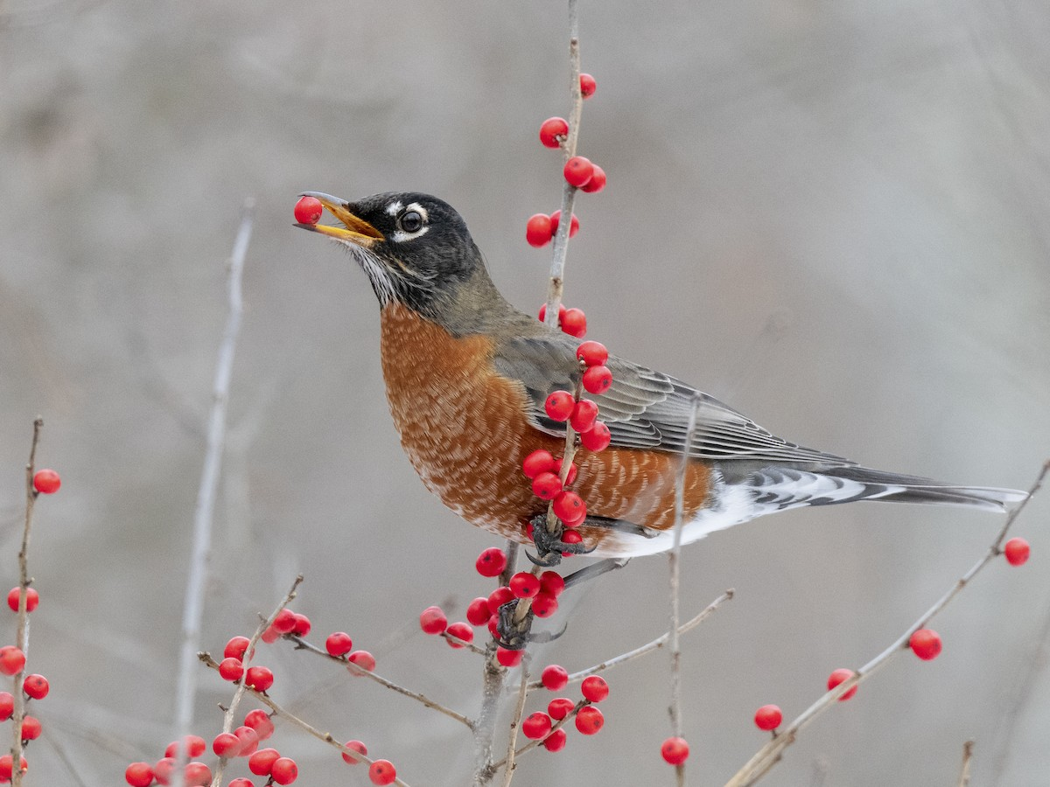

alt text here

### Eastern Bluebird

Adult males are striking royal blue above with bright orange throat and breast and bright white belly. Females are paler overall; grayish with orange on breast and sides of neck, and white belly. Favors fields and open woods. Often in small groups. Frequently perches on wires or fence posts. Nests in cavities. Listen for its soft, chortling calls.

r run_columnbreak() *Typical seasons: Ordinary Time*

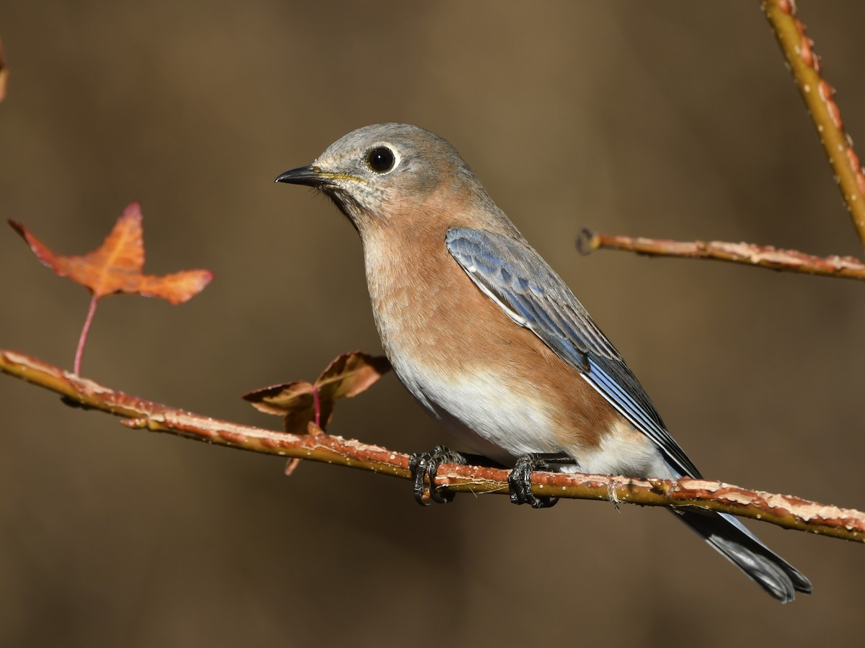

alt text here

## Tyrannidae: Tyrant Flycatchers

### Eastern Kingbird

Fairly large flycatcher, dark gray above and clean white below with blacker head. Look for white tail tip. Name is somewhat misleading; it does occur over most of eastern North America but also reaches as far west as British Columbia, Washington, and Oregon. Fairly common and conspicuous; perches out in the open, often on tall trees, snags, fences, and utility lines. Watches for large insects and makes quick flights to snatch them. Listen for metallic twittering calls. Winters in lowlands of South America.

r run_columnbreak() *Typical seasons: Ordinary Time*

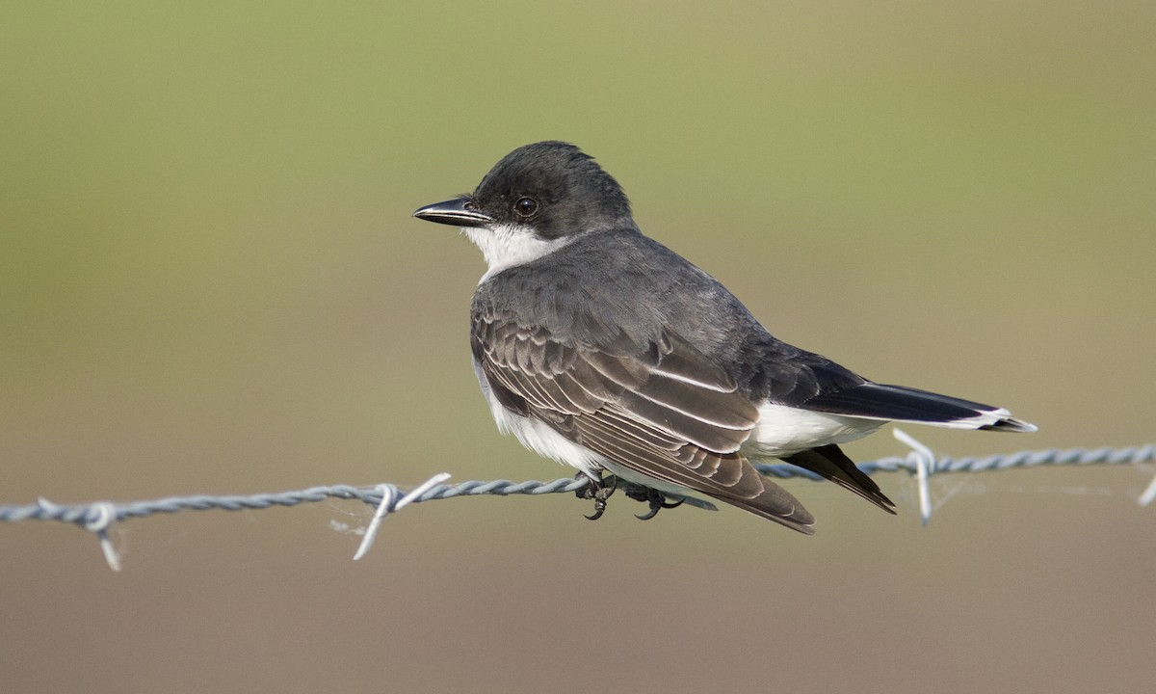

alt text here

### Eastern Phoebe

A drab, medium-sized flycatcher. Brownish above and pale below, often with a light yellowish wash on the belly. Watch for constant tail-wagging, and also note duller wingbars than Empidonax flycatchers. Common and familiar throughout eastern North America, wintering as far south as southern Mexico. Usually seen singly or in pairs in relatively open habitats such as woodland edge, brushy fields, or edges of ponds. Often nests under eaves of buildings and other human-made structures. An early migrant, returning north to breed much earlier than other flycatchers. Listen for its harsh “FEE-bee” song in the spring, but don’t get confused by Black-capped Chickadee’s higher-pitched, sweet whistled song of a similar pattern!

r run_columnbreak() *Typical seasons: Ordinary Time*

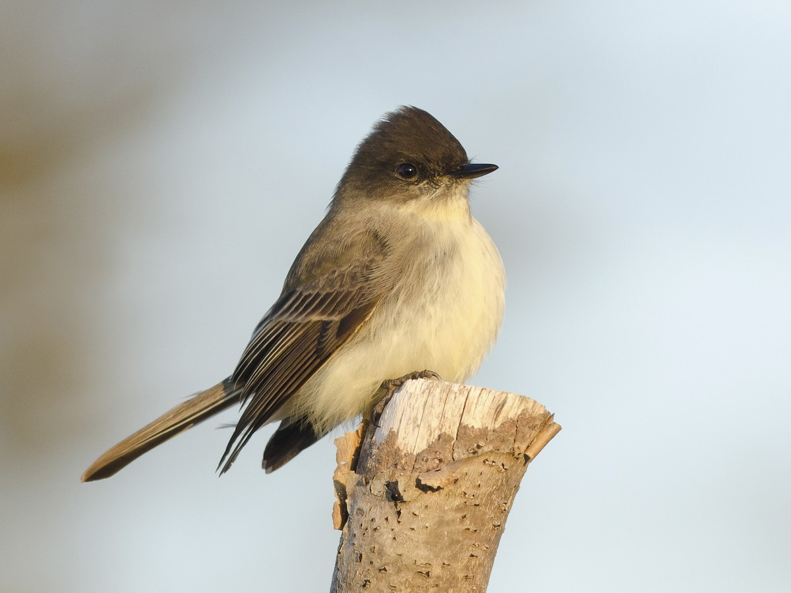

alt text here